UWORKS DEMO

Prepared by: StateWorks IT
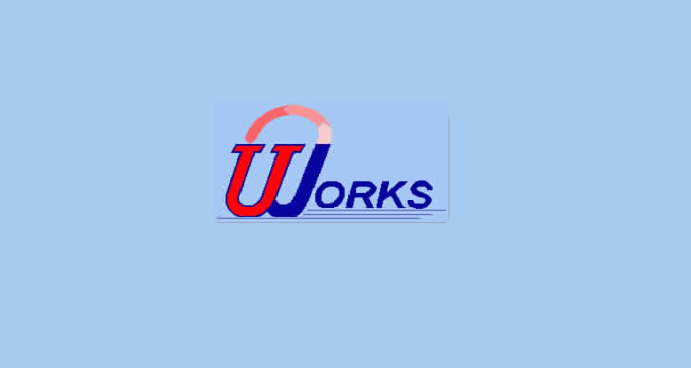

Case Management Training Guide

January 2007

Table of Contents

Case Management Search & Report 3 - 6

Initial Interview Screens & Report 7 - 10

PACMIS/Eligibility System Interface Info Screens 11 - 16

Assessment Screens 17 - 24

Eligibility for Services Screens 25 - 36

Employment Plans Screens & Reports 37 – 49

TANF Verifications 50 – 51

Provider Screens 52 - 54

Correspondence Screens & Letter 55 - 58

Counselor Information Screen 59

Customer (Seeker) Misc. Screens 60 - 64

Seeker History Screens 65 - 67

Workshops Screens & Reports 68 - 77

Edits for Job Orders & Case Management 78 - 80

Veteran Report Screens 81 - 85

Appendix - Objectives & Services Listing 86 -102

UWORKS CASE MANAGEMENT SEARCH: General
Version 1/20/07

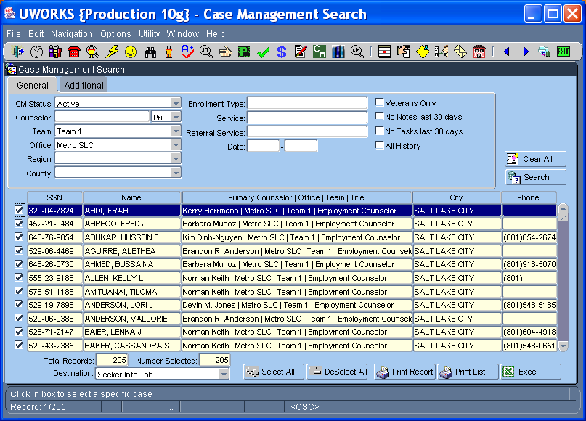

Use the Case Management Search to find customers that are being case managed. This can be a powerful tool if used correctly. There are many search elements that can be used to find customers but the primary purpose of this screen is matching case managed customers to workers. Print search results or export to Excel.
- Search for customers by Case Management Status, Worker Name, Team, Office, Region, and County.
- Search for customers based on Enrollment Type, Employment Plan Service, Referral Service Provider, Date, Veterans Only, Cases with No Notes in 30 Days, and Cases with No Tasks in 30 Days.
- The All History check box searches for all customers that were assigned to a worker. The worker may not be assigned to the customer now but they were at some time in the past.
- The search results are displayed in the table and can be re-sorted by right clicking in the column you want to resort.

UWORKS CASE MANAGEMENT SEARCH: Additional
Version 1/20/07

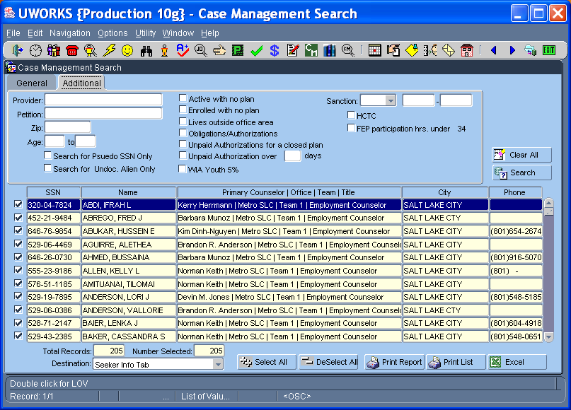

- Provider they received an authorization for, Petition Number, Zip Code, Age Range, Pseudo SSN or Undocumented Aliens.
- The check boxes on the right side of the screen provide specialized searches. Find customers that are Active with no plan, Enrolled with no plan, Live outside office area, only customers with Obligation/Authorizations, customers that have Unpaid Authorizations and have a closed plan and Authorizations that are not paid over blank days.
- Ability to search for FEP Sanctions by date if wanted, HCTC or FEP participation hrs. under 34.
- The search results are displayed in the table and can be re-sorted by right clicking in the column you want to resort.

UWORKS CASE MANAGEMENT SEARCH: Customer Report
Version 1/20/07

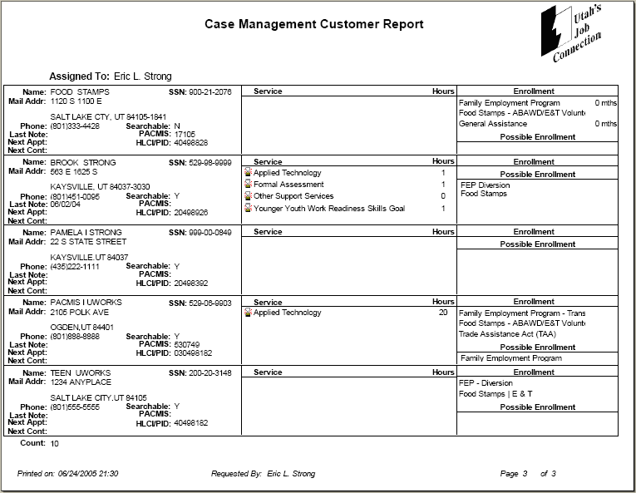
Selecting the button from the Case Management Search screen brings up detailed information about each person found in the query. The information is specific to their employment plan. Workers use this report to make sure that they are working with their customers and following up on their progress.

(As you can see, this example only shows 1 page of the 3-page report.)

UWORKS CASE MANAGEMENT SEARCH: Customer List

Version 1/20/07

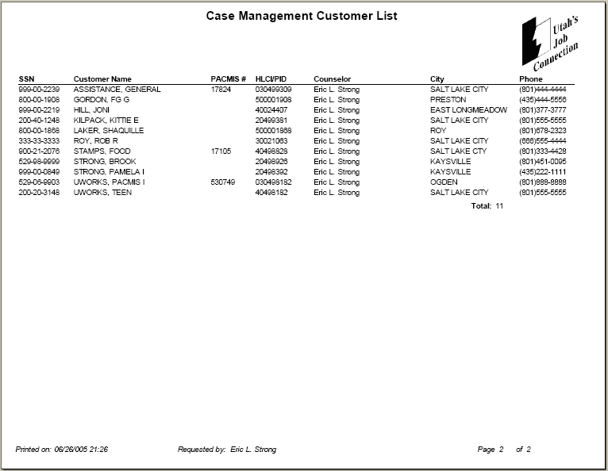
Selecting the button from the Case Management Search screen bring up a list of all the seekers found from the query. It displays general information about each person.

UWORKS INITIAL INTERVIEW
Version 1/20/07
Initial Interview

- The purpose of the Initial Interview is to provide a brief informal assessment of customers needs and respond with internal and external resources and referrals.
- By intervening in a timely manner and by assisting the job seeker in overcoming situational factors that lead to crisis, job seeking and job retention are likely to occur.

Why use the Initial Interview?
- The counselor and customer can take the time to conduct a comprehensive assessment and develop a quality employment plan in subsequent visits. Example: The Employment plan can then be constructed in a way that incorporates and addresses information identified in the initial interview assessment.
- It provides documentation of the customer interaction and gives credit to the employment counselor for the service provided.
- The initial interview can be used as a tool to educate customers in the participation requirements for Intensive or Training services. This allows discussion with the customer regarding some preliminary steps to determine if they are appropriate or eligible for training services. Also, participation requirements of specific program services can be discussed with the customer. Then the customer can make an informed decision about participating in programs.
- For customers who do not follow through after the first visit, time has not been spent on the details of assessment and employment planning.

Benefits for the Customer:
- The customer’s immediate needs are addressed.
- The customer is provided internal and external resources on the first visit.
- The customer is not rushed through the assessment process.

Other benefits include:
- The Initial Interview activity shows advocacy groups that the department is working to address customer’s immediate needs and connect them to appropriate resources.
- The department will reduce duplication of effort with community partners.

  - By explaining (and signing) the application participation agreement(s), customers can make informed choices whether they are able and/or willing to participate in our programs (without taking time to go into the assessment and employment planning processes.)

UWORKS INITIAL INTERVIEW
Version 1/20/07

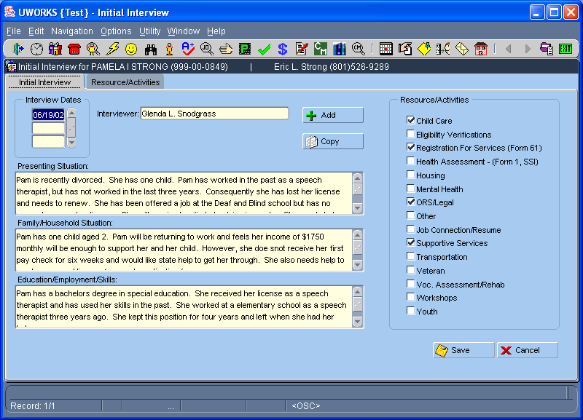

The purpose of the Initial Interview is to provide a brief informal assessment of the customer's immediate needs and respond with internal and external resources and referrals. This screen can be used as a tool to help the worker with the informal assessment and resources.
- The Interview Dates section allows the worker to create additional Initial Interview records. Use the Add button to create new records. Use the Copy button to create a new record using the data from an existing record. Information can be modified during the day it was entered.
- Use the Presenting Situation section to summarize the customer current situation.
- Use the Family/Household Situation section to summarize the customer’s family/household. Address items like marital status, who lives in the household and does the customer have dependent children.
- Use the Education/Employment/Skills section to summarize the customer's Education/Employment/Skills. Ask questions like, “Are you currently employed?” “Have you been employed in the past?” “What type of education do you have?”
- Use the Resource/Activities section to check the boxes that you have determined are issues for the customer at this point in time.
UWORKS INITIAL INTERVIEW: Resource/Activities
Version 1/20/07

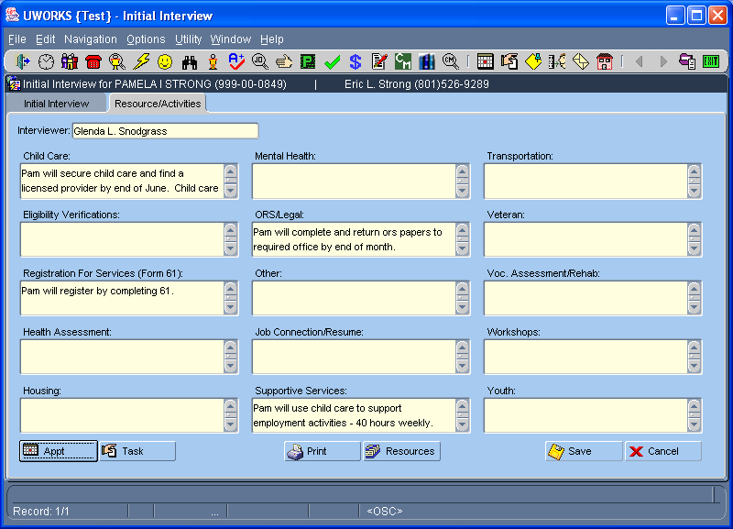

The purpose of the Initial Interview – Resource/Activities screen is to enter a brief description of possible resources and how the customer can access those resources. Only the boxes that were checked on the Initial Interview screen will be available to enter information, all other boxes will be protected. Can cut and past common resource information from a template.
- Enter brief details in every box on the screen that is not (yellowed-out) protected. The information entered should provide the customer with enough details about the resource or referrals to enable them access the services available to them.
- Use the Appointment and/or Task buttons to create an appointment for the customer to meet with another worker and set a task.
- The Resources button can be used to access an Information & Referral web site to find resources, phone numbers and addresses for referrals.
- When all the information has been entered and you are ready to provide the customer with all the data you have gathered, select the Print button. The resources and activities printout should be give to the customer to take with them. If you have made appointments for the customer they will be printed at the bottom of the sheet. (Seen next page for example)
UWORKS INITIAL INTERVIEW: Resource/Activities
Version 1/20/07

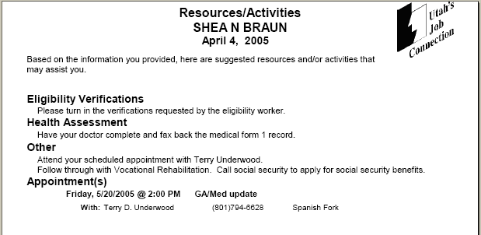
The Resource Activities printout details resource and activity information that will help the customer start improving their situation. The Printout is given to the customer. This example shows that the customer needs return eligibility verifications, see their doctor, work with Voc Rehab, apply for social security and their appointment date and time is listed.

UWORKS PACMIS: Interface

Version 1/20/07

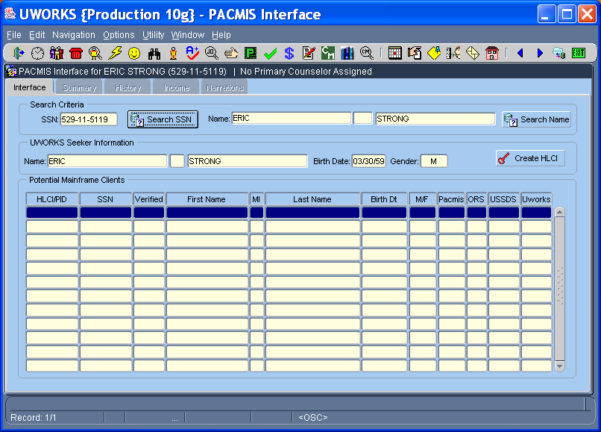

The purpose of the PACMIS Interface screen is to find a customer in the eligibility system and tie it to the same customer in the UWORKS system. This creates a common tie for customer records in both systems and allows for exchange of data information through system interfaces.
- A Social Security Search is done to try and find the customer in the PACMIS/TANF system. If there is a match the customer information will populate in the grid.
- If there is no SSN match then a Name Search is done. The results of the name search will display in the grid. If the customer is found in the grid the worker double clicks on the name to select that record.
- If the customer is not found in either search then select the Create HLCI button to add the customer record to the PACMIS.TANF system.
- Once the customer is interface the other tabs will be available to view data from the eligibility system.

UWORKS PACMIS: Summary

Version 1/20/07

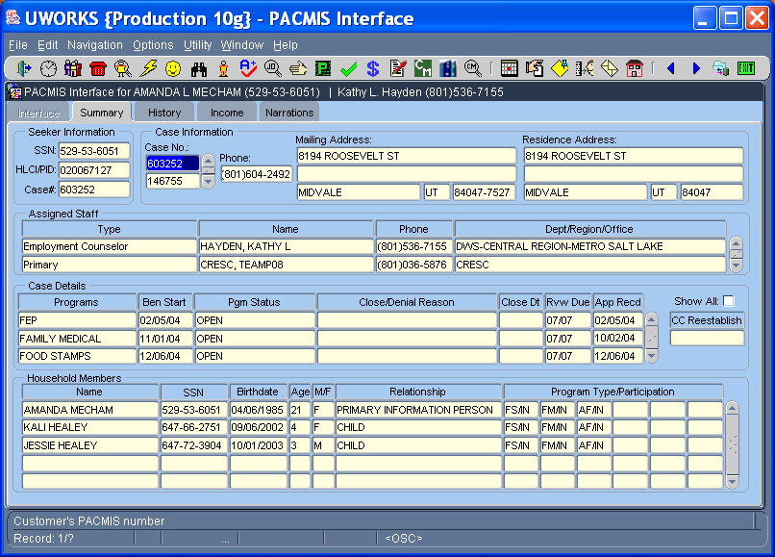

The purpose of the PACMIS Summary screen is to allow the user to see a summary of key information from the PACMIS eligibility system.
- The top portion of the screen shows the Case Information. If there is more than one case number the other numbers can be selected and the data on the screen will change to reflect the information from the different case number. Address information from PACMIS is displayed.
- Assigned Staff displays the workers that are assigned for case management, eligibility and other caseworkers that work with the customer.
- Case Details shows the open eligibility programs, dates and status. Show All will display programs that have been closed for a greater history.
- Household Members displays information about the people that are included in the eligibility case. Double Click on the customer name and it opens a pop-up screen of more customer specific information (see next page).

UWORKS PACMIS: Summary – Customer Detail

Version 1/20/07

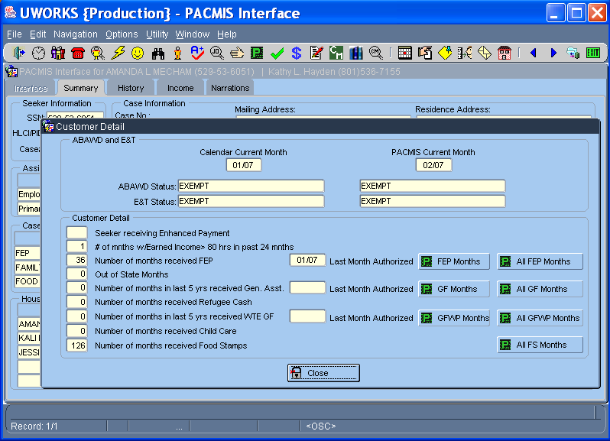

The Customer Detail pop-up screen displays information specific to the customer not the entire case.
- The Food Stamp ABAWD and E & T displays for the current and next month.
- The Customer Detail section generally shows the different time periods that this customer has received specific benefits. Most eligibility programs have time limits so this information helps the worker see how many months the customer has received benefits.
- All of the “Months” buttons will take you to screens that display a more detailed record of the benefits received.

UWORKS PACMIS: History
Version 1/20/07

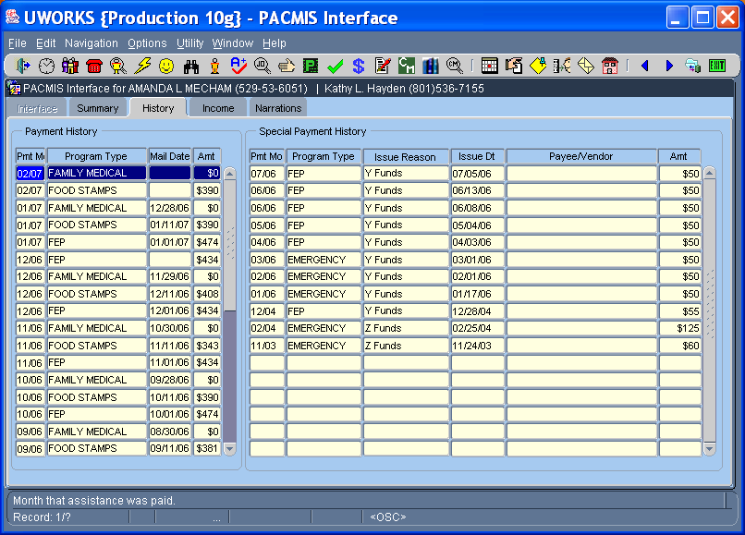

The History screen displays a history of information about the benefits the customer has received. Right-Click in the grid to resort the data.
- The Payment History section lists the Program, Payment Month, Date benefits were mailed and the amount of the benefits.
- The Special Payment History section shows payments for FEP supportive services, emergency services and other types of cash payments.

UWORKS PACMIS: Income
Version 1/20/07

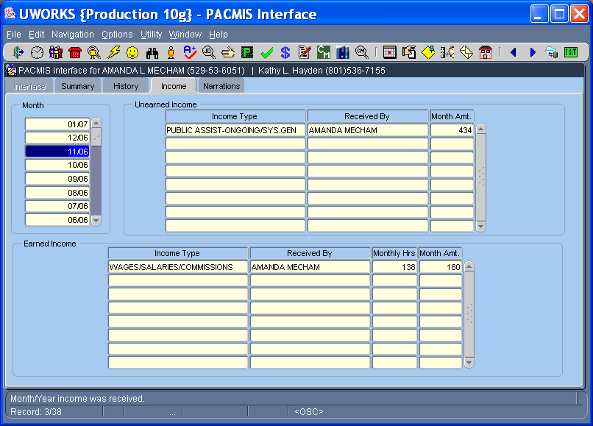

The Income screen allows the worker to view different types of income that the customer has earned and received.
- The Month section is used to select the month and year. As these are selected the Unearned Income and Earned Income sections will display the income received in the month selected.

UWORKS PACMIS: Narrations
Version 1/20/07

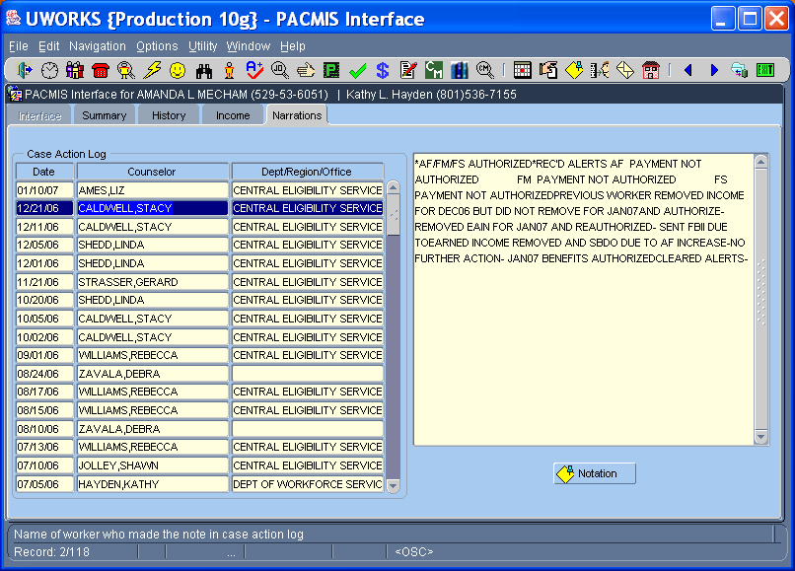

The Narrations screen displays the case notes that the eligibility workers enter into the PACMIS/eligibility system.
- The Case Action Log shows the Date and Counselor that entered the note. The counselors’ Dept/Region/Office also show.
- As you click through the Case Action Log the related note information is displayed in the box on the right.
- Use the Notation button to create a note in UWORKS using the data from the eligibility note. This is like a cut and paste option.

UWORKS ASSESSMENT:

Version 1/20/07
Assessment

- Assessment should be; customer-centered, comprehensive, linked to services, goal-oriented, and on going.
- During the assessment process, employment counselors must not only evaluate general employability factors (i.e., work history, habits and skills, educational levels and ability to learn), but also the customer’s social-emotional competence.
- The goal of the Employment Counselor is to conduct an assessment that will not only identify the customer’s needs, but will identify the circumstances, strengths, and abilities for fulfilling those needs.

CAGE Questionnaire

- In the past year have you ever felt you should Cut down on your drinking or drug use?
- In the past year have people Annoyed you by criticizing your drinking or drug
- In the past year have you ever-felt bad or Guilty about your drinking or drug use?
- In the past year have you ever had a drink or used drugs first thing in the morning (Eye opener) to steady your nerves, to get rid of a hangover, or to get the day started?

  - Item responses on the CAGE are scored 0 or 1; with a higher score an indication of alcohol problems. A total score of 2 or greater indicates a need for further assessment. Yes = 1 No = 0
  - Developed by Dr. John Ewing, founding Director of the Bowles Center for Alcohol Studies, University of North Carolina at Chapel Hill, CAGE is an internationally used assessment instrument for identifying alcoholics and drug users. It is particularly popular with primary care givers. CAGE has been translated into several languages.
  - When there is a score of 2 or more, a referral to the DWS Social Worker will be made so further assessment using the SASSI can be made. At anytime an Employment Counselor feels substance abuse may be a barrier due to how a customer performs on their Employment Plan, a referral to the DWS Social Worker for further assessment will be made.

TALE Questionnaire

- In the past year have you ever felt Threatened or afraid that a partner might hurt you in any way?
- In the past year have you ever been Annoyed by friends or family for criticizing the way a partner treated you?
- In the past year have you ever Lost a friend or stopped associating with someone because of a partner?
- In the past year have you ever been physically or Emotionally injured by a partner?

  - If one or of the above questions are answered “yes” FEP customers should be referred to the “in-house” Licensed Clinical Therapist (LTC) for further evaluation.
  - DWS customers receiving services other than FEP should be referred to other r appropriate community resources. A current listing of local resources may be obtained from the “in-house” LCT.

UWORKS ASSESSMENT: Employment
Version 1/20/07

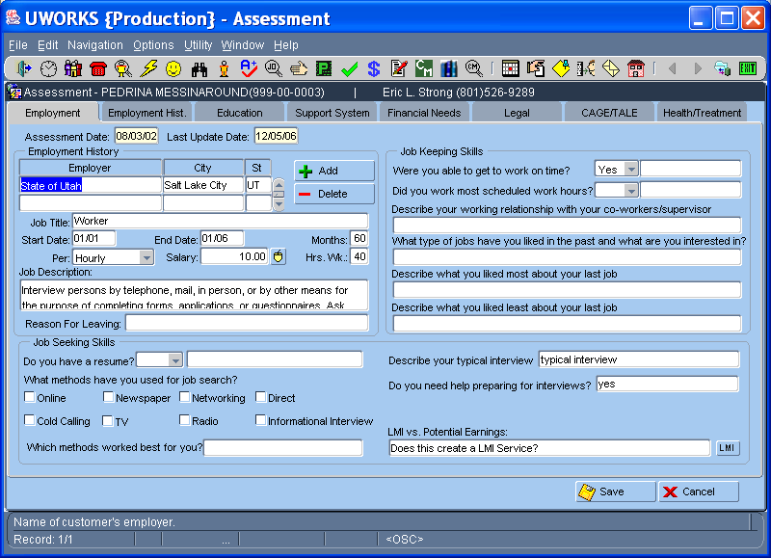

The Assessment - Employment screen is used to enter information about the customers work potential and barriers. Information entered on this screen will help the worker understand the customer’s employment strengths and weaknesses.
- The Employment History section of the screen includes the customer Employment History records. Employment history records entered on the Seeker Employment History screen will display here. New records can be added here and will display on the Seeker screen.
- The Job Seeking Skills section of the screen allows the worker to enter job search skills that the seeker has.
- The Job Keeping Skills section of the screen identifies skills that the job seeker has for maintaining their employment. This section also includes an LMI button. The LMI button can be used to access State Labor Market Information.

UWORKS ASSESSMENT: Education
Version 1/20/07

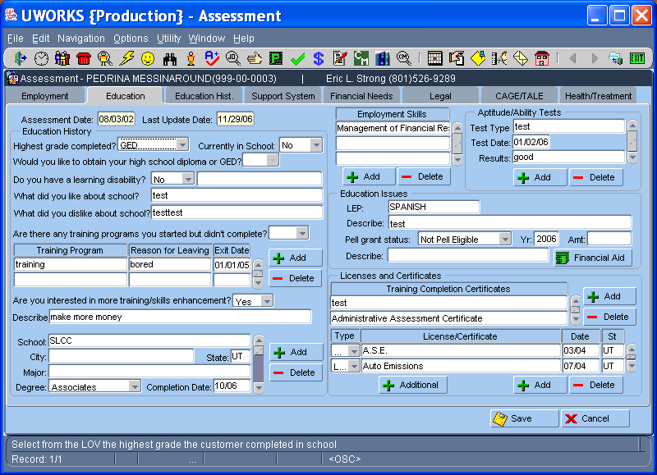

The Assessment - Education screen is used to enter information about the customer’s educational background. Information entered on this screen will help the worker understand the customer’s educational strengths and weaknesses.
- The Education History section of the screen lists the customer’s education history. This information pre-populates from the Seeker screen. New records can be added here and will display on the Seeker screen.
- The Education Issues section of the screen allows the worker to enter possible education issues the customer may have. The Financial Aid button provides access to the Free Application for Federal Student Aid (FAFSA) web site.
- The Licenses and Certificates section of the screen lists Certificates of Training and Licenses/Certificates the customer may have. New records can be added here and will display on the Seeker screen. The “Additional” button is a pop-up that displays Additional Education records for education not related to a specific degree.

UWORKS ASSESSMENT: Support System
Version 1/20/07

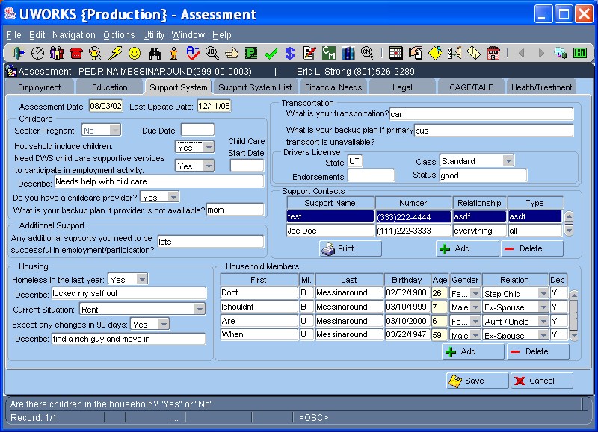

The Assessment - Support System screen is used to enter information about the customer’s family. Information entered on this screen will help the worker understand the customer’s family situation including potential for support and any dangers that may be family related.
- The Child Care and Additional Support section of the screen can be used to assess any childcare or other needs the customer has.
- The Housing section of the screen provides current and past housing information.
- The Transportation section of the screen allows the worker to enter transportation problems and solutions.
- The Support Contacts section of the screen can be used to identify individuals that may be able to help support the family.
- The Household Members section of the screen can be used to enter information about the family members living in the household.

UWORKS ASSESSMENT: Financial Needs
Version 1/20/07

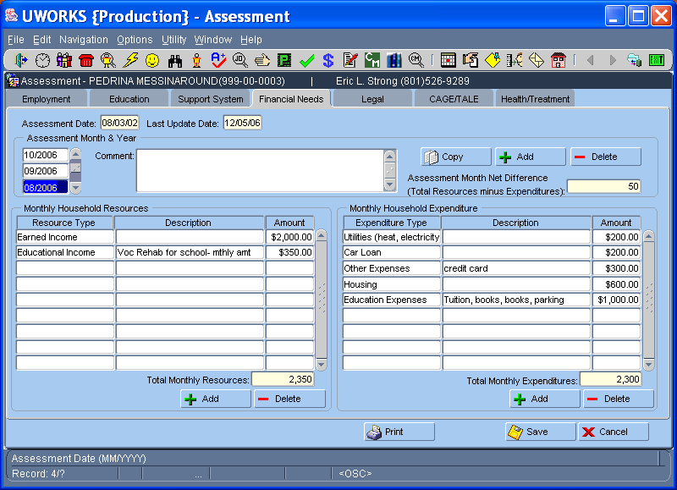

The Assessment – Financial Needs screen is used to determine the customer’s income and expenses. Information entered on this screen will help the worker create a budget for the customer and determine their financial status.
- The Assessment Month & Year section of the screen can be used to enter the budget month and year. There is a section for comments and a field that displays the monthly difference between the Income and expenses.
- The Copy button allows the worker to copy another month’s budget information into the current month. After the information is copied it can be modified before it is saved. The Add and Delete buttons allow the worker to add new budget months or delete them.
- The Monthly Household Resources section of the screen is used to enter the resources the household has for a given month. Resources can be added or deleted by selecting the Add or Delete buttons at the bottom of the section.
- The Monthly Household Expenditure section of the screen is used to enter the expenses the household has for a given month. Expenses can be added or deleted by selecting the Add or Delete buttons at the bottom of the section.
UWORKS ASSESSMENT: Legal
Version 1/20/07

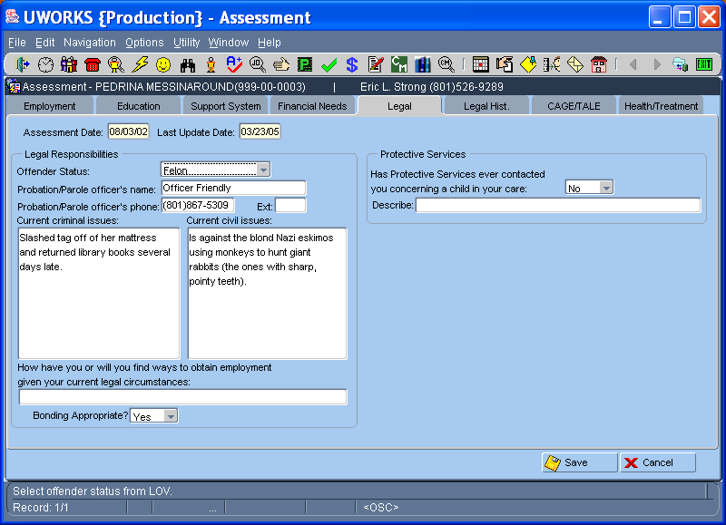

The Assessment - Legal screen is used to enter any legal information about the customer. Information entered on this screen will help the worker determine if the customer has legal problems that could effect their ability to become self sufficient.
- The Legal Responsibilities section of the screen can be used to enter any legal information about the customer. Select from the Offender Status dropdown if applicable and enter any related information. Detail any Current Criminal Issues or Current Civil Issues in the Free Format boxes provided.
- The Protective Services section of the screen can be used to enter problems related to caring for children the customer has had in the past.

UWORKS ASSESSMENT: CAGE/TALE
Version 1/20/07

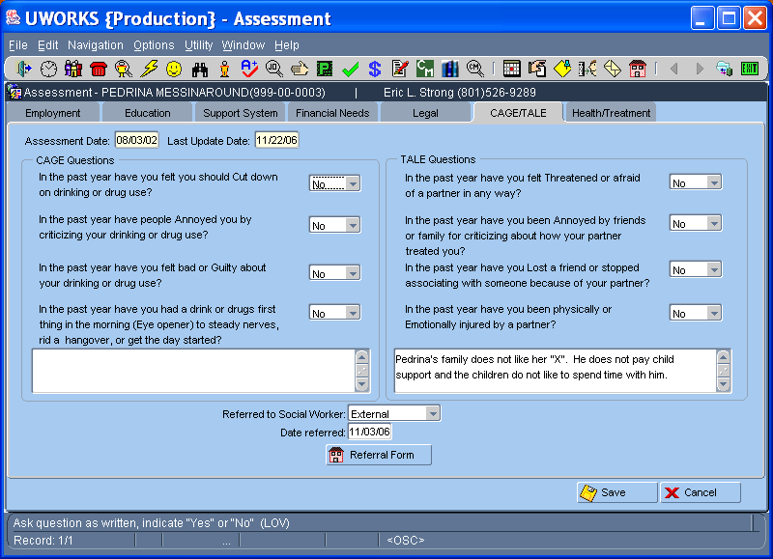

The Assessment – CAGE/TALE screen is used to determine if the customer has problems related to Substance Abuse or Domestic Violence. Unlike the rest of the Assessment screens, ask these questions exactly as they are written.
- The CAGE section of the screen is used to ask the customer question about substance abuse. If the customer answers yes to two or more of these questions then they should be referred to a social worker for professional help. Enter any details in the box at the bottom of the section.
- The TALE section of the screen is used to ask the customer question about domestic violence. If the customer answers yes to one or more of these questions then they should be referred to a social worker for professional help. Enter any details in the box at the bottom of the section.
- Select where the referral was made from the dropdown box. Enter today’s date in the Date-Referred box and use the Referral Form button to create a referral and give to the customer.

UWORKS ASSESSMENT: Health/Treatment
Version 1/20/07

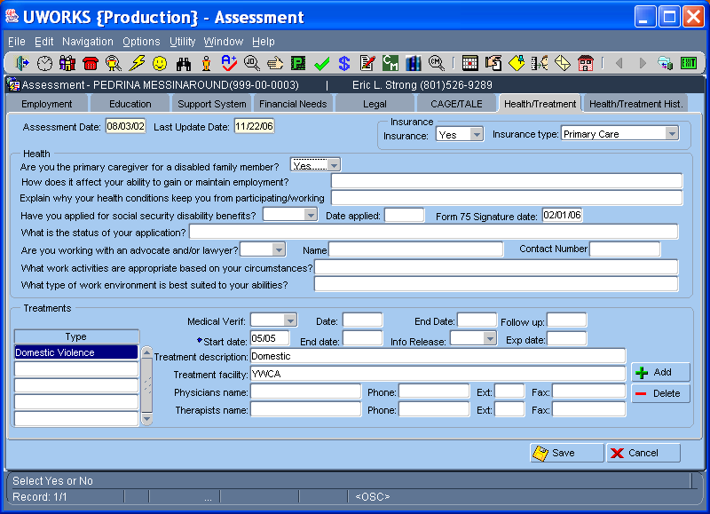

The Assessment – Health/Treatment screen is used to enter information about the customer’s health. Information entered on this screen will help the worker determine if the customer is in a treatment program, has health problems or has insurance related issues.
- The Health section of the screen can be used to enter Health concerns about the customer. Enter any disability information in this section including information about medical forms that the customer has had the Doctor complete to prove temporary disability.
- The Insurance section of the screen can be used to enter Insurance information the customer has.
- Use the Treatments section of the screen to enter any information about Treatments the customer may be receiving. Double click or F2 in the Type field to select type of treatment the customer is receiving. Use the Add button if you need to enter multiple treatment records.

UWORKS ELIGIBILITY: Application
Version 1/20/07

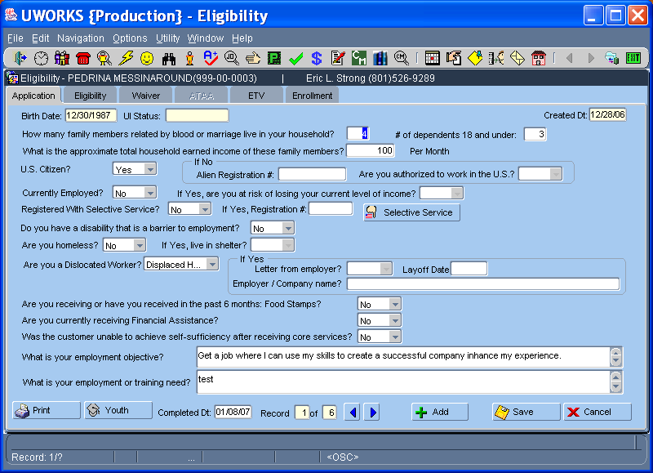

The Eligibility Application screen is used to enter general information about a customer that is being considered for training services. Most of this information could be populated if the job seeker completed the application on-line.
- Information entered on first half of the application screen is Household, Income, Citizenship, Employment and Living Situation information.
- If the seeker is a Dislocated Worker then information about the job they lost is entered.
- Information about Food Stamp and Financial grants are also entered. We also need to determine if the customer is can achieve self-sufficiency after completing training core services.
- The customers Employment Objective and Training Needs are also entered.
- After all the information including the Youth Application pop-up is completed the worker enters the Completion Date, which freezes the application so no changes can be made. The worker selects the Print button and prints a report of the application information and has the customer sign the form.
UWORKS ELIGIBILITY: Application (Youth)
Version 1/20/07

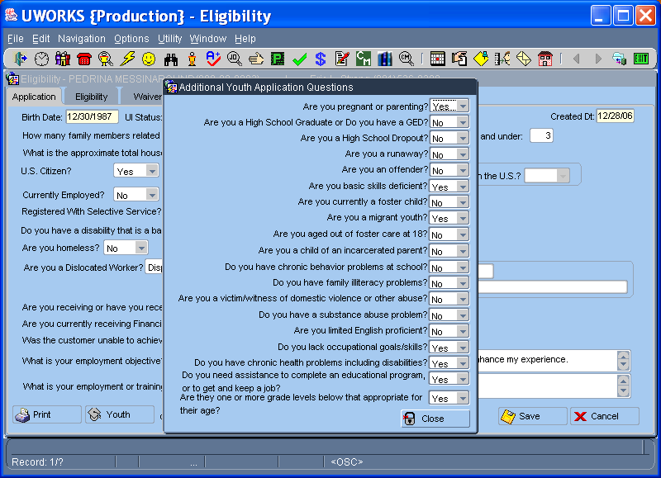

If the customer is a Youth (age 14 through 21) the Youth button will display on the Application screen and the Youth Application pop-up should be completed before entering the application completion date.
- Click the Youth button on the Eligibility Application screen to open the Youth Application pop-up screen.
- The Youth questions help the worker determine problem areas that the customer may have. The answers to these questions will populate on the eligibility Barriers pop-up and determine if the customer is eligible for youth services.

UWORKS ELIGIBILITY: Eligibility
Version 1/20/07

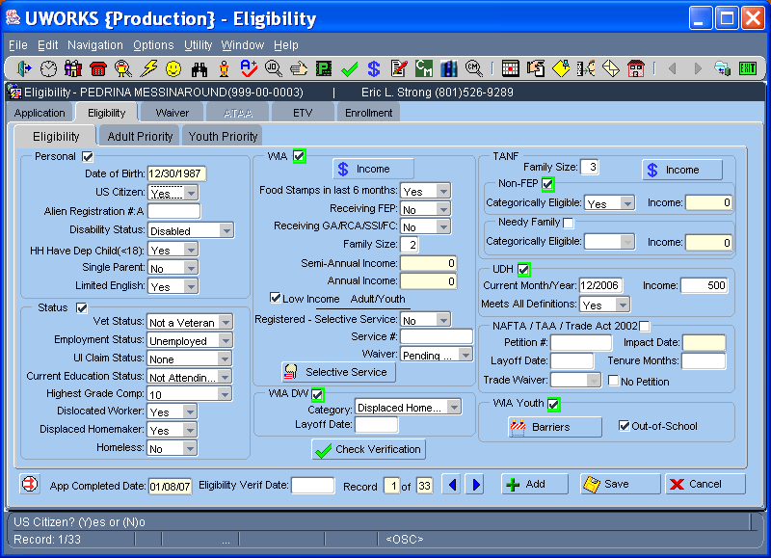

The Eligibility screen is used by the worker to determine is a customer meets the eligibility requirements for training programs.
- The screen is divided into sections: Personal, Status, WIA, WIA DW, TANF, UDH, NAFTA/TAA/Trade Act 2002 and WIA Youth,. With the exception of Personal and status the sections are grouped by Programs/Funding Sources and often referred to as Enrollments.
- Some of the information on this screen populates from the seeker screens and eligibility application and does not have to be entered. Most of the information requires detailed knowledge of the customer’s situation.
- As information is entered into the specific sections the box next to the Program may highlight in green. When this occurs the eligibility rules for this program have been met.
- The program is not considered as eligible until the program box is highlighted in green and has a check in it. The check is populated when the worker clicks the “Check Verification” button and checks off all the items that they have verified.
- When the desired programs are highlighted in green, the box(s) are checked and the Priority screen have been completed, the worker enters today’s date in the “Eligibility Verif Date” field. This freezes the record and it cannot be changed. The eligible programs populate on the Enrollment screen in the Eligible Enrollments section.
UWORKS ELIGIBILITY: Check Verification (General)
Version 1/20/07

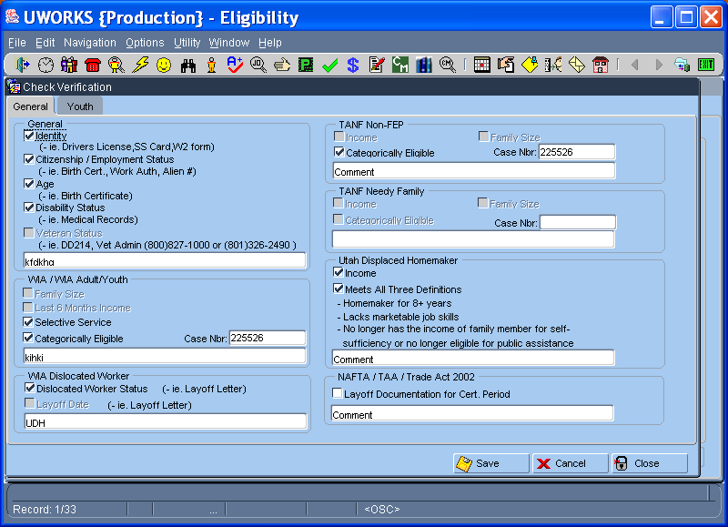

The Check Verification General pop-up opens when the worker selects the Check Verification button on the Eligibility screen. This screen must be completed before the customer is eligible for program services.
- Checking a box indicates that the worker has received the documents required to verify the information next to the box.
- If a box is grayed out the worker cannot check the box and there is no need to verify that information.
- After each section there is a free format box that the worker must complete if boxes in that section were checked.
- If a Categorically Eligible box is checked the Case Number field must have the eligibility system case number entered.

UWORKS ELIGIBILITY: Check Verification (Youth)
Version 1/20/07

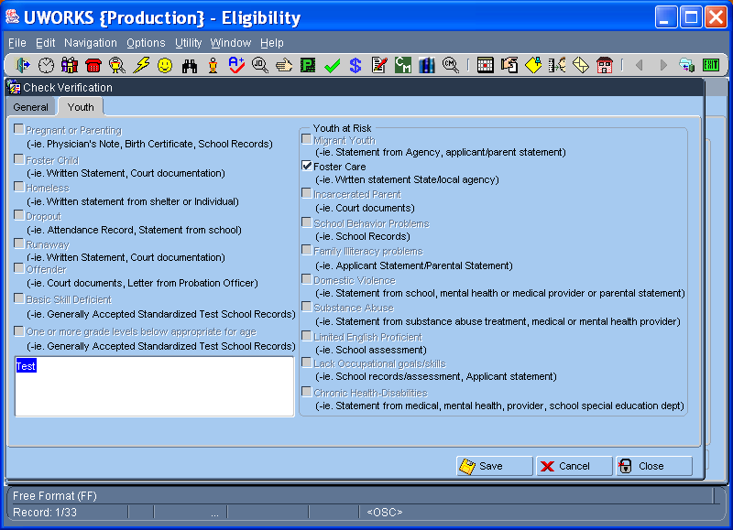

The Check Verification Youth pop-up opens when the worker selects the Youth tab. This screen must be completed before the customer is eligible for Youth program services. This tab will not be available if the customer is not a Youth.
- Checking a box indicates that the worker has received the documents required to verify the information next to the box.
- If a box is grayed out the worker cannot check the box and there is no need to verify that information.
- There is a free format box that the worker must complete in order to Save the information entered on this screen.

UWORKS ELIGIBILITY: Barriers (Youth)
Version 1/20/07

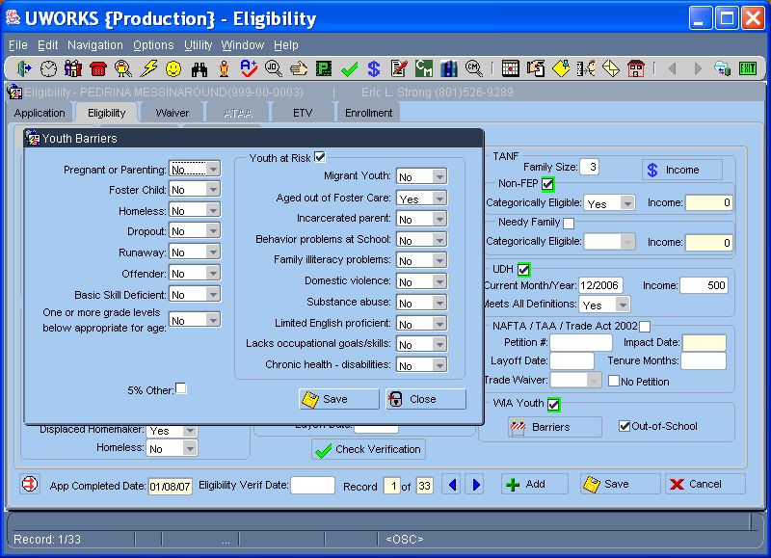

The Youth Barriers pop-up opens when the worker selects the Barriers button on the Eligibility screen. This screen must be completed before the customer is eligible for Youth program services. This pop-up will not be available if the customer is not a Youth.
- The answers on this pop-up are pre-populated from the Youth Application. If changes need to be made the worker can make the changes on this screen.
- The left column shows Youth Barriers while the right column has the Youth at Risk questions. If any of the answers in the Youth at Risk column are answered “yes” the Youth at Risk box at the top of the screen will be checked.

UWORKS ELIGIBILITY: Adult Priority
Version 1/20/07

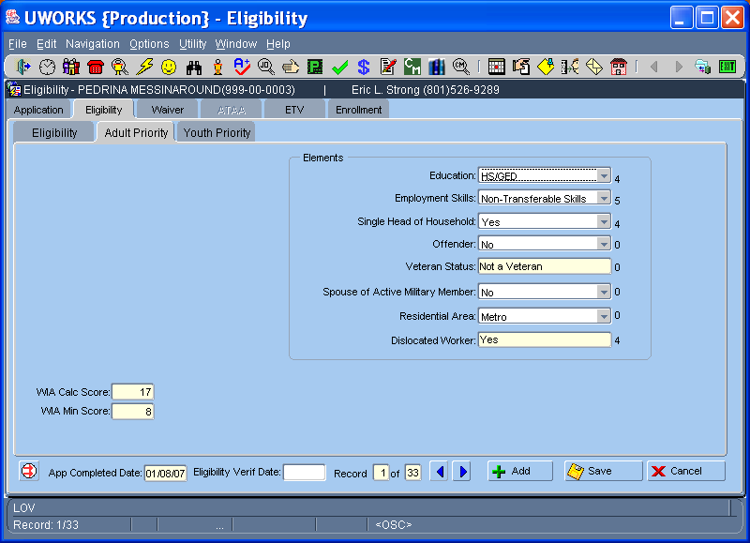

After completing all aspects of the Eligibility screen the worker can click on the Adult Priority tab to complete the priority questions. Even though the customer meets the eligibility requirements they must also meet the minimum priority qualifications to receive training services.
- Complete each field in the Elements section of the screen. Select the correct item from each dropdown list. Veteran and Dislocated Worker fields will auto-populate based on the information entered on the Eligibility screen.
- Each selection is given a score, which shows, to the right of the field. The scores are totaled and show in WIA Calculated Score on the bottom left of the screen.
- If the WIA Calculated Score is higher than the WIA Minimum Score then the customer meets the Priority requirements and is eligible for training services.
UWORKS ELIGIBILITY: Youth Priority
Version 1/20/07

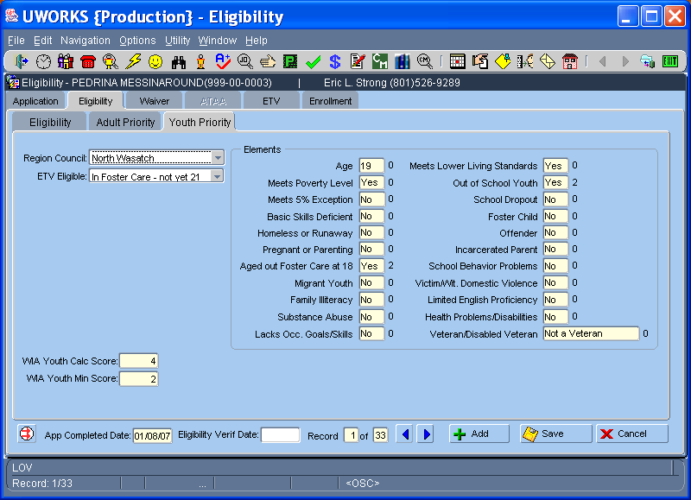

After completing all aspects of the Eligibility screen the worker can click on the Youth Priority tab to see the priority questions. Even though the customer meets the eligibility requirements they must also meet the minimum priority qualifications to receive training services. This tab only shows when the customer is a Youth.
- The Elements section of the screen populates with information from the Youth Barriers pop-up and the Eligibility screen.
- At the top of the screen the Regional Council field is pre-populated but can be changed if it is incorrect. The ETV Eligible dropdown must be completed before the priority screen is complete.
- Scores display to the right of each field. The scores are totaled and show in WIA Youth Calculated Score on the bottom left of the screen.
- If the WIA Youth Calculated Score is higher than the WIA Youth Minimum Score then the customer meets the Priority requirements and is eligible for Youth training services. Each Regional Council may set different scores for each element listed.

UWORKS ELIGIBILITY: Waiver
Version 1/20/07

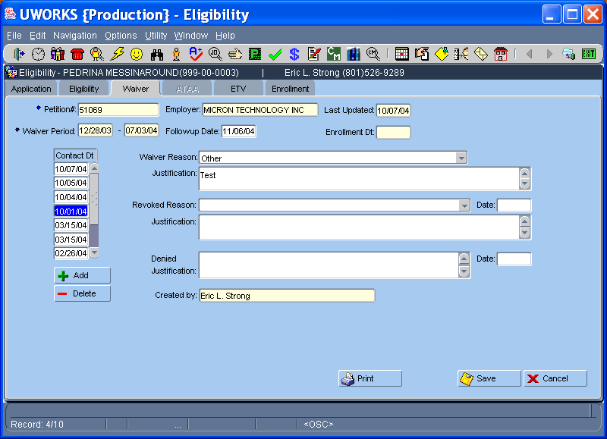

The TRA Waiver (Trade Readjustment Allowances Waivers) screen is used to determine eligibility for the waiver program. Trade Act certified customers eligible for TRA might qualify for the Waiver if training is not appropriate or training cannot be obtained within 16/8 week requirement.
- The Petition Number and Employer fields will auto-populate. The Waiver Period shows the 6 months time frame the customer is eligible. This is obtained from the UI Waiver notice.
- The Contact Date is the date the employment counselor meets with the customer. Enter the date each month as the waiver is reviewed and it will automatically trigger a Follow-up Date and a Task 20 days from the contact date.
- Waiver Reason is a list of values (LOV). Select a reason the waiver is being granted. Justify the reason for granting the waiver in the Justification field.
- Revoked Reason is a list of values (LOV). Select a reason the waiver is being revoked. Justify the reason for revoking the waiver in the Justification field.
- If the waiver is Denied, narrate and justify your reason.
UWORKS ELIGIBILITY: ATAA
Version 1/20/07

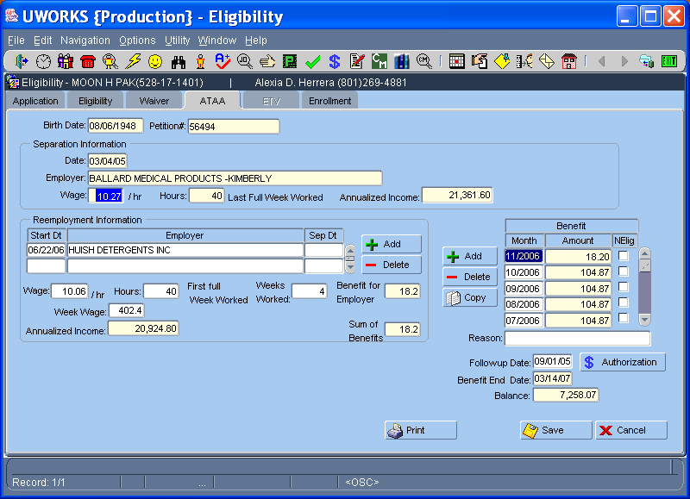

The ATAA (Alternative Trade Adjustment Assistance) screen is used to determine the wage subsidy for ATAA customers. A Wage Subsidy is used to help bridge the salary gap between the old and new employment. The ATAA program is for older (50+) TAA eligible customers that may not be appropriate for training and who become reemployed prior to 26 weeks from the date of separation.
- The customer Birth Date and Petition Number (if there is only one) will auto-populate on the screen. The Employer information and Separation Date will populate when the petition number is selected.
- The employment counselor will enter the Wage/hr and the Hours worked based on the Last Full Week Worked before separation. Based on the wage and hours the system will calculate the Annualized Income.
- The employment counselor enters the Reemployment Date and selects the Reemployment Employer from the list of values (LOV) field. Enter the reemployment Wage/hr and the Hours – First full Week Worked. The system will calculate the reemployment Annualized Income.
- Enter the Benefit Month and the system will calculate the Benefit Amount. Enter a Follow-up Date, the Benefit End Date will be two years from the reemployment date and the Balance will display the amount of money left for the program.
UWORKS ELIGIBILITY: ETV
Version 1/20/07

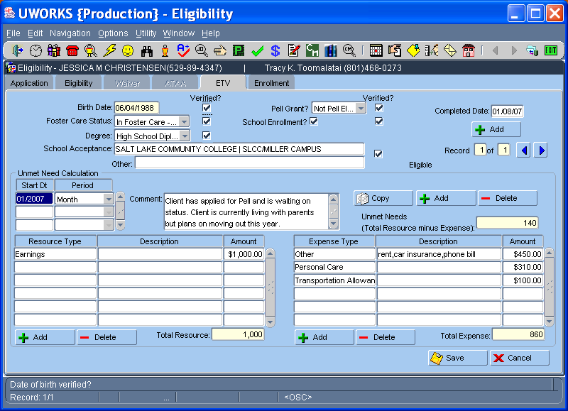

The ETV (Education Training Voucher) screen is used to determine eligibility for youth (18yrs) that have been involved in the foster care system, who are referred through the Transitional to Adult Living (TAL) initiative. ETV may provide career assessment, continuing education/employment related resources, financial resources for post-secondary education, vocational training, and other support necessary to obtain employment or to support the customer's employment goals.
- Select the Foster Care Status from the list of values (LOV). Select the Degree and enter the School Acceptance field from the list of values (LOV). Use the Other field if the school provider is not in the list. Select the Pell Grant status from the list of values (LOV) and check the School Enrollment box. Remember to verify this information and check the Verified boxes as proof of verification. When the Completion Date is entered the record will be frozen.
- Use the Unmet Need Calculation section of the screen to determine how the ETV funds will be distributed. ETV funds can be used for training and support. Enter Start Date and select Period from the list of values (LOV). Enter the Resource information and then the Expense information and the system will calculate the unmet need.
- Use the Add button to calculate the unmet need for a different period. Use the Copy button to copy the resources and expenses from an old period to a new period.
UWORKS ELIGIBILITY: Enrollment
Version 1/20/07

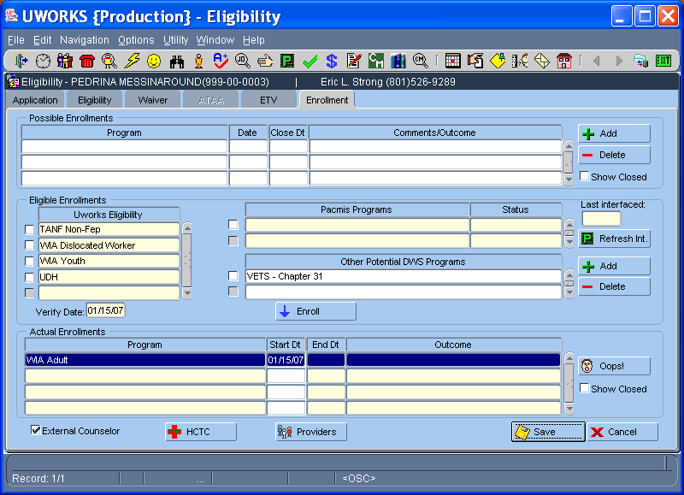

The Enrollment screen is used to enroll customers in programs they are eligible and qualify for.
- Possible Enrollments section displays programs being considered for enrollment. Programs cannot be enrolled from this section. This is the Worker’s FYI or scratch pad section.
- Eligible Enrollments section lists programs that pass eligibility requirements. Workers determine if the customer is appropriate to participate. Programs show in this section after eligibility has been determined. Check the box next to the program and click on the “Enroll” button to move to Actual Enrollments.
- Other Potential Programs section lists (LOV) programs that do not require use of the Eligibility screen to determine eligibility. Check the box next to the program and click on the “Enroll” button to move to Actual Enrollments.
- The Actual Enrollments section shows the program(s) the customer is officially enrolled in.
- The “Oops!” button can be used to un-enroll an actual enrollment when an enrollment has been enrolled in error. The “Oops” button only works the day the enrollment is made.

UWORKS EMPLOYMENT PLAN:
Version 1/20/07
Employment Plan

Employment Planning is required for all intensive services. The employment plan is the agreement between the State Department and the customer that outlines the customer’s activities and responsibilities that will help the customer become employed. The employment plan is developed and then monitored and updated as needed to ensure that the customer is progressing toward the employment goal.

- Employment Plans are based on an evaluation of the information gathered during the assessment process, the customer and the Employment Counselor will negotiate an Employment Plan.
- The Employment Plan describes the here and now, who the customer is, and the activities the customer is involved in. It should answer the question, "What are the presenting problems of this customer and the household AND what are the customer’s current abilities and strengths?" Include information on customer’s work and school situation.
- A customer is required to sign and make a good faith effort to participate to the maximum extent possible in a negotiated employment plan. The customer must meet the performance expectations of each activity in the employment plan to stay eligible for intensive and/or training services. The customer should be provided a copy of the most recent employment plan. The customer must agree, as part of the employment plan, to cooperate with other agencies or with individuals or companies under contract with the Department as outlined in the employment plan.

Employment plans are to be written following the “SMART” plan guidelines. A “SMART” plan is one that is:
Specific: States what the goal is in behavior and results. Incorporate the O*NET Code/Title from the appropriate case
management computer system in the goal statement.
Measurable: Measures both quality as well as quantity.
Attainable: It must be realistic.
Relevant: Relevant to the results and outcome desired.
Trackable: So that progress over time can be documented.

The employment plan includes the following elements:
- A realistic, specific Employment Goal. Base each customer's employment goal on employment that is available, or is expected to be available by the conclusion of training or education. If no such employment is available, do not approve training or education unless the customer is willing to relocate and relocation is part of the plan. The goal should also state the expected outcomes.
- The justification information must include: L E W I S it stands for:
  - LMI and Potential Earnings
  - Education
  - Work History
  - Interest & Aptitude
  - Skills

UWORKS EMPLOYMENT PLAN: Enrollment
Version 1/20/07

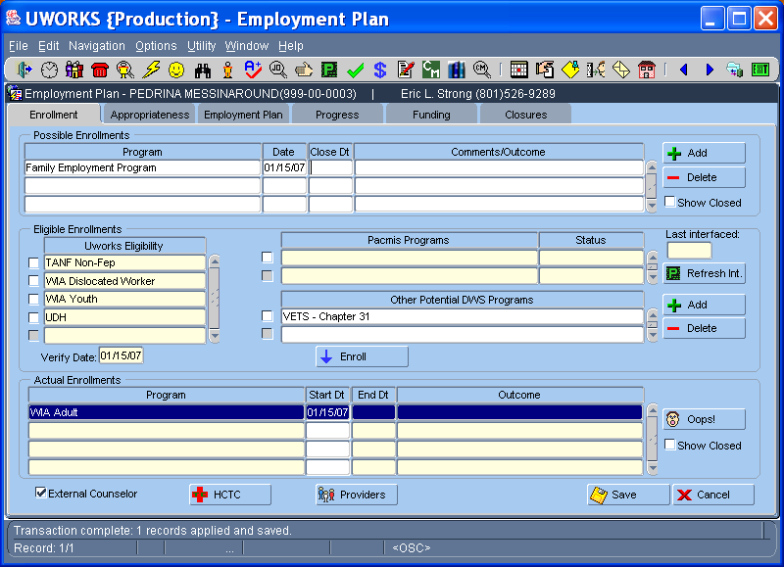

The Enrollment screen is used to enroll customers in programs they are eligible and qualify for. You may notice that the Enrollment screen exists in Eligibility and Employment Plan.
- Possible Enrollments section displays programs being considered for enrollment. Programs cannot be enrolled from this section. This is the Worker’s FYI or scratch pad section.
- Eligible Enrollments section lists programs that pass eligibility requirements. Workers determine if the customer is appropriate to participate. Programs show in this section after eligibility has been determined. Check the box next to the program and click on the “Enroll” button to move to Actual Enrollments.
- Other Potential Programs section lists (LOV) programs that do not require use of the Eligibility screen to determine eligibility. Check the box next to the program and click on the “Enroll” button to move to Actual Enrollments.
- The Actual Enrollments section shows the program(s) the customer is officially enrolled in.
- The “Oops!” button can be used to un-enroll an actual enrollment when an enrollment has been enrolled in error. The “Oops” button only works the day the enrollment is made.

UWORKS EMPLOYMENT PLAN: Appropriateness

Version 1/20/07

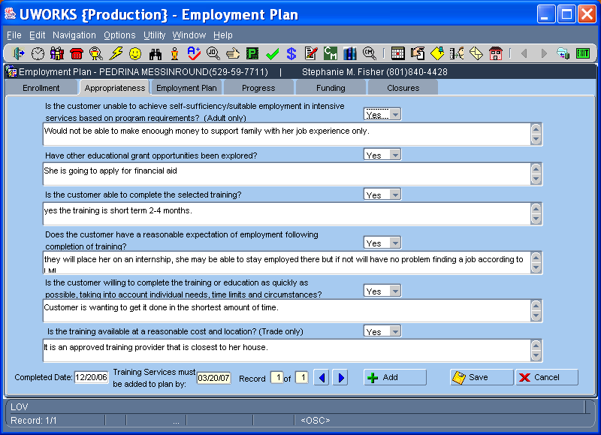

Use the Employment Plan Appropriateness screen to determine if the customer is appropriate for training programs. This screen must be completed before the system will allow any training money to be used.
- Answer each of the six questions Yes, No or N/A and then complete the information below the question to expand on the Yes/No/NA question. The first question is Adult Only and the last question is a Trade Only question so they may not need to be addressed if the customer is only Youth or a Trade.
- The system will populate the Completed Date and will also display the Training Services must be added to plan by date. If training services need to be entered after the date this screen will need to be completed again.

UWORKS EMPLOYMENT PLAN: Employment Plan
Version 1/20/07

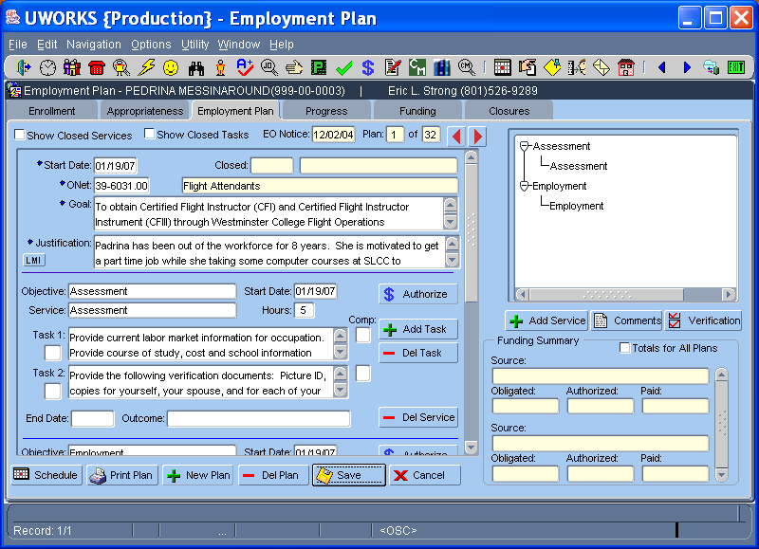

The Employment Plan screen is a tool the Worker can use to outline a plan to help customers achieve financial independence.
- Employment Plans must have a Start Date, ONET, Employment Goal and Justification.
- Objectives & Services are selected from an (LOV). Use these to build the outline of the plan. Objectives/Services can be closed when the customer has completed all the tasks related to the objective/service. Enter Date and Outcome (LOV) to close. Click the “Add Service” or “Del Service” buttons to add or delete objectives/services.
- Tasks allow more specific detail about how the customer will meet each Objective/Service. Tasks are used to detail how the customer will achieve each section of their employment plan. Tasks can be set as completed (Y) or not completed (N). Click the “Add Task” or “Del Task” buttons to add or delete tasks.
- The “Authorize” button is used to create a payment authorization. Some programs allow the use of funds to help the customer meet their employment goals.
- The Funding Summary displays a summary of the funds Obligated, Authorized and Paid when a program/enrollment with funds is used.
- Use the Employment Plan Tree to go to a specific objective or service by clicking on the objective or service desired.

UWORKS EMPLOYMENT PLAN: Employment Plan Printout
Version 1/20/07

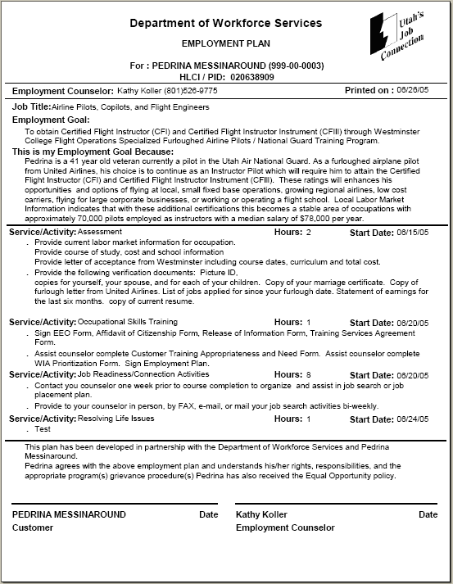
Generally an Employment Plan is developed with the counselor and customer working together to create the best plan possible for the success of the customer. The plan is an agreement between the counselor and customer and should be signed by both. Each should retain a copy of the plan.

UWORKS EMPLOYMENT PLAN: Progress

Version 1/20/07

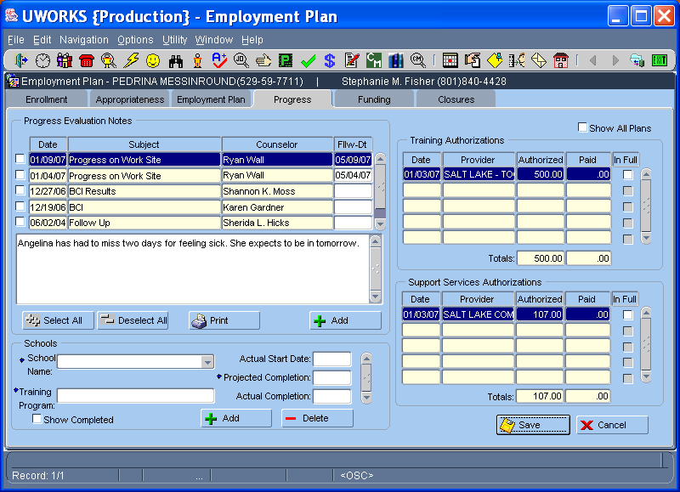

The Employment Plan Progress screen is used by the worker as a monitoring screen. Much of the information on the screen is related to the follow-up process and plan monitoring that must occur when customers are involved in training programs.
- Progress Evaluation Notes are displayed and worker can add new notes or print out the existing notes.
- The Schools section of the screen displays the School Name where the training is provided and the Training Program the customer is in. The program Actual Start Date, Projected Completion, and Actual Completion dates can all be entered in this section.
- The right hand side of the screen shows Training Authorizations and Support Service Authorizations. Each section shows all the money spent for those types of services and calculates the total amount authorized and paid.

UWORKS EMPLOYMENT PLAN: Funding
Version 1/20/07

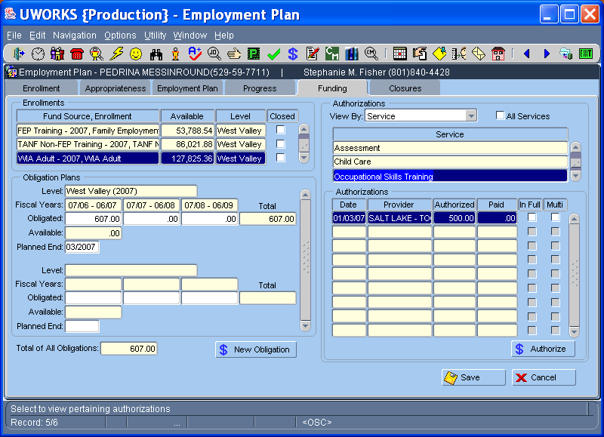

The Funding screen provides Worker’s the ability to create Obligations and Authorizations to pay for agreed upon services for customers.
- The Enrollments section displays the possible funds that may be available. The Fund Source/Enrollment must be open and have funds available to use.
- After selecting a Fund Source that has funds available, click the “New Obligation” button to create an obligation. An Obligation pop-up screen requires you to enter the amount of money (can be divided over 3 fiscal years) and a planned end date when you anticipate the money will be used.
- The Obligation Plans section displays the dollar amount obligated for each fiscal year, the amount available and the Planned End Date for each obligation.
- The upper Authorizations section allows you to view the authorizations that have been created. You can View By or sort the authorizations by Service, Enrollment, Obligation or Plan. As you select different options in the “View By” dropdown the section below will change to reflect how you view the authorizations.
- The lower Authorizations section displays information about the authorizations. Each authorization has the Date, Provider, Amount Authorized, Amount Paid, Paid In Full and Multiple obligations used. Double click on an Authorization and the authorization pop-up screen opens.
- To create a new Authorization click on the “Authorize” button.

UWORKS EMPLOYMENT PLAN: Authorization
Version 1/20/07

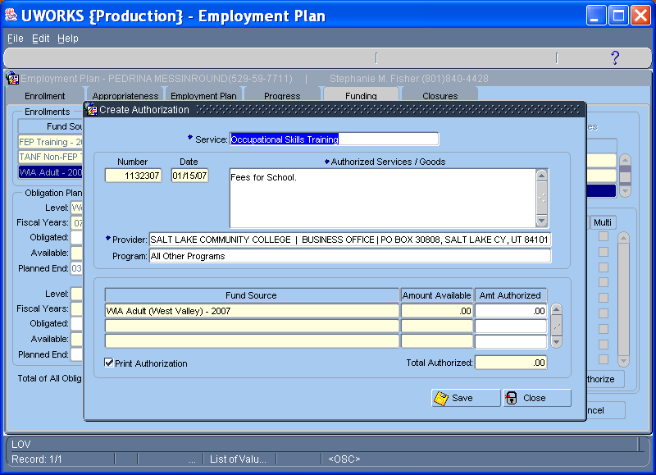

The Authorization Pop-Up screen is used to create payment vouchers to give to customers and create a record of funds authorized in the system.
- The Service may populate but can be changed to another open service from the plan. The system creates an Authorization Number and populates today’s date in the date field.
- Enter a brief description of the service provided in the Authorized Services / Goods box.
- The Provider field is a (LOV) so you can double click to bring up a list of providers. Some Programs/Fund Sources require a Program to be selected. The Program field is a (LOV) field so double click and bring up the program list.
- The Fund Source populates with the possible fund source(s) available to use (Based on obligations created). The Amount Available field will display the amount of money you have available to authorize. Enter the dollar amount of the authorization in the Amount Authorized field.
- The Print Authorization check box defaults as checked. When you click “Save” the system will print a Payment Authorization voucher, which can be given to the customer. The customer takes the voucher to the provider listed and receives the services. The provider will bill the state for the services they provided.

UWORKS EMPLOYMENT PLAN: Payment Authorization Voucher
Version 1/20/07

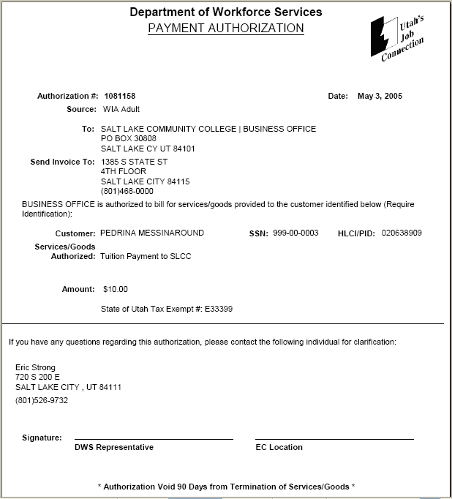
When you create an Authorization there will be an option to print the Payment Authorization voucher. The seeker can take the voucher to the provider specified and that provider can bill the Department for the services listed on the voucher.

UWORKS EMPLOYMENT PLAN: Closures
Version 1/20/07

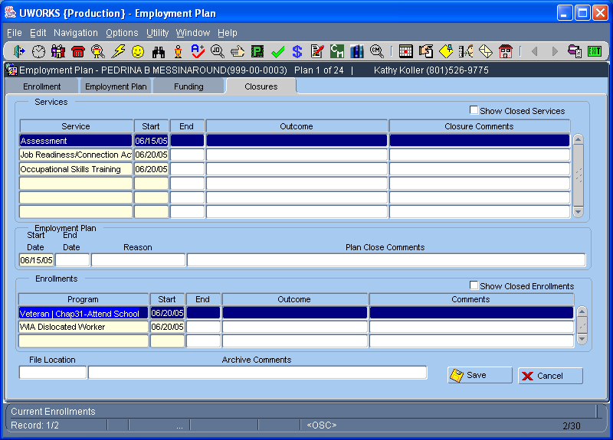

The Closures screen provides Worker’s the ability to close Services, Enrollments and the Employment Plan from one screen.
- The Services section displays all of the open services for the current employment plan. To see closed services for this plan click the “Show Closed Services” box. To close services enter a service End Date and Outcome. The Closure Comments field is optional and Outcomes are selected from a list (LOV).
- The Employment Plan section only displays the employment plan start date. To close the plan, enter the End Date and Reason for closure. The Plan Closure Comments field is optional and Reason is selected from a list (LOV). Employment plans cannot be closed if there are open services.
- The Enrollments section displays all of the open enrollments. To see closed enrollments click the “Show Closed Services” box. To close enrollments enter an End Date and Outcome. The Comments field is optional and Outcomes are selected from a list (LOV).
- The File Location and Archive Comments section is used to identify the location of cases. The information aide’s workers looking for case files that closed in the past and now are re-opening.
- When you close a Plan and all enrollments the system will prompt you and ask if you want to De-obligate any funds still remaining. You will also be asked if you want the Case Management status changes to inactive. If you click “Yes” the status will be set to Inactive and worker status will be inactivated.
UWORKS EMPLOYMENT PLAN OPTIONS: Clone Plan
Version 1/20/07

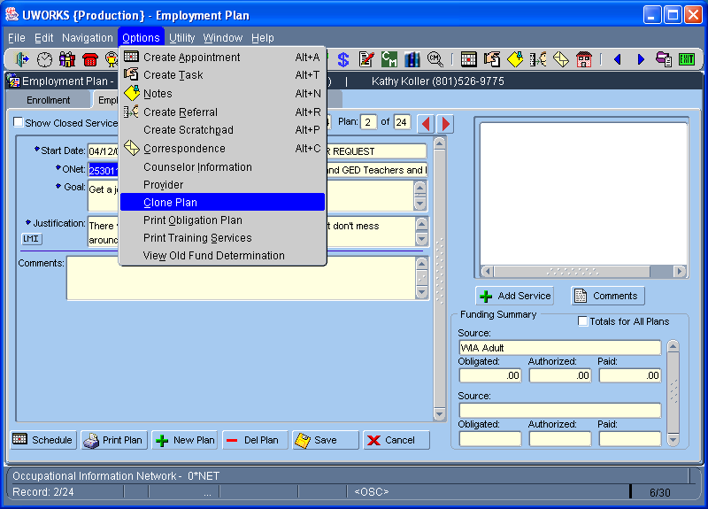

The Clone Employment Plan option allows workers to copy an existing employment plan. Sometimes workers close plans and find that within a month the customer is back and the worker has to create a new plan. This is a short cut way to get the plan open and retain some of the information that was entered.
- Employment Plans can only be cloned if they have been closed within 30 days.
- Start Date, ONET, Goal and Justification will always clone from the old plan.
- Only Objectives/Services that were closed on the same day as the employment plan will clone and re-open with the plan.
- Tasks do not close, so the tasks associated with the Objectives/Services that are cloned will also display when you clone the plan.
- When a plan is cloned the worker can modify any of the information that cloned/copied. Cloned Objectives/Services can be changed the day the plan is cloned but the next day the worker will have to close the service they will not be able to change it.
UWORKS EMPLOYMENT PLAN OPTIONS: Print Obligation Plan
Version 1/20/07

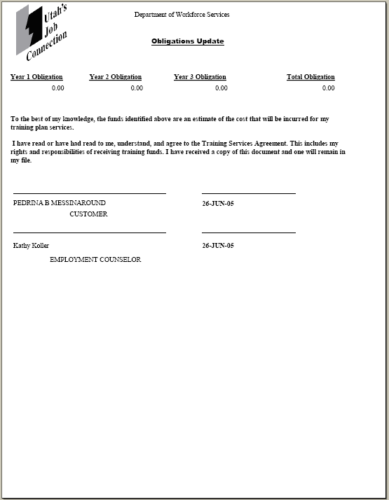
The Obligation Plan displays the money that has been dedicated to this seeker’s training plan over a three-year period.
UWORKS EMPLOYMENT PLAN OPTIONS: Print Training Services
Version 1/20/07

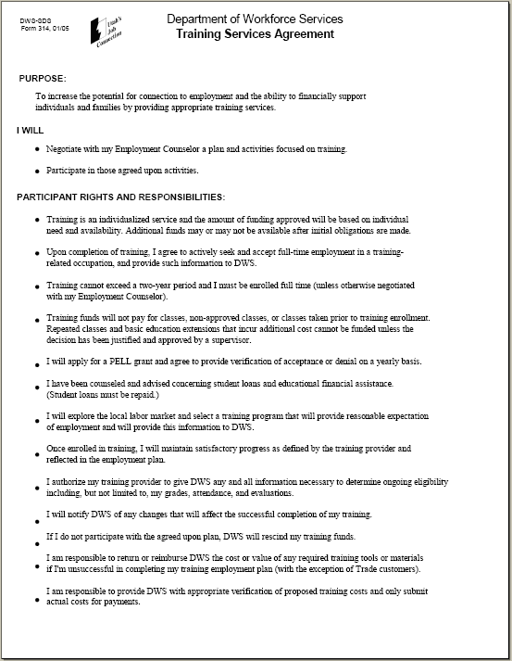
The Employment Plan Training Agreement is part of the Employment Plan report. It only prints out when you have an employment plan with training programs attached. This usually occurs when you obligate training money. The Training Services Plan is an agreement between the counselor and customer and should be signed by both. There is a second page to this report but it looks much like the Obligation Plan report on the previous page.
UWORKS EMPLOYMENT PLAN: Verification
Version 1/20/07

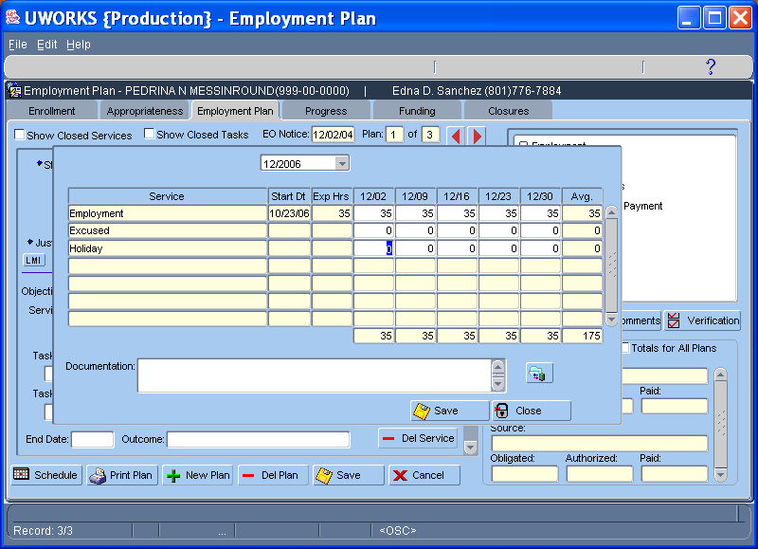

Access the verification pop-up by clicking on the Verification button from the Employment Plan screen. This screen allows you to record FEP/TANF verification hours. TANF participation rates are required by the Federal Government. This screen is the tool created to capture participation hours.
Only cases that have a FEP enrollment will have this screen available. Specific services are identified as services that have participation requirements.
- Hours of participation are recorded by Month. The Service is displayed, the Start Date, Expected Hours, Verified Hours per week-end and the Average Hours for the month. Each verification hour entry can have a Documentation comment entered.
- Excused and Holiday hours can also be entered to keep the participation hours at the correct level when holidays and excused time occur.
- There is also an icon button next to the documentation field that will open the content manager imaging system so verification images can be viewed.
UWORKS CASE MANAGEMENT SEARCH OPTIONS: Mass Verification
Version 1/20/07

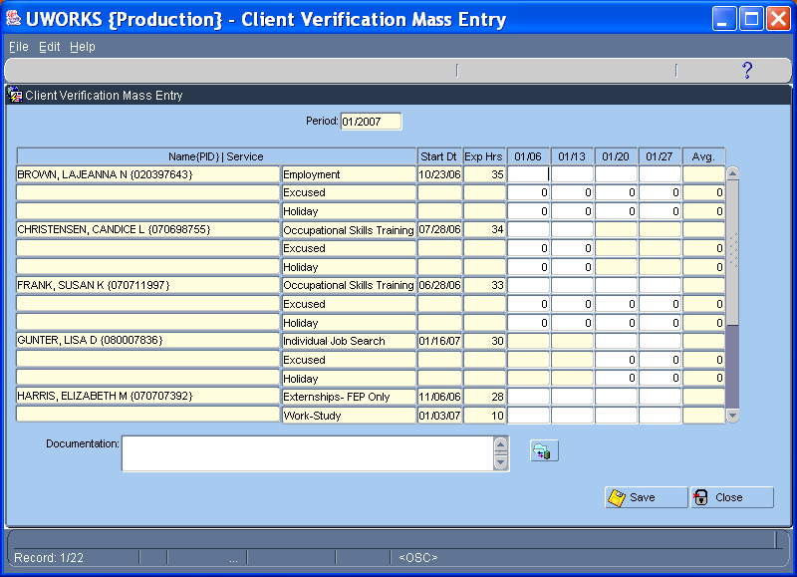

Verification hours can also be entered on the Mass Verification screen. Access this screen from the case management search options menu. Generally a search will be done to bring up a worker caseload. The customers for that caseload that have services that require verification of participation will display on the screen.
- Only the current verification reporting month will be available from this screen.
- Enter the Service(s), Start Date, Expected Hours are displayed per customer. Enter the Verified Hours for each week-end and the Average Hours for the month will populate. Enter a Documentation comment for the hours entered.
- Excused and Holiday hours can also be entered

UWORKS EMPLOYMENT PLAN OPTIONS: Provider
Version 1/20/07

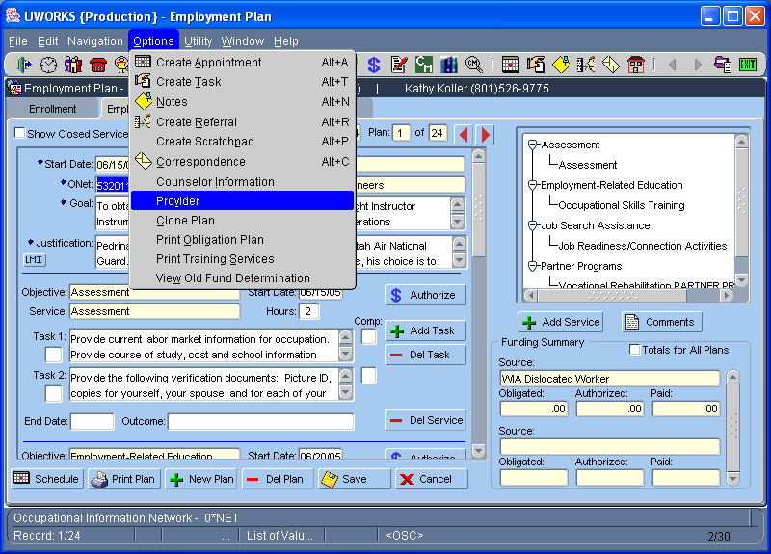

Workers find providers that can deliver services to their customers by using the Provider option. When a worker creates a payment authorization they are required to select a provider that delivers the desired service. Workers use the Provider screens to find providers that can give their customers the services they need to help them meet their employment plan goals.
- See the next page for Provider screen details.

UWORKS EMPLOYMENT PLAN OPTIONS: Provider Search (Con’t)
Version 1/20/07

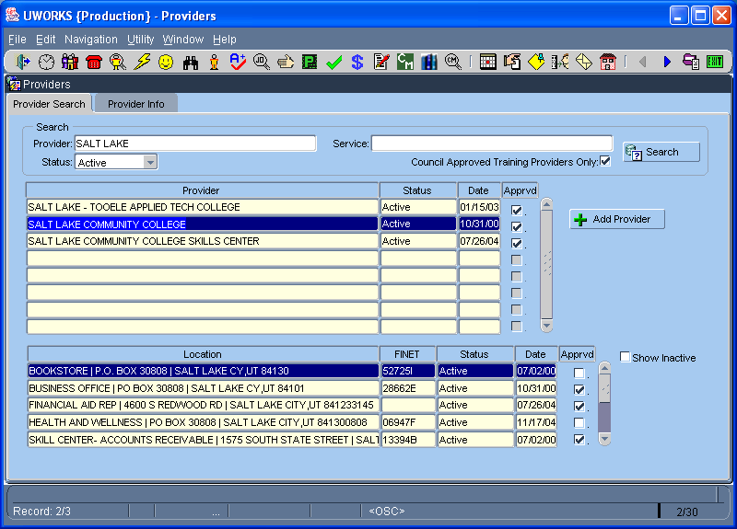

The Provider Search screen is used to search for providers that can deliver services to your customer.
- The Search section of the screen allows workers to search for Providers by Provider Name, Type of Service, Provider Status and Approved Training Providers Only. Type in the desired search criteria and click the “Search” button.
- The Provider section displays the Provider Name(s), Status, Date the Provider was added to the system and the Approved check box.
- Some Providers may be located in many locations. When a Provider is highlighted in the provider section all of the different locations will be displayed in the section below. This section shows the Location of the provider, the FINET number (State Finance #) the provider Status, Date and the Approved check box. Click the “Show Inactive” box to display the active and inactive provider locations.
- Only a limited number of workers will be able to add new providers. If the worker has the “Add Provider” security profile they will be able to click on the “Add Provider” button to add new providers.
- To see more details about a provider double click on the desired provider or provider location to open the Provider Information screen.
UWORKS EMPLOYMENT PLAN OPTIONS: Provider Info (Con’t)
Version 1/20/07

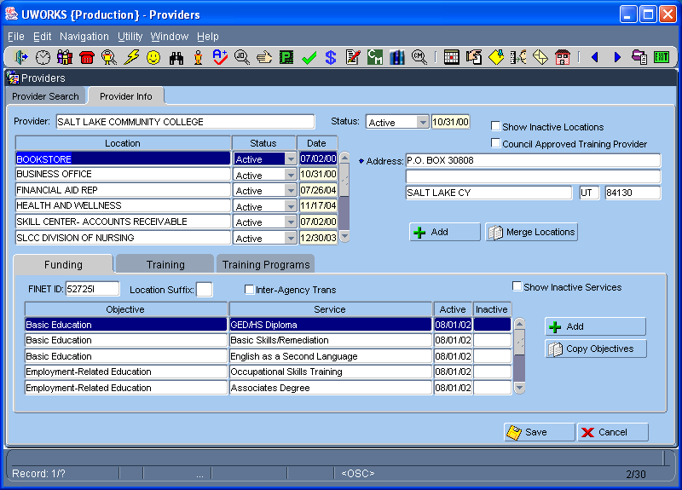

The Provider Information screen displays detailed information about providers.
- Highlight the Provider Location to see the Address information and determine if the provider is an Approved provider. Many Programs/Fund Sources require providers to go through an approval process before customers can be referred to receive their services.
- Based on the Provider Location highlighted the Funding tab information changes in the bottom section of the screen. The Funding Tab shows the FINET ID (Finance Account #) and the specific Objectives and Services that the provider delivers.
- The Training Tab displays information about the provider contact person. The Training tab is used by the worker(s) that are responsible for the provider training approval process and follow-up.
- The Training Programs Tab displays the Training Programs that the provider delivers. This tab also displays some stats about the training programs, like completion and employment success percentages.

UWORKS EMPLOYMENT PLAN OPTIONS: Correspondence – Edit/Create
Version 1/20/07

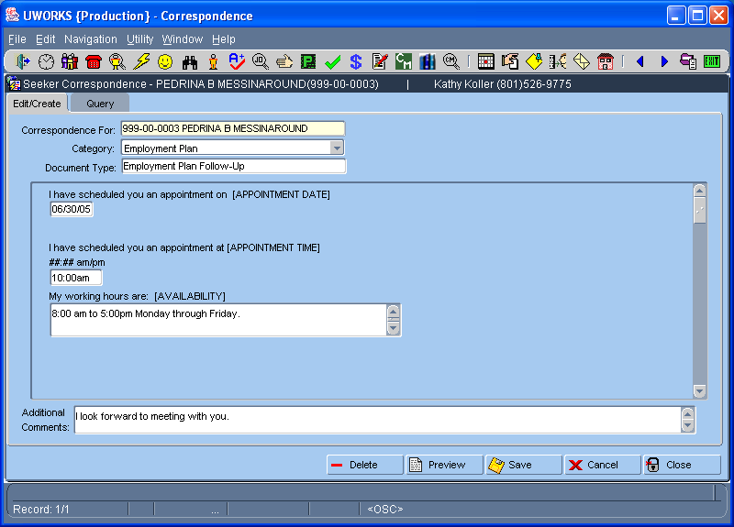

The Seeker Correspondence option is used to send letters to customers. The letters are set up in categories and document types. Letters are in template format so only limited information needs to be entered to create a letter.
- The SSN and Name of the seeker you are working on will pre-populate in the Correspondence For field.
- Select the letter Category from the pull down list then select the Document Type from the list (LOV).
- The customized information required to complete a letter will populate in the Letter Text field. The worker will need to enter data in unpopulated sections. Additional Comments can be entered at worker discretion
- The worker can see what a letter looks like by entering the Category, Document Type and selecting the Preview button. The customized information has not been entered so it will not display but you will be able to see the format of the letter. Letters that have been created but not sent yet can be edited or deleted (see next page).

UWORKS EMPLOYMENT PLAN OPTIONS: Correspondence – Query
Version 1/20/07

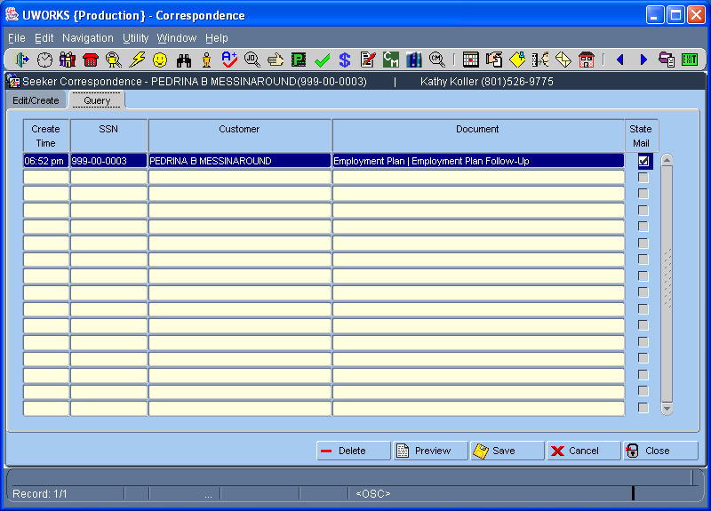

The Seeker Correspondence Query is used to review letters that have been created but not sent.
- The Correspondence Query tab displays all of the letters that a worker has created during the day for all customers. If a letter has been sent it will no longer show on this screen, you will have to view it from the Seeker History screen.
- To make Changes/Edit to letters that have already been created, double click on the letter and the Edit/Create tab will open with the letter you want to change. Make changes to the letter and click save.
- The Query screen displays the Time the letter was created, the customer Social Security Number, the Customer Name, the Document Type and the State Mail box will be checked if the letter is being sent through state mail.
- The worker can view a letter by selecting the Preview button. This will show display the letter just as the customer will see it.
- If the worker decides that they do not want to send the letter to the customer, select the Delete button to delete the letter.

UWORKS EMPLOYMENT PLAN OPTIONS: Correspondence Create Letter (Template)
Version 1/20/07

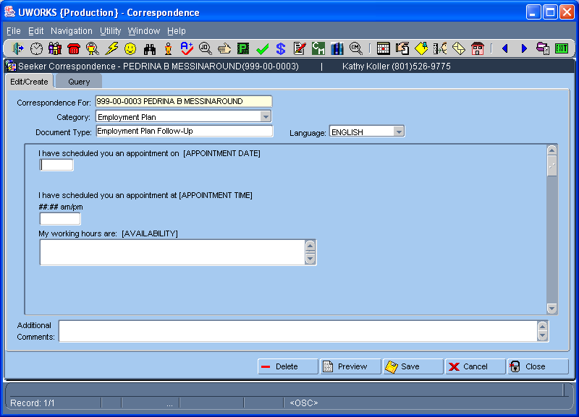
The Correspondence Template is used to select letters from a list. Use the template to enter listed information related to the letter you are sending.

UWORKS EMPLOYMENT PLAN OPTIONS: Correspondence Letter
Version 1/20/07

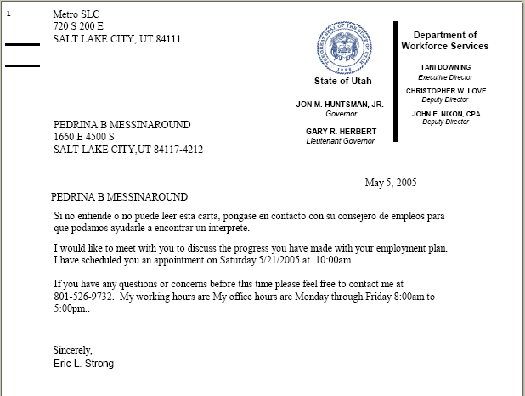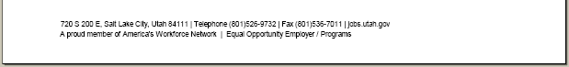
The information entered on the template is used to create a letter. The letters are generally set up for case managed customers. This letter is an example of a customer that is being scheduled to come into the office and meet with their worker and discuss progress on their employment plan.

UWORKS EMPLOYMENT PLAN OPTIONS: Counselor Information
Version 1/20/07

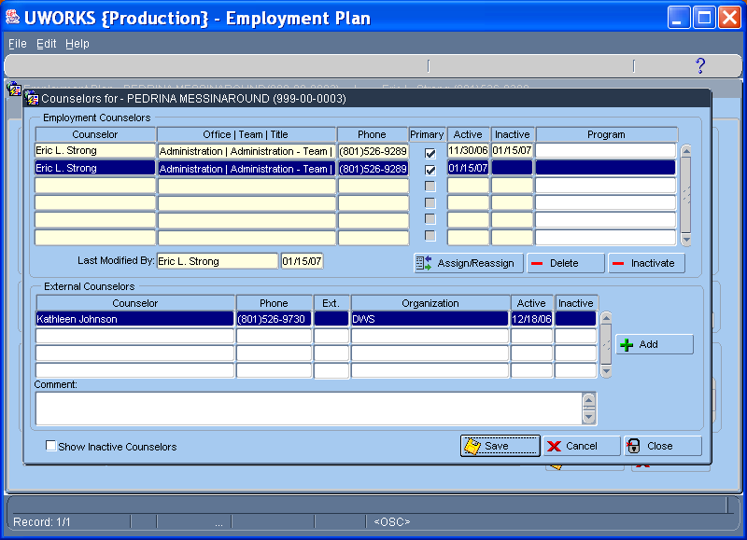

The Counselor Information option is used to assign case managed customers to workers.
- The Employment Counselors section of the screen shows a history of assigned counselors. The grid is view only and actions can only be taken by using the Assign/Reassign, Delete and Inactivate buttons.
- Assigned counselor, Office/Team/Title, Worker Phone, Primary Counselor if box checked, the Active start dates and Inactive end dates and Program is a Free Format field to enter program type.
- A history of External Counselors can also be seen. (Counselor, Phone, Organization, Active and Inactive dates are displayed)
- Workers can make Comments on this pop-up as needed.
- Both Employment Counselors and External Counselors will display only active counselors unless the Show Inactive Counselors check box is checked.
UWORKS CUSTOMER (SEEKER) MISC.: Placement History
Version 1/20/07

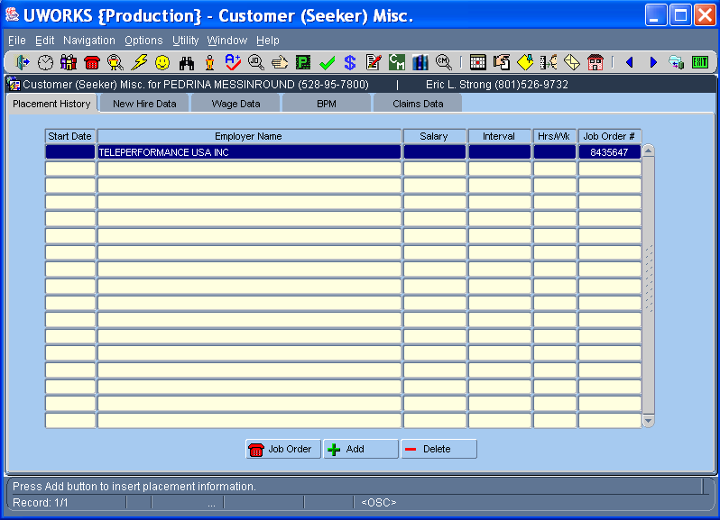

The Customer (Seeker) Misc. Placement History screen displays all of the placement records for that customer. When “hires” are posted on job orders in the system it also creates a placement record for the customer hired. When this occurs the Job Order # column will have a job order number showing. Double clicking on a placement record will pull up the Placement Pop-Up screen where all of the job hire information is enterd.
- Each placement record can display the job Start Date, Employer Name, Salary amount, Interval, Hour Worked per Week and the job order number.
- The Job Order Number will not show if the placement record is not related to a job order in the system.
- Only data that is entered on the Placement Pop-Up screen will show so some fields may be blank if they were not entered.

UWORKS CUSTOMER (SEEKER) MISC.: New Hire Data
Version 1/20/07

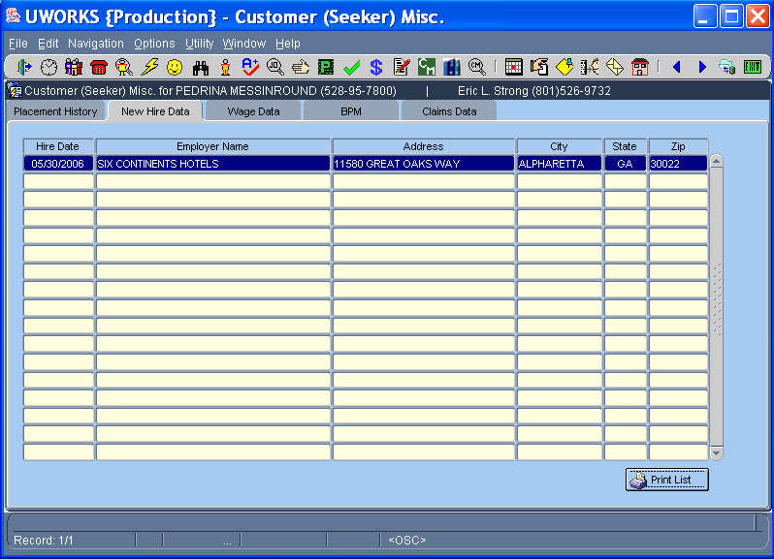

The Customer (Seeker) Misc. New Hires screen shows jobs where the Job seeker has been hired. When employers report a new hire it is added to the screen through an interface process with the state New Hire listing.
- When this employer hires a job seeker it will show some of the employer information.
- The Hire Date, Employer Name and Address information is listed.

UWORKS CUSTOMER (SEEKER) MISC.: Wage Data
Version 1/20/07

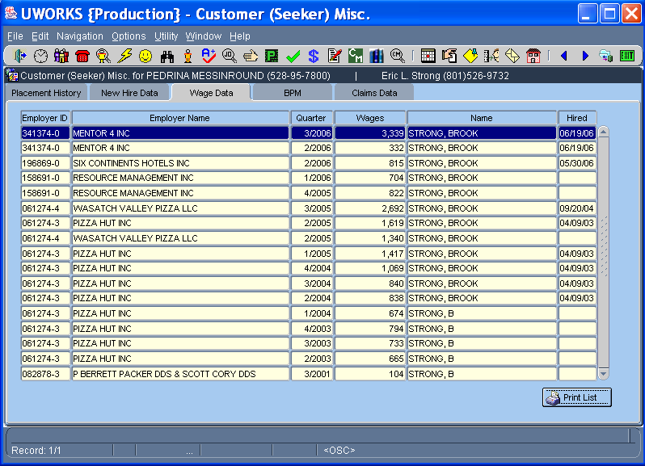

The Customer (Seeker) Misc. Wage Data screen shows the Job Seekers wage history record.
- The Employer ID, Employer Name, Quarter of the year, Wages earned during the quarter, Job Seeker Name and date of Hire are shown on this screen.

UWORKS CUSTOMER (SEEKER) MISC.: Wage Data
Version 1/20/07

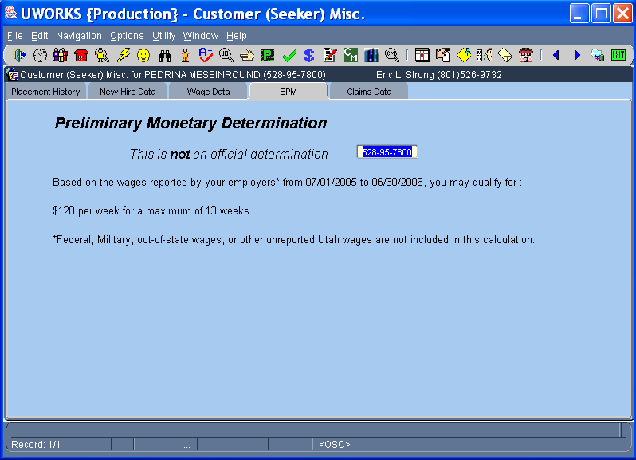

The Customer (Seeker) Misc. BPM screen displays information about possible Unemployment Insurance benefits.
- Based on employer reported wages this screen gives an estimated unemployment benefit amount that the job seeker may be eligible to receive. It also shows the maximum number of weeks that the job seeker may be eligible to receive benefits.

UWORKS CUSTOMER (SEEKER) MISC.: Wage Data
Version 1/20/07

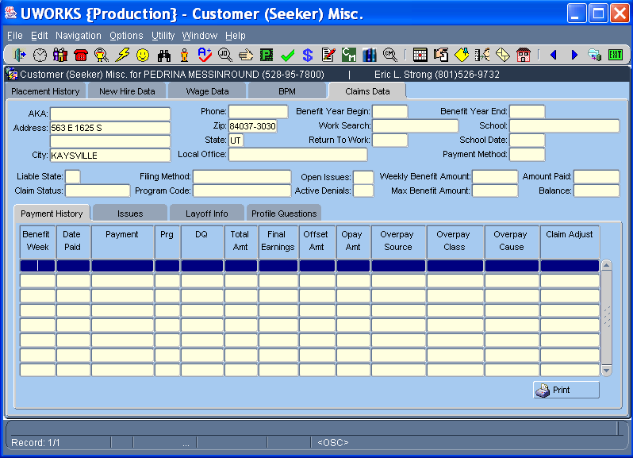

The Customer (Seeker) Misc. Claims Data screen displays information about Unemployment Insurance claims benefits. If a Job Seeker has received Unemployment benefits much of the claims information can be seen from this screen without having to go into the Unemployment system to look it up.

UWORKS SEEKER HISTORY: Seeker Services
Version 1/20/07

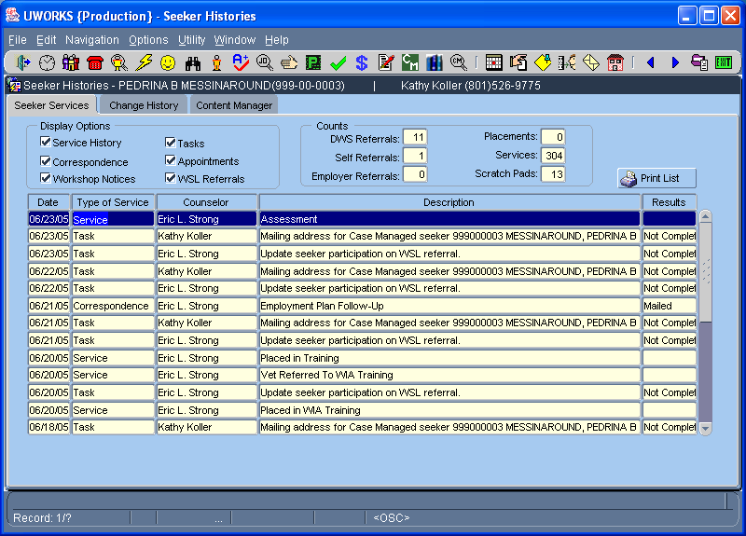

The Seeker Services tab shows a history of services provided to the job seeker.
- When Display Options check boxes are checked those services will be shown in the grid if any exist. For example if you only want to see tasks and appointments you would only have the Tasks and Appointments boxes checked.
- The Counts section allows you to see staff-assisted, Self, and Employer Referrals. You can also see Job Placements, Services and Scratch Pad counts.
- Print List allows you to print out a list of all of the services shown on the screen.

UWORKS SEEKER HISTORY: Change History
Version 1/20/07

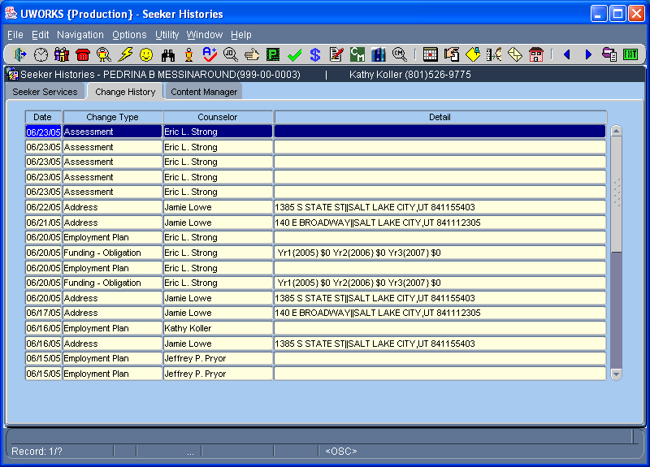

The Change History tab shows a history of some of the important changes that have been made.
- Change history will show the Date of the change, Change Type, Staff (Worker that made the change) and the Details.

UWORKS SEEKER HISTORY: Content Manager
Version 1/20/07

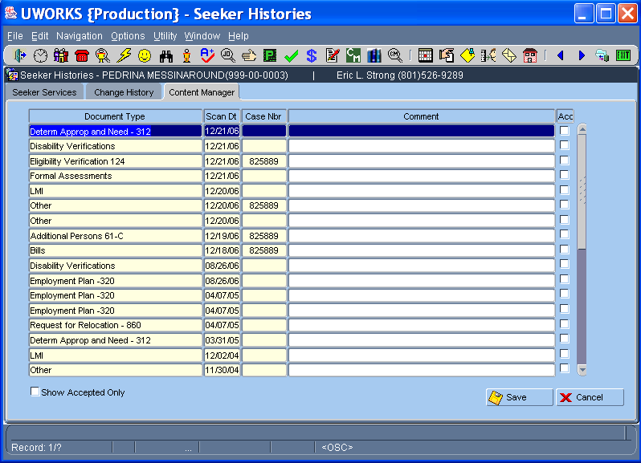

The Content Manager screen shows the documents that have been scanned into the content manager imaging system.
- Document Type shows the name of the document that was imaged, the Date it was scanned in, the eligibility Case Number and any Comments that may have been entered related to the document.
- Double- click on the document and it opens up the content manager system and displays the imaged document.

UWORKS WORKSHOPS: Workshop Tab
Version 1/20/07

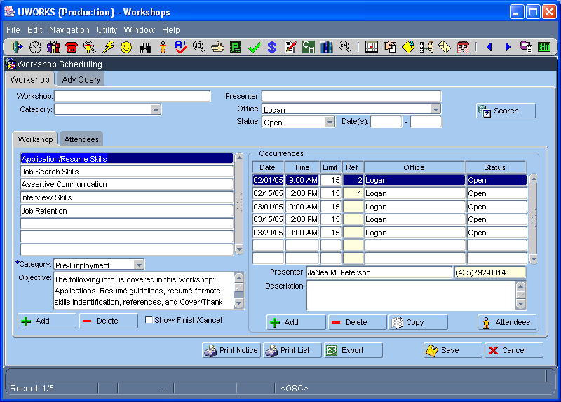
Search Criteria:
Can search by varied multiple criteria for specific workshops
Workshop Info:
Title, Category, Active/Inactive Dates, and specific objective(s) of workshop
Also includes merge, add, delete abilities
Workshop Occurrences:
Date, Time, Office, Status, and statistics for occurrences of each workshop.
Includes functions for adding, deleting, and copying occurrences.
Function Buttons:
Allows user to print workshop info notice for customer, listing of customers assigned, and export list to EXCEL.
Attendees Link:
Pressing Attendees, will navigate to attendees tab.

UWORKS WORKSHOPS: Workshop Tab
Version 1/20/07

Workshop Scheduling is a tool used to create / track workshop occurrences and allow workers to assign seekers to these occurrences.

Upon entry into the screen, system will auto-search all open workshop occurrences in your office area

There are 3 major security levels:
  - Maintenance allows user to create new workshops in the system
  - Presenter allows user to create new occurrences and update occurrence/attendees information
  - Workshops allows user to schedule attendees for workshop occurrences

UWORKS WORKSHOPS: Workshop Tab – Add Workshop
Version 1/20/07

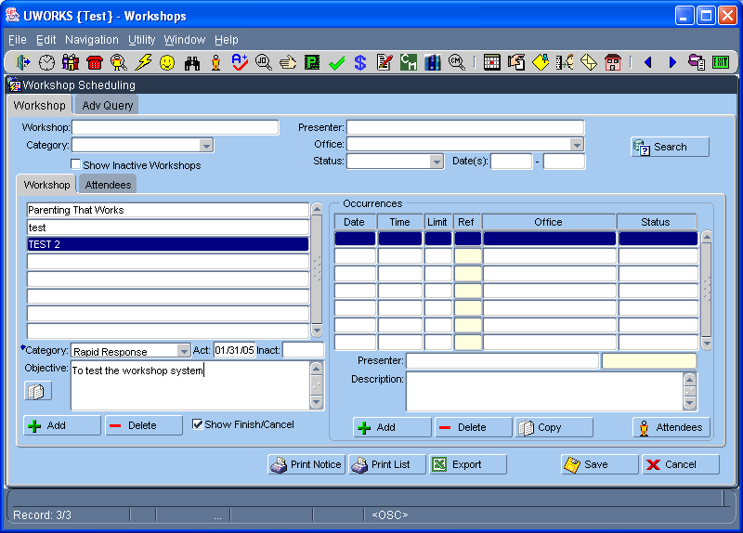

Maintenance security allows user to create a workshop

After selecting Add or simply starting to type on a new blank line, user can enter Title of workshop, select the Category, and specify the Objective of the workshop

User can also specify Active / Inactive dates to limit when occurrences can be created
- Finally, user can merge workshops when needed

UWORKS WORKSHOPS: Workshop Tab – Add Workshop Occurrence
Version 1/20/07

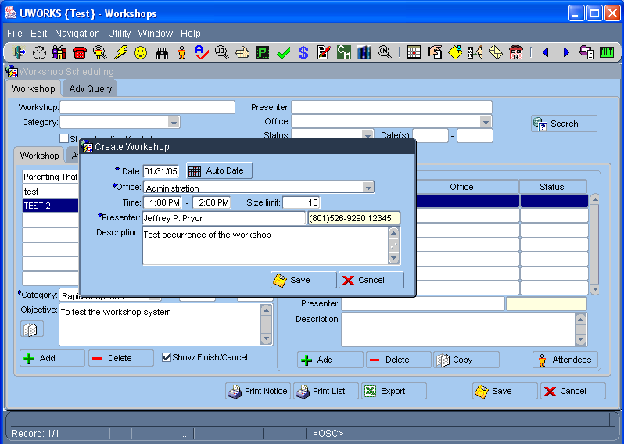

Presenter security allows user to create Workshop Occurrences for their area
- After selecting ‘Add’ button, user enters one / multiple (Auto-Date) dates, specifies office, time frame, attendees limit, and description of the workshop occurrence
- Presenter defaults to user logged in to the system (may be updated with other presenter in their region)
- Description of the workshop is entered as Free Format text.
- Selecting ‘Save’ will “attach” that occurrence to the specified workshop
- Occurrence information may be updated by the presenter before and up to 14 days after the occurrence

UWORKS WORKSHOPS: Workshop Tab – Add Workshop Attendees
Version 1/20/07

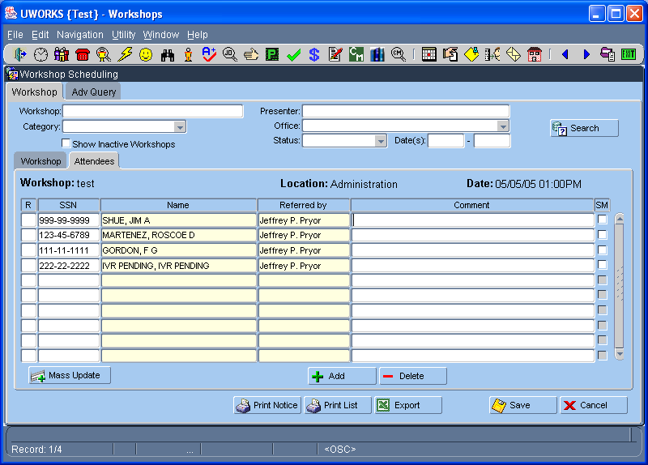

Workshop security allows the user to assign customers to workshop occurrences
- After entering a social security number, system will populate customer name and user logged in
- User may also enter comments about the customer for the presenter instructing the workshop
- The Add button will auto populate SSN of customer in the global.
- User may check the ‘SM’ (state mail) checkbox if they want a workshop notice to be sent to the customer
- User can select the “Print List” button to print a list of customers that are assigned to come to the workshop (See Page below)
- User can also select the ‘Print Notice’ button to print out notification of workshop(s) the customer is assigned to attend (See Page below)

UWORKS WORKSHOPS: Workshop List – Printout
Version 1/20/07

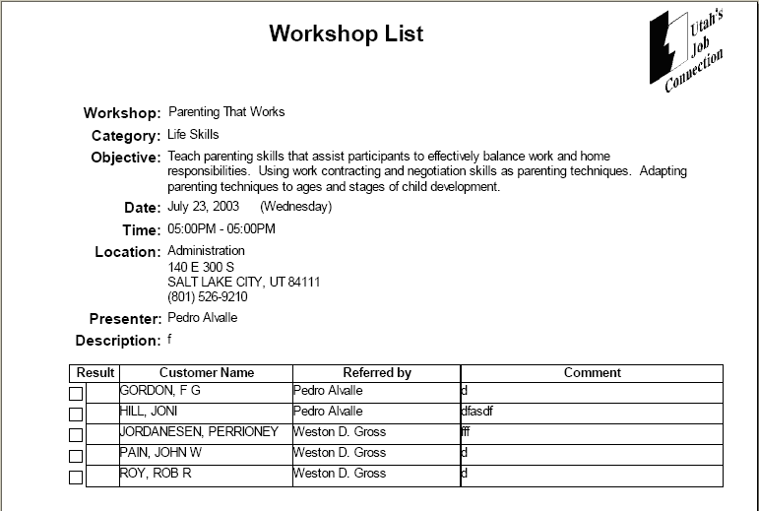
The Workshop List report displays details about the workshop and lists all of the job seekers that were or have been scheduled for the workshop.

UWORKS WORKSHOPS: Print Notice – Printout
Version 1/20/07

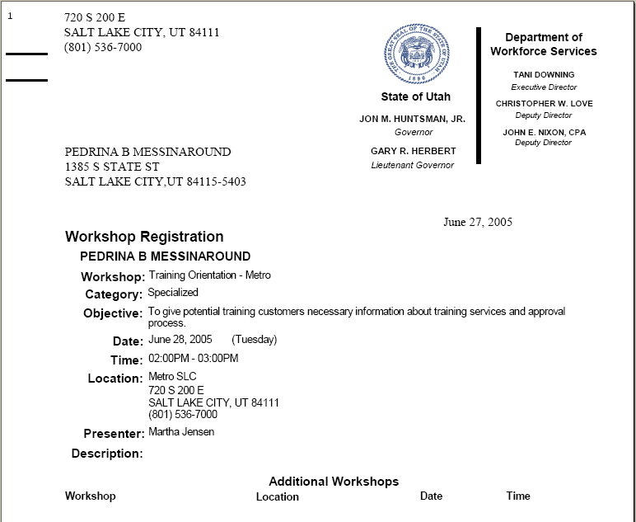
The Workshop List Notice is a letter that can be sent to a seeker. The letter gives details about the workshop. It lets the seeker know what day, time and place to attend the workshop.

UWORKS WORKSHOPS: Workshop Tab – Update Results
Version 1/20/07

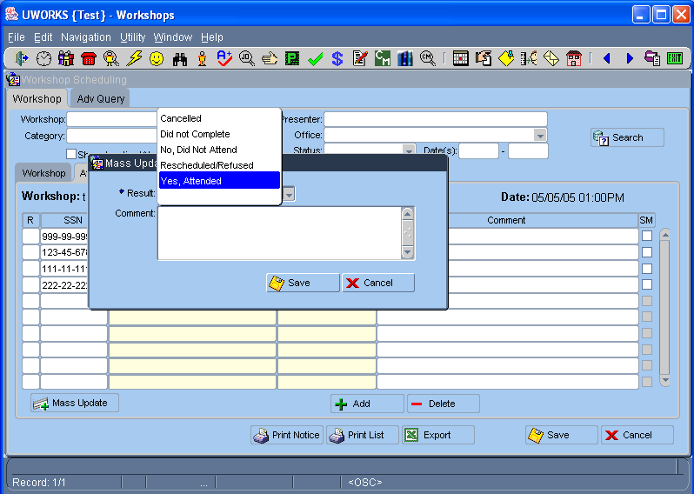

After workshop occurrence has been completed, workshop presenter may update results

Results selected from the list of values (LOV) may be entered individually or in mass using the Mass Update popup. Results can be entered for up to 14 days after the workshop started.
- Comments may also be entered on the customer (either individually or through the Mass Update popup)
- If customer is case-managed, system will send a task to the assigned counselor, indicating the result of workshop occurrence along with any comments entered by the presenter

UWORKS WORKSHOPS: Advanced Query Tab – Workshop Result(s) View
Version 1/20/07

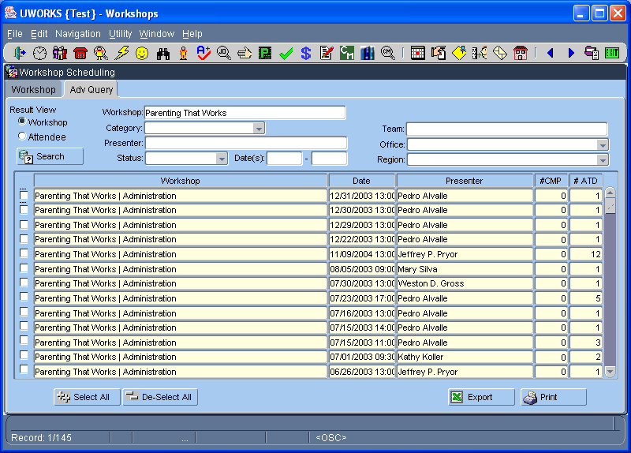

Any user that has access to workshops may also use the Advanced Query to obtain customized Workshop reports
- After specifying search criteria, system will display Workshop, Date of Occurrence, Presenter, and Number Completed / Attended
- User may select / deselect occurrences in the list for printing or exporting to EXCEL

UWORKS WORKSHOPS: Advanced Query Tab – Attendee Result(s) View
Version 1/20/07

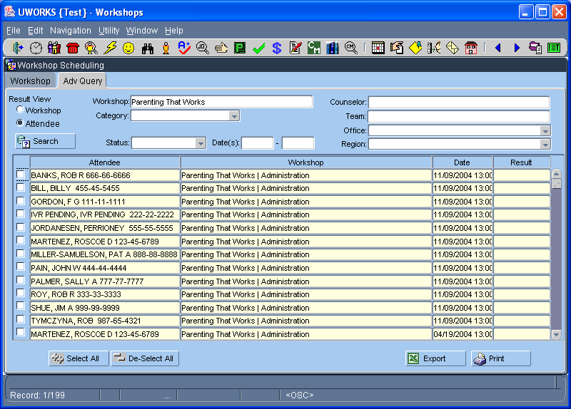

Any user that has access to workshops may also use the Advanced Query to obtain customized Attendees reports
- After specifying search criteria, system will display Attendee Name / SSN, Workshop Name, Occurrence Date and Result posted to the attendee
- User may select / deselect occurrences in the list for printing or exporting to EXCEL

UWORKS UTILITIES EDITS: Result Sets
Version 1/20/07

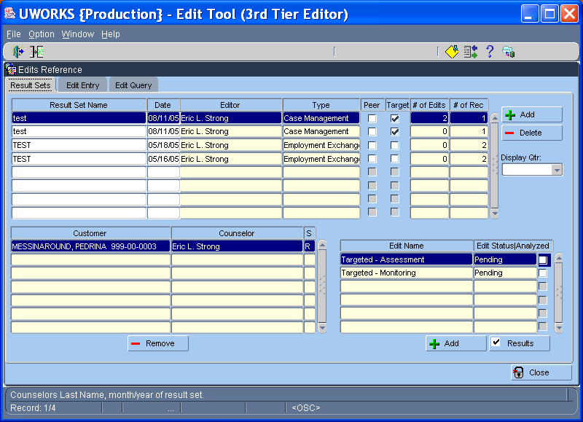

UWORKS UTILITIES EDITS: Edit Entry
Version 1/20/07

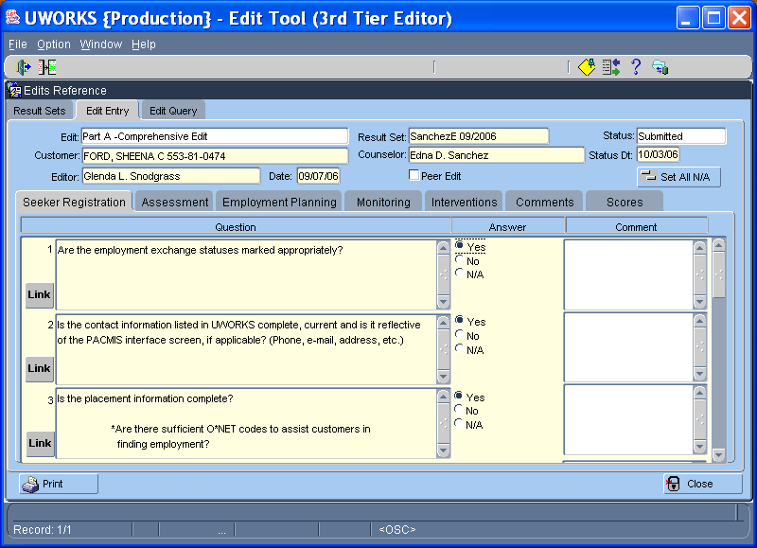

UWORKS UTILITIES EDITS: Edit Query

Version 1/20/07

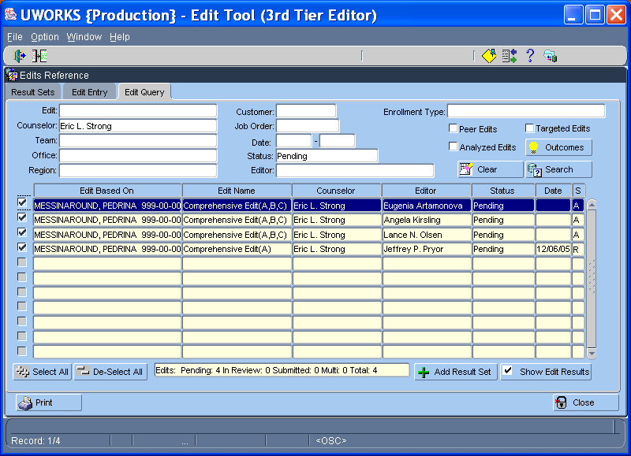

UWORKS UTILITIES: Veteran Reports - Access
Version 1/20/07

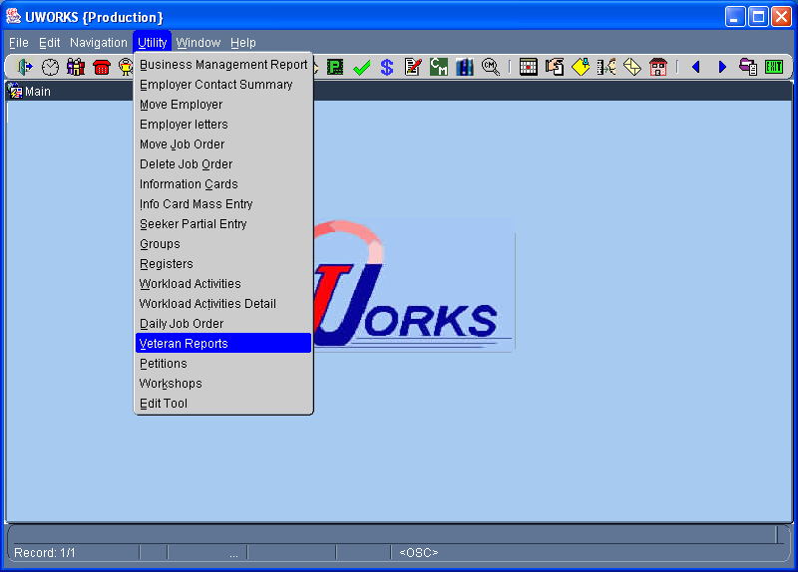
Select then click on to access the Veteran Reports.

UWORKS UTILITIES: Veteran Reports - Customer
Version 1/20/07

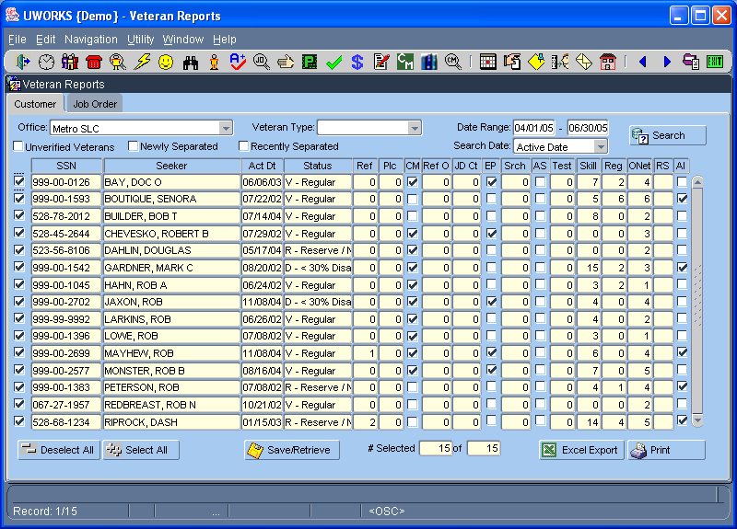
From the Veteran Reports Customer tab you can enter query information like Office, Veteran Type, Date Range, Search Date. Unverified Veterans, Newly Separated and Recently Separated. After entering the search criteria select to populate the grid with data.

Click to save the search data. The next time you open the report you can select the same button to retrieve your data. Only one search can be saved.

Click to create a Veteran Customer Report.

UWORKS UTILITIES: Veteran Reports – Customer Report Printout
Version 1/20/07

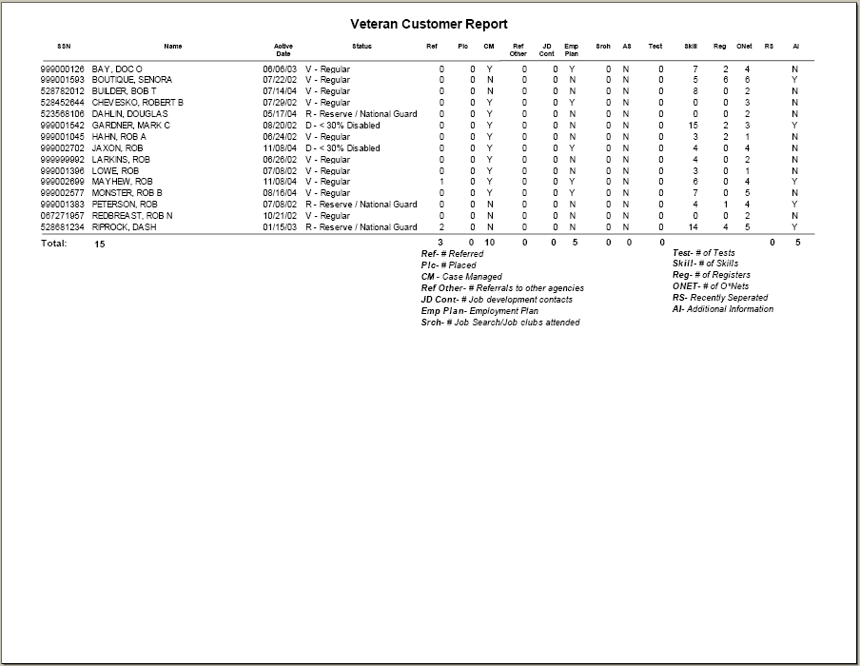
The Veteran Customer Report lists customer information about veterans. The information on this report, generally displays the services that the veterans listed on the report have received.
- The first four columns display information about the veteran like: Social Security Number, Name, Active Date and Veteran Status.
- The next 14 columns display counts of the services that have been received like: Number Referred, Number Placed, is the veteran Case Managed, Number of Referrals to Other Agencies, Number of Job Development Contacts, does the veteran have an Employment Plan, Number of Job Search/Job Clubs Attended, Number of Tests, Number of Skills, Number of Registers, Number of ONETS (Desired Jobs Selected), is the veteran Recently Separated and Additional Information.
- The Total number of veterans is listed at the bottom of the report along with the total of each of the services in the columns.

UWORKS UTILITIES: Veteran Reports – Job Order Report Printout
Version 1/20/07

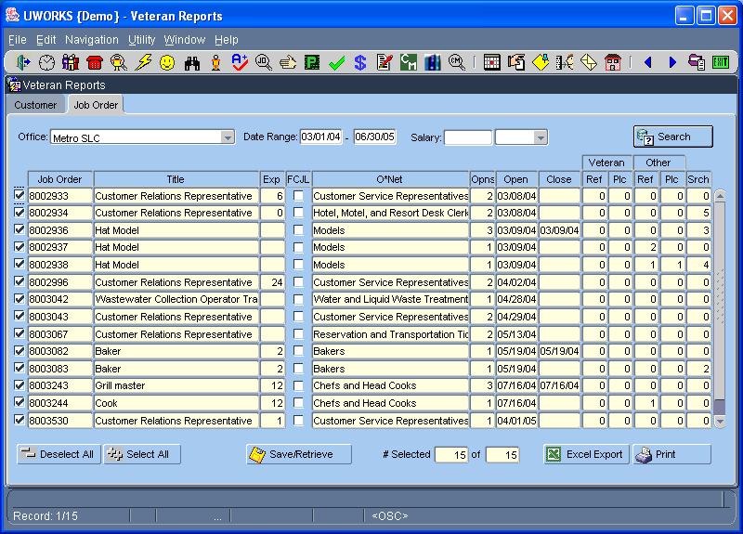
From the Veteran Reports Job Order tab you can enter query information like Office, Veteran Type, Date Range, and Salary. After entering the search criteria select to populate the grid with data.

Click to save the search data. The next time you open the report you can select the same button to retrieve your data. Only one search can be saved.

Click to create a Veteran Job Order Report.

UWORKS UTILITIES: Veteran Reports – Job Order
Version 1/20/07

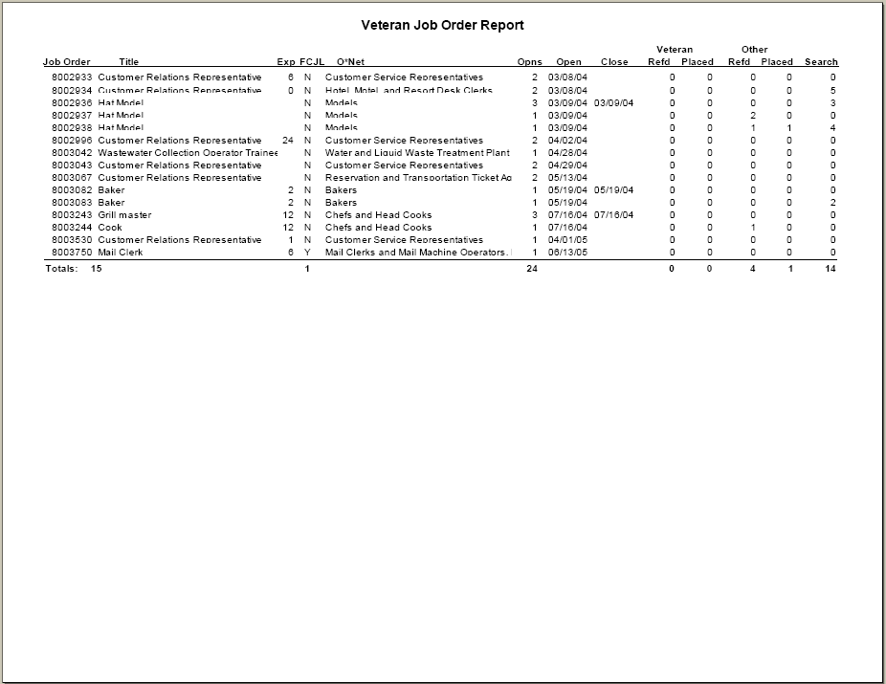
The Veteran Job Order Report lists information about veterans that relates to job orders.
- The first eight columns display information about the job orders like: Job Order Number, Job Order Title, Months Experience Required, is it an FCJL job, ONET Title, Number of Openings, the Date the Job Opened and the Date the job Closed.
- The next 5 columns display counts of referrals, placements and searches of veterans and non-veterans for comparison purposes. These include: Number of Veterans Referred, Number of Veteran Placements, Number of Non-Veteran Referrals, Number of Non-Veteran Placements and the number of searches for each job order.
- The Total number of job orders is listed at the bottom of the report along with the total FCJL jobs, openings, veterans referred, veterans placed, non-veteran referrals, non-veteran placements and total searches.

UWORKS Employment Plan Objectives, Services and Outcomes

Version 1/20/07

Employment plan

Objectives, Services, and Outcomes

Table 15

Index
OBJECTIVE | PAGE
Assessment | 87
Basic Education | 88
Employment | 88 – 89
Employment Related Education | 89 – 90
Life Skills | 91
Intensive Employment Services | 91 – 92
Job Search Assistance | 92 – 93
Supportive Services | 93 – 94
Treatment | 94 – 95
Worksite Learning | 95 – 96
Follow-Up | 96 – 97
Youth Services | 97 – 100
Partner Programs | 100 – 102
ATAA | 102

Objective- Assessment
Service | Definition of Service | Outcomes
Assessment | Conducting initial interview and comprehensive assessment, completion of any participation agreement, identifying strengths & barriers used in developing the plan, evaluation of appropriateness of FEP Diversion or FEP extension. It also includes activities related to amending, changing, determining the appropriateness of a training program, or updating a current plan. | Completed  Did Not Complete  Service in Error
Formal Assessment | Administering/participating in skills testing such as reading/math, aptitude, interest, work maturity tests, and medical/mental health evaluations. May include referrals to partner agencies or others in DWS that do assessment testing. | Completed  Did Not Complete  Service in Error
DWS Social Worker/LCT | FEP referral to Social Worker for Assessment; ongoing services with the Social Worker/LCT. | Completed  Did Not Complete  Service in Error
Problem Solving Assessment | Activities associated with initial problem solving and mediated intervention for all services. Also for resolving participation at FEP participation review. | Resolved  Moved to Next Level  Service in Error  Did Not Complete
Non-Participation Assessment | Activities related to resolving participation at phase three for FEP non-participation problem solving process or any other non-participation issues. | Resolved  Did Not Complete  Service in Error
Trial Participation | Customer must demonstrate participation before the program can be opened in PACMIS, because of previous non-participation closure. For FEP customers, participation is a mandatory 2 weeks. For other programs the Trial period may vary | Completed  Did Not Complete  Services in Error

Objective- Basic Education
Service | Definition of Service | Outcomes
Basic Skills Remediation | Enrolled in training that may include adult education, literacy activities, remedial reading, writing, mathematics, or a combination thereof; for customers who have proficiencies below the Ninth grade level or to improve basic skills to a level greater than the customer held at assessment. FEP Eligible Activity | Certificate Obtained  Service in Error  Did Not Complete
GED/HS Diploma | Enrolled in General Education Diploma (GED) and High School Diploma (HS)  FEP Eligible Activity | Service in Error  GED/High School Diploma  Did Not Complete
English as a Second Language | Enrolled in English as a Second Language includes activities around ESL and educational services  FEP Eligible Activity | GED/High School Diploma  Certificate Obtained  Did Not Complete  Service in Error  Completed

Objective- Employment
Service | Definition of Service | Outcomes
Employment | A job that pays wages, salary, or in-kind benefits  For FEP, employment that pays in-kind benefits is not an eligible activity. Do not open this service unless the customer is paid wages or a salary.  FEP Priority Activity | Still Employed  No Longer Employed  Service in Error
Self Employment | An individual who actively earns income directly from his own business, trade or profession rather than as wages or salary from an employer. May include but is not limited to, domestic work, ranching, farming, fishing and the provision of childcare. For FEP, hours of participation (which must be 30 hours) equals total gross income minus expenses divided by federal minimum wage.  FEP Priority Activity | Still Employed  No Longer Employed  Service in Error
Subsidized Employment-Private | This is private sector employment for which the employer receives a subsidy from TANF or other public funds to offset some or all of the wages and costs of employing a customer. The customer is paid wages and receives the same benefits as other employee who performs similar work.  FEP Priority Activity | Still Employed  No Longer Employed  Service in Error
Subsidized Employment-Public | This is public employment for which the employer receives a subsidy from TANF or other public funds to offset some or all of the wages and costs of employing a customer. The customer is paid wages and receives the same benefits as a non-subsidized employee who performs similar work.  FEP Priority Activity | Still Employed  No Longer Employed  Service in Error
Apprenticeship-Employment | The employment component of an apprenticeship that leads to skilled labor for customers who want to learn a trade. This must meet the apprenticeship criteria established by the Bureau of Apprenticeship and Training (BAT). Open to all programs with the exception of GA and WTE.  FEP Priority Activity | License Obtained  Certificate Obtained  Did Not Complete  Service in Error  Completed

Objective- Employment Related Education
Service | Definition of Service | Outcomes
Occupational Skills Training | Enrolled in employment related education provided with the expectation of the customer obtaining specific occupational skills sufficient to be employed in an entry-level, semi-skilled, or skilled job. This service includes short-term, certificate programs such as CNA, CPR, CDL, etc. Occupational skills education/training occurs at career and technical education schools, vocational centers, community colleges, universities, and other community settings. Open the appropriate service if an Associate's, Bachelor's, or Master's degree is the desired outcome. For WIA & FEP this service is limited to 24 months, unless a waiver is approved. WTE customers are limited to a maximum of 7 months. GA customers cannot be enrolled in Post Secondary or Higher Education. However, open this service for GA customers approved for a short-term skill enhancement opportunity offered through Community Education only. Refer to appropriate program policy.  FEP Priority Activity | License Obtained  Certificate Obtained  Completed  Did Not Complete  Service in Error
Associate’s Degree | Enrolled in educational program related to the pursuit of a two-year post high school degree.  FEP Priority Activity | Associates Degree Obtained  License Obtained  Certificate Obtained  Did Not Complete  Service in Error
Bachelor’s Degree | Enrolled in educational program related to the pursuit of a four-year post high school degree. | Bachelors Degree Obtained  License Obtained  Certificate Obtained  Did Not Complete  Service in Error
Masters Degree | Enrolled in educational program related to the attainment of a Graduate degree. Not allowed for FEP Customer | Masters Degree Obtained  License Obtained  Certificate Obtained  Did Not Complete  Service in Error
Required Training Related Services/ Supplies | This service is only used to pay for Supplies and Services that are required by a related training. Authorizations made under this service count toward the training fund limit. EXAMPLES: Tools that are required for a Welding Program or License for a Register Nurse or CDL. | Service in Error  Closed
Refugee Credential Verification | Enrolled in training or a recertification program that results in a refugee being qualified to practice his/her profession in the United States. Training or recertification may last no longer than one year and the customer must be employed during this period. | Certification/Accreditation Not Available  Did Not Complete  Service in Error
Work-Study | Work-Study is an educational benefit for undergraduates and graduate students with financial need. Work-Study placements are sites developed or contracted out by educational institutions where students who qualify for this benefit are placed to work in order to receive the stipend. The stipend is usually received as an hourly salary that cannot exceed the total Work-Study award.  Work-Study may not be appropriate for FEP student customers when negotiating employment plans. Consider carefully if Work-Study will benefit the customer's employment goal. For FEP, Work-Study is considered employment for undergraduate and graduate students with financial need. Customers who already have work history or job skills should find work in the labor market as well as go to school.  In cases where the FEP customer has little work history or poor job skills and requires flexible hours to coincide with training schedule, or the work site is relevant to the student's employment goal, Work-Study may be appropriate to help the customer achieve success in their employment and educational goal. FEP Priority Activity | Complete  Did Not Complete  Service in Error  No Longer Applies

Objective- Life Skills
Service/ Activities | Definition of Service | Outcomes
Cultural Integration | Training in basic living skills, primarily for people who are refugees. This includes learning to ride the bus, the use of household facilities, etc. It can also include citizenship classes for refugees. | Completed  Did Not Complete  No Longer Applies  Service in Error
Employment Mentoring | Customer is matched with a volunteer mentor who assists in the attainment of the employment goal or other activities involving employment mentoring. | Completed  Did Not Complete  No Longer Applies  Service in Error
Family Counseling | Services related to resolving family crises, grief counseling, and juvenile justice/behavioral problems. | Completed  Did Not Complete  No Longer Applies  Service in Error
Life Skills (other) | Activities that lead to improving the customer’s general life skills. This includes money management courses, parenting, food and nutrition courses, etc. This service also includes the Life Management Skills Training Workshop and Assertive Communication Skills Training Workshop. | Completed  Did Not Complete  Certificate Obtained  Service in Error
Pursuing Disability Income | Activities related to the pursuit of long term disability payments. | Approved for Benefits  Did Not Complete  No Longer Applies  Service in Error
Resolving Life Issues | Open this service when the customer needs to resolve childcare, adult care, court/legal, housing, or transportation issues. Tasks should reflect which barrier the customer is resolving. | No longer Applies  Did Not Complete  Resolved

Objective- Intensive Employment Services
Service/ Activities | Definition of Service | Outcomes
Intensive Employment Services- Vendor Contracts | FEP participation with an agency and/or a job coach that provides employment barrier resolution followed by a link to intensively supported employment. While enrolled in this service, the customer will participate in job readiness activities that lead to employment. Once employment is obtained, the employment service should be opened and actual hours recorded in UWORKS.  FEP Priority Activity | Service in Error  Did Not Complete  Obtained Employment
Choose to Work Assisted Primary Services | Where individuals with disabilities receive intensive job development services including: Staffing to establish need for Choose To Work, Career Counseling, Self Directed Services, Labor Market Information, Application/Resume, Workshops, General job search, Other reported tasks, DWS job matching system. | Service in Error  Did Not Complete  No Longer Applies  Obtained Employment
Choose to Work Expanded Services | Activities around participation and referral to Choose-to-Work Specialist where individuals with disabilities receive intensive job development services.  Goal of Job Placement by: Individually job development (contacting employers), Referrals from Business Consultant (before posting to Job Boards), Established contact with employer, Access to Job fairs and On-site recruitments, Use of OJT's, Tax Credit, WTE, WOTC, internships, VR Case Services  FEP Priority Activity | Service in Error  Did Not Complete  No Longer Applies  Obtained Employment

Objective- Job Search Assistance
Service/ Activities | Definition of Service | Outcomes
Individual Job Search | Participation in individual job search that is intensive and generally less than 30 days with close monitoring.  FEP Priority Activity * | Completed  Did Not Complete  Obtained Employment  Service in Error  No Longer Applies
Pre/POST-Employment Training Workshop | Participation in workshops dealing with resume writing, interviewing, interpersonal relationships in the workplace, as well as employer expectations regarding dress, grooming, ethics, responsibility, etc.  FEP Priority Activity* | Service in Error  Did Not Complete  Certificate or Skills Obtained
Job Readiness/ Connection Activities | Assignment to use DWS Job Connection Area services such as: self- directed job search, Electronic Job Board, Labor Market Information. Could also include use of job boards, WinWay, Choices, employment related counseling, problem solving, etc  FEP Priority Activity* | Completed  Did Not Complete  No Longer Applies  Service in Error
Out of Area Job Search Allowance | Activities related to securing job openings with-in the U.S. that are outside the customer’s commuting area which is defined at 50 miles one way from place of residence. This can include transportation, lodging, meals, etc. A bonafied job interview must be scheduled and verified and the job search must be approved prior to the activities beginning. Refer to appropriate program policy for specific requirements. | Service in Error  Completed  Did Not Complete  Obtained Employment
Relocation Assistance | This service is only used to pay for the necessary arrangements for a family to move to a new home to accept permanent bona fide employment. This may include the cost of actual transfer of goods and property, including mileage for the family's travel, emergency assistance, rent subsidies. Refer to appropriate program policy. | Service in Error  Completed  Did Not Complete  Obtained Employment
Mental Health Treatment-Job Readiness* | Addressing job readiness issues by attending counseling sessions, participating in day treatment, taking medications, etc. To count as a FEP priority activity, the customer must be otherwise employable, and the need for this service must be based on documentation from a medical doctor or physician supported by medical evidence. If the customer is not engaged in other eligible activities, or has already used six weeks of job search for the year, use the mental health treatment service.  FEP Priority Activity | Completed  Service in Error  Did Not Complete
Substance Abuse Treatment-Job Readiness* | Addressing job readiness issues by participating in activities related to resolving drug, alcohol or substance abuse barriers. To count as a FEP priority activity, the customer must be otherwise employable, and the need for this service must be based on documentation from a medical doctor or physician supported by medical evidence. If the customer is not engaged in other eligible activities, or has already used six weeks of job search for the year, use the substance abuse health treatment service.  FEP Priority Activity | Completed  Service in Error  Did Not Complete
Physical Treatment-Job Readiness* | Addressing job readiness issues by participating in activities related to treatment of a medical condition. This includes physical therapy, appointments, etc. To count as a FEP priority activity, the customer must be otherwise employable, and the need for this service must be based on documentation from a medical doctor or physician supported by medical evidence. If the customer is not engaged in other eligible activities, or has already used six weeks of job search for the year, use the physical health treatment service.  FEP Priority Activity | Completed  Service in Error  Did Not Complete

Objective- Supportive Services
Service/ Activities | Definition of Service | Outcomes
Child Care | Services that help customers meet their child care needs during participation. Child care ranges from day care to after-school programs, and can be inside or outside the home. Report only Child Care here, not Family Care. | Service in Error  Closed  Did Not Complete
Transportation | A payment to ensure mobility between home and the location of employment, training and/or other supportive services. | Service in Error  Closed
Other Supportive Services | Payments provided to eligible customers to enable them to participate in planned activities. Includes the provision of family care, tools, equipment, special work clothing, housing costs and medical services. (Supportive services through Y-funds and Z-funds continue to be authorized in PACMIS.) | Service in Error  Closed
FEP Enhanced Payment * | Creates an automatic alert to the Eligibility Specialist to authorize the $40 Enhanced Payment for one of the following:  1) Employment of 20 or more hours and other eligible activities that together total 30 hours a week  2) Full-time student enrolled and attending training or post secondary education. Actual class attendance hours and supervised study hours must be at least 30 hours a week.  3) Work Site Learning/Community Service 20 or more hours and other eligible activities that together total 30 hours a week.  4) Work Site Learning/Community service sites of at least 30 hours per week. | Service in Error  Closed
FEP 32+ Months * | For FEP customers who have received 32 months or more. Used to track long term customers | Service in Error  Closed
FEP Extension | For FEP customers who are eligible for an extension beyond the 36 months. Used to track and monitor eligibility while on an extension. | Service in Error  Closed
Adult Caring for a Disabled Family Member | This service is for a parent providing care for a disabled family member living in the home who does not attend school on a full-time basis. The customer must provide medical verification to support the need for the parent to remain in the home to care for the disabled family member. | Service in Error  Closed

Objective- Treatment
Service/ Activities | Definition of Service | Outcomes
Mental Health Treatment | Attending counseling sessions, participation in day treatment, taking medications, etc. | Completed  Service in Error  Did Not Complete
Substance Abuse Treatment | Activities related to resolving drug, alcohol or substance abuse barriers. | Completed  Service in Error  Did Not Complete
Physical Treatment | Activities related to treatment of a medical condition. This includes physical therapy, appointments, etc. | Completed  Service in Error  Did Not Complete
Family Violence Treatment | Counseling and support groups designed to resolved family/domestic violence. | Completed  Service in Error  Did Not Complete
PCN Requirement | PCN Requirement is used ONLY for GA. All GA customers must apply for and meet PCN eligibility criteria unless they have other health insurance, such as the VAMC for Veterans. The PCN requirement must remain open on the employment plan to ensure that re-enrollment occurs as appropriate | Closed  Did not Complete  No Longer Eligible  Service in Error
PCN Waiver | Used only for GA customers when the PCN enrollment cap is imposed. The PCN Waiver must remain open on the employment plan until open enrollment occurs. | Closed  Service in Error

Objective- Worksite Learning
Service/ Activities | Definition of Service | Outcomes
Apprenticeship-Training | The On-the-job training component of an apprenticeship that leads to skilled labor for customers who want to learn a trade. Programs must meet the apprenticeship criteria established by the Bureau of Apprenticeship and Training (BAT). For FEP, this service may include some basic skill remediation if it’s limited in duration and is necessary or a regular part of the training program. Open to all programs with the exception of GA and WTE. | License Obtained  Certificate Obtained  Did Not Complete  Service in Error
On-the-Job Training | On-the-job training is a paid worksite learning activity available for all programs with the exception of GA, WTE, and WIA Youth for customers that are job ready and need career training. The length of the OJT should be determined by the time needed to learn the necessary skills, not more than 6 months and is not allowable for jobs that are intermittent, temporary, seasonal, or that pay only commission, or piece rate. Refer to appropriate policy for additional criteria.  FEP Priority Activity | Completed  Did Not Complete  Service in Error
Unpaid Internship | A short-term and usually part-time worksite learning assignment with a public or private organization for a customer to enhance their work readiness skills. The customer does not receive a wage. This service is not for WIA Adults.  FEP Priority Activity | Completed  Did Not Complete  Service in Error
Externships-FEP Only | Experiential learning opportunities offered by educational institutions to give students practical experience in their field of study. Externships are a required component of curriculum. The educational institution sets up and assigns the student to the externship site.  This service is for FEP customers only. | Completed  Did Not Complete  Service in Error

Objective- Follow-UP
Service/ Activities | Definition of Service | Outcomes
Follow Up Choose to Work | An appropriate service that is opened after a customer attains employment or an employment placement. This service involves contact with the customer and/or the employer as appropriate for a minimum of 90 days and a maximum of 12 months. The purpose of CTW Follow Up Services is to facilitate employment retention by the provision of consultation and collaboration with an employer and a customer in order to facilitate a customer’s employment retention. (Obtain the customer’s permission prior to contacting an employer) | Completed  Did Not Complete  Service in Error
Follow Up Supportive Services | An appropriate service opened after a WIA Adult or Dislocated Worker exits the program with unsubsidized employment. Provides necessary support to customers to ensure continued success in employment. Use support funds for items listed in section 1205 of the Employment and Business Services Manual in InfoSource. | Completed  Did Not Complete  Service in Error
Follow Up Youth Leadership Development | An appropriate service during follow-up. Exposure to post-secondary educational opportunities; community and service learning projects; peer-centered activities, including peer mentoring and tutoring; organizational and teamwork training; training in decision making; citizenship training including life skills training such as parenting, work behavior training and budgeting of resources; employability; and positive social behaviors. Job Search, Life Skills and other workshops, as well as Job Search Assistance; and assisting a customer with getting a Utah Driver's License, fit into this category.  FEP Priority Activity (customer must be co-enrolled in WIA)  Job Search, Life Skills and other workshops, as well as Job Search Assistance, and assisting a customer with getting a Utah Driver’s License, fit into this category. | Completed  Did Not Complete  Service in Error
Follow Up Youth Mentoring | An appropriate service during follow-up. Youth Mentoring. Regular contact between customers and trusted, caring adults. | Completed  Did Not Complete  Service in Error
Follow Up Youth Supportive Service | An appropriate service during follow-up. Services such as childcare, dependent care, financial, housing, material, and medical, supplies, transportation and other types of assistance provided to the participant so they can reach their goal. Supportive Services assist customers to succeed in post-program activities and may only be provided if they are necessary to allow the customer to meet the negotiated goals in them employment plan. Provision of these services must be coordinated with other resources.  In rare situations, youth may earn incentives during follow-up. Use this service to pay a Youth Incentive Bonus to recognize achievement. | Completed  Did Not Complete  Service in Error

Objective- Youth Services
Service/ Activities | Definition of Service | Outcomes
Youth Assessment | This activity includes conducting the Initial Interview, completing Assessment tabs in UWORKS, providing skill testing such as reading, math, ESL, aptitude, interest, and other tests. This information is used to develop the employment plan. This is also the appropriate service to record health/treatment and/or legal issues that need to be tracked on the Employment Plan. | Completed  Did Not Complete  Service in Error
Youth Formal Assessment | Enroll youth is this Service/Activities when formal assessment, medical/mental health assessment are being paid from WIA Youth funds. This information is to be used to develop the employment plan. | Completed  Did Not Complete  Service in Error
Youth Tutoring/ Dropout Prevention | Coaching, teaching and guiding customers to increase academic success potential. This includes study skills, dropout prevention strategies and instruction leading to secondary school completion. This service also applies to assisting youth with basic skills improvement (remediation), and obtaining a high school diploma or GED. Use this service when an in-school-youth is involved in ESL  FEP Eligible Activity (customer must be co-enrolled in WIA)  Use this service to pay a Youth Incentive Bonus to recognize achievement. | Completed  Did Not Complete  GED Obtained  High School Diploma Obtained  Certificate Obtained  Service in Error
Alternative School | Specialized, structured curriculum offered inside or outside the public school system, which may provide work/study and/or assist youth with obtaining a High School diploma or GED. This includes Basic Skills improvement activities for out-of-school Youth. Use this service when an out-of-school youth is involved in ESL FEP Priority Activity (customer must be co-enrolled in WIA)  Use this service to pay a Youth Incentive Bonus to recognize achievement. | Completed  Did Not Complete  GED Obtained  High School Diploma Obtained  Certificate Obtained  Service in Error
Summer Youth Employment Opportunities | A summer worksite learning experience, which provides direct linkages between academic and occupational learning. FEP Priority Activity (customer must be co-enrolled in WIA)  Use this service to pay a Youth Incentive Bonus to recognize achievement. | Completed  Did Not Complete  Service in Error
Paid Youth Intern-ships/ Work Site Learning | An internship/work site learning activity is a short-term and usually part-time worksite learning assignment with a public or private organization for a customer who needs assistance in learning basic work-readiness skills and work requirements f. Internships are designed to promote the development of good work habits and reinforcement of work-readiness skills.  Use this service to pay a Youth Incentive Bonus to recognize achievement. | Completed  Did Not Complete  Service in Error
Unpaid Youth Intern-ships/ Work Site Learning | An internship/work site learning activity is a short-term and usually part-time worksite learning assignment with a public or private organization for a customer who needs assistance in becoming accustomed to basic work requirements. Internships are designed to promote the development of good work habits and basic work skills. FEP Priority Activity (customer must be co-enrolled in WIA)  Use this service to pay a Youth Incentive Bonus to recognize achievement. | Completed  Did Not Complete  Service in Error
Youth Occupational Skills Training | Employment related education provided with the expectation of the customer obtaining specific occupational skills sufficient to be employed in an entry level, semi-skilled, or skilled job. Enrollment in Occupational Skills Training is a post-secondary education activity. (Even if the youth is taking ATC classes or advanced classes while in high school.) This service includes short term and certificate programs such as CNA, CPR, lifesaving, etc. This service is limited to 24 months of vocational training except when funded by Education Training Voucher (ETV).  FEP Priority Activity (customer must be co-enrolled in WIA) | Did Not Complete  Associates Degree Obtained  Certificate Obtained  License Obtained  Service in Error
Youth Occ Skls Trng-Bachelor | This service is for WIA youth customers enrolled in Bachelor degree programs. Primarily, it is for youth who have already completed enough of the program that they need 24 months or less to attain their Bachelors degree. This service is limited to 24 months of vocational training, except when funded by Education Training Voucher—ETV, or in circumstances approved by Supervisors. | Bachelors Degree Obtained  License Obtained  Certificate Obtained  Did Not Complete  Service in Error
Leadership Development | Exposure to post-secondary educational opportunities; community and service learning projects; peer-centered activities, including peer mentoring and tutoring; organizational and teamwork training; training in decision making; citizenship training including life skills training such as parenting, work behavior training and budgeting of resources; employability; and positive social behaviors. Job Search, Life Skills and other workshops, as well as Job Search Assistance; and assisting a customer with getting a Utah Driver's License, fit into this category.  Job Search, Life Skills and other workshops, as well as Job Search Assistance, and assisting a customer with getting a Utah Driver’s License, fit into this category. Use this service to pay a Youth Incentive Bonus to recognize achievement. | Complete  Did Not Complete  Service in Error
Youth Supportive Services | Services such as child-care, dependent care, financial, housing, material, and medical, supplies, transportation and other types of assistance provided to the participant so they can reach their goal. Supportive Services assist customers to participate in intensive or training services and may only be provided if they are necessary to allow the customer to meet the negotiated goals in them employment plan. Provision of these services must be coordinated with other resources. | Completed  Service in Error
Youth Mentoring | Youth Mentoring. Regular contact between customers and trusted, caring adults.  Use this service to pay a Youth Incentive Bonus to recognize achievement. | Completed  Did Not Complete  Service in Error
Comprehensive Guidance and Counseling | Comprehensive guidance dialogue between a customer and a qualified professional, including drug and alcohol abuse prevention and treatment services.  Use this service to pay a Youth Incentive Bonus to recognize achievement. | Completed  Did Not Complete  Service in Error  Resolved
Youth Employment | Youth who are in unsubsidized employment  FEP Priority Activity (customer must be co-enrolled in WIA)  Use this service to pay a Youth Incentive Bonus to recognize achievement. | Still Employed  No Longer Employed  Service in Error
Youth Required Training-Related Service | This service is only used for supplies and services that are required by occupational skills training, but are not delivered by a DWS Approved Provider. For example; tools for a welding program that cannot be purchased through the school, a CNA licensing test that is not administered by the school, other licensing examinations, etc. This is also the service to use when assisting with college application fees.  Use this service to pay a Youth Incentive Bonus to recognize academic achievement in post-secondary education. | Completed  Service in Error

Objective- Partner Programs
Open the appropriate Partner Program when the customer is involved or receives a service from one of the funding sources, agency, or program listed. These services do not print on the plan.
Service/ Activities | Definition of Service | Outcomes
Collaborative-Coordinated Services (C.C.S) PARTNER PROGRAM * | Open this service when the customer is involved in collaborative activities with a core team composed of family members, professionals and other concerned community members working toward the goal of improved outcomes for an identified FEP child and his/her family. Collaborative services may include all forms of appropriate communication, i.e., e-mail, data sharing and face-to-face meetings.  To record hours of participation open appropriate service such as Family Counseling or any of the services under the Life Skills Objective. | Completed  Did Not Complete  No Longer Applies  Service in Error
Transition to Adult Living PARTNER PROGRAM * | Open this service when the customer is a youth in foster care, youth aging out of foster care, and court involved youth in the Governor's Transition to Adult Living-TAL. The vision for TAL is that these targeted youth will live successfully as adults. All TAL youth must be co-enrolled in WIA.  To record hours open appropriate adult or youth activities such as Basic Education, GED/HS, Life Skills, Youth Supportive services, etc. | Completed  Did Not Complete  No Longer Applies  Service in Error
Job Corp PARTNER PROGRAM * | Open this partner program when the customer is in Job Corps. Job Corps is a federally funded education and vocational training program offered to customers ages 16-24. Students enroll to learn a trade, earn a high school diploma or GED and get help finding a good job. Students are paid a monthly allowance and offered continued support once they graduate from the program.  To record hours of participation, open other appropriate services such as Basic Skills/Remediation (B.E.), GED/HS Diploma, or Occupational Skills Training, etc. (For WIA Youth customers, make sure the associated service(s) are from the WIA Youth Matrix.) | Completed  Did Not Complete  No Longer Applies  Service in Error
Older American Program (Title V) PARTNER PROGRAM * | Open this partner program when the customer is employed or in training under the Older American's Act Title V. This funding source provides funding for subsidized part-time employment and training opportunities for low-income persons age 55 and over who lack the basic skills and experience to acquire the employment they seek. USDA Forest Service, Division of Aging and Adult Services, Easter Seals of Utah and Experience Works, Inc administer funds.  To record hours of participation open appropriate services such as Employment, Occupational skills, Basic education, etc. | Completed  Did Not Complete  No Longer Applies  Service in Error
MSFW Training PARTNER PROGRAM * | Open this partner program when the customer is participating with Futures Through Training in Migrant and Seasonal Farm worker Employment and Training Program. (Migrant Workers Program) Services include individual employability development assistance and related assistance for those individuals, including their dependents, who are primarily employed in agricultural labor that is characterized by chronic unemployment and underemployment.  To record hours open appropriate services such as Basic education, Assessment, Life skills, Occupational training, etc. | Completed  Did Not Complete  No Longer Applies  Service in Error
Targeted Industries PARTNER PROGRAM * | Open this service when an intensive customer is receiving career counseling and assistance with career progression in one of the DWS targeted industry sectors.  To record hours of participation, open appropriate services such as Occupational Skills, Associates Degree, Job Search, etc. | Complete  Did Not Complete  No Longer Applies  Service in Error
Vocational Rehabilitation PARTNER PROGRAM * | Open this partner program when the customer is receiving services through the Utah State Office of Rehabilitation (USOR). USOR assists individuals with disabilities to prepare for and obtain employment and increase their independence. USOR may provide services in support of training towards a career goal.  Independence is the anticipated outcome of all services offered through USOR. Whether independence is achieved through employment or through increased independence in daily activities, the ultimate goal is to assist individuals in becoming less dependent on others and able to maximized self-determination.  To record hours open appropriate services such as Formal Assessment, Occupational Skills Training, Associates Degree, Bachelors Degree, etc. | Completed  Did Not Complete  No Longer Applies  Service in Error
Work Based Learning PARTNER PROGRAM * | Open this partner program when the customer is in work-based learning experience to bridge the gap between schoolwork and post secondary opportunities.  To record hours of participation open appropriate services such as On-the-Job training, Internship, Assessment, GED/HS, Apprenticeship | Completed  Did Not Complete  No Longer Applies  Service in Error

Objective- ATAA
Service/ Activities | Definition of Service | Outcomes
ATAA Wage Subsidy | Alternative Trade Adjustment Assistance established by the Trade Adjustment Assistance Reform Act of 2002. ATAA is an alternated program for older TAA eligible customers for who retraining may not be appropriate, and who become re-employed, to receive a wage subsidy to help bridge the salary gap between their old an new employment. | Service in Error  No Longer Eligible

