UWORKS DEMO

Prepared by: StateWorks IT


Employment Exchange Training Guide

January 2007

Table of Contents

UWORKS Framework 3 - 10

UWORKS Navigation 11 - 14

Find Seeker / Seeker Search 15

Seeker Entry Screens 16 - 25

Seeker Screens 26 - 35

Seeker Options from Options Menu 36 - 46

Seeker Utilities from Utility Menu 47 - 48

Seeker History 49 - 51

Seeker Notes 52 - 53

Testing 54 - 56

Employer Screens 57 - 73

Employer Utilities from Utility Menu 74 - 75

Job Order Screens 76 - 85

Job Order Options from Options Menu 86 - 91

Job Order Utilities from Utility Menu 92 - 94

Seeker Matching Screens & Quick Referral Screen 95 - 98

Individual Job Search 99 - 101

Scheduling Screens 102 - 110

FRAMEWORK OF UWORKS: Areas of the UWORKS Screen
Version 1/20/07

Menu Bar
Example: “Click Options on the menu bar.”
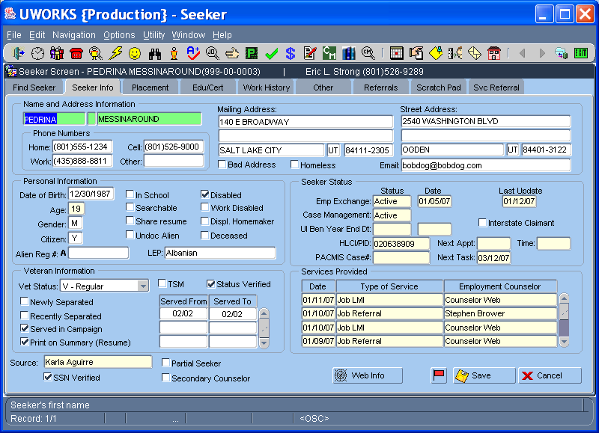

Speed Button Bar
Example: “Speed buttons are located on the speed bar.”

Title Bar
Example: “Seeker name and Counselor assigned appear in the title bar.”

Tabs
Example: “Click on the Seeker Info tab.”
Hint Text (not Help text)
Example: “Notice that Seeker’s first name appears in the hint text.”

FRAMEWORK OF UWORKS: Navigation
Version 1/20/07

Pull Down Menu
Example: “Click on the Options pull down menu located on the menu bar.”

Speed Button
Example: “Click on the Notes speed button located on the speed button bar.”

UWORKS Window Controls
- Minimize
- Maximize
- Close (not for logging out)

Status Bar
The record counter and hint text appear in the status bar.

Record Counter

Unselected Tab

Selected Tab
Active screen or the screen you are on.

FRAMEWORK OF UWORKS: Parts of a Screen
Version 1/20/07

Field
Highlighted Field

Field Title

View Only Field
Shaded in light yellow
Checkbox

Pull Down Box
Example: “Select V-Regular from the Vet Status pull down box.”
Area Title
Row

Scroll Bar
Column Title

Area
Example: “The status change date field can be found in the Seeker Status area of the Seeker Info screen.”

Table
Example: “Notice the fourth row in the Services Provided table.”

Button
Example: “Click the Save button.”

FRAMEWORK OF UWORKS: Pop-up Screens
Version 1/20/07

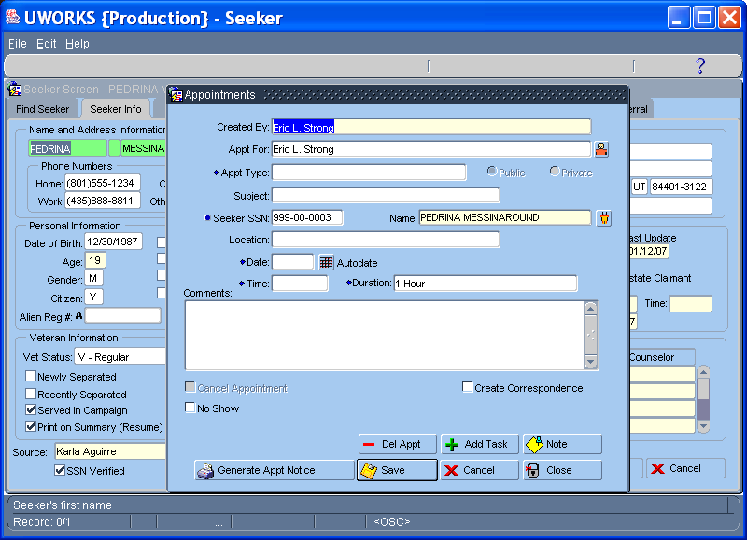

Pop-up Screen
Example: “Create an appointment on the Appointment pop-up screen.”

FRAMEWORK OF UWORKS: Pop-up Message Boxes
Version 1/20/07

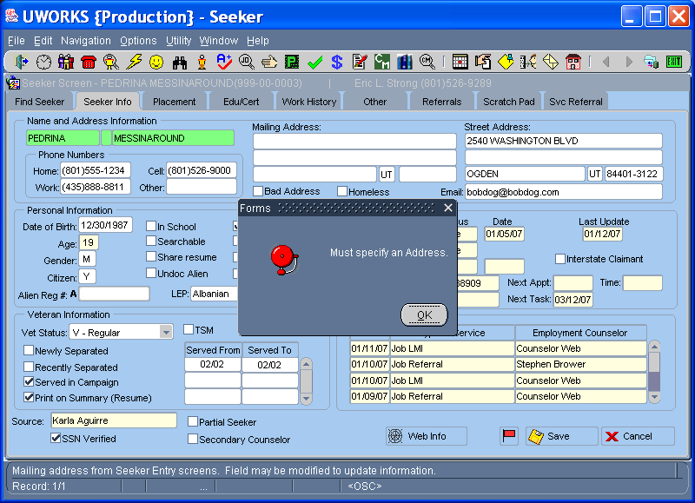
Error Message Pop-up Box
Example: “Pressing the Save button without completing all the Address fields will result in an error message.

FRAMEWORK OF UWORKS: Help Text (F1)
Version 1/20/07

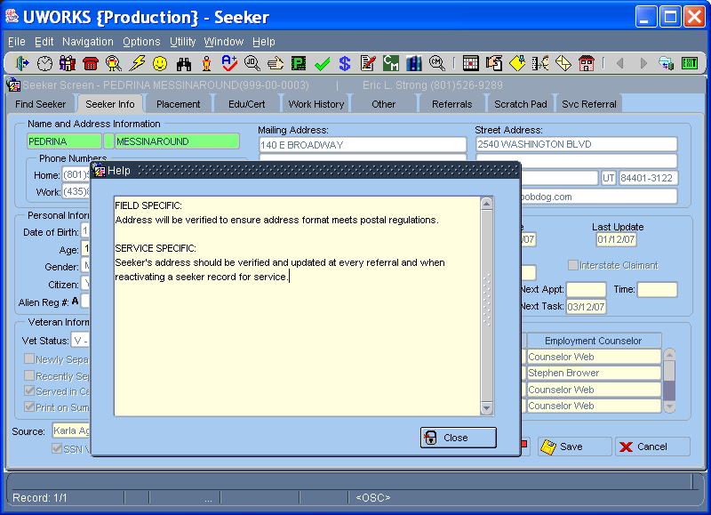
Help Text (F1)
Users pull up help text by putting their cursor in a field that they want help with and then pressing F1. Example” “User wanted to know what Address information needed to be entered.

FRAMEWORK OF UWORKS: List of Values or LOV for Short (F2)
Version 1/20/07

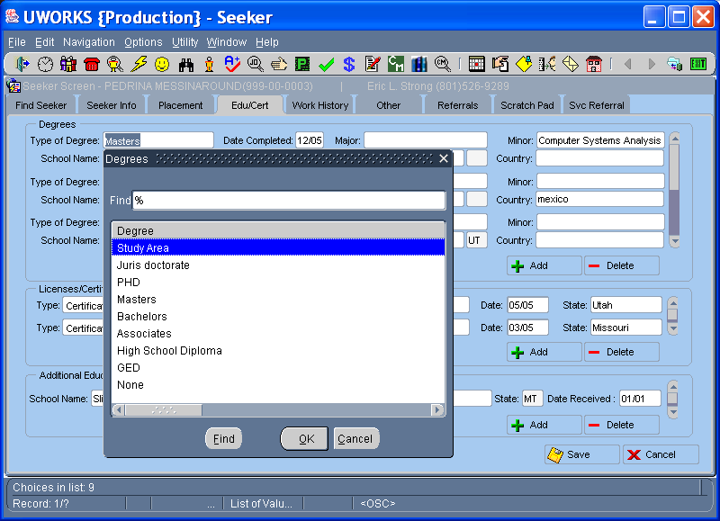
List Of Values / LOV (F2)
Users pull up a list of values for a field by putting their cursor in the field they want help with and then pressing F2. (Double clicking in the field will also bring up the LOV.) Example: “When a user wants to know what Type of Degree they can enter they press F2 when their cursor is on the Type of Degree field.” Not all fields are LOV fields. When your cursor is in a field that has a list of values the Hint Text will show the letters LOV to indicate that the field is an LOV field. “List of Valu…” will also appear in the status bar at the bottom of the screen.

FRAMEWORK OF UWORKS: Edit Box (Double Click)
Version 1/20/07

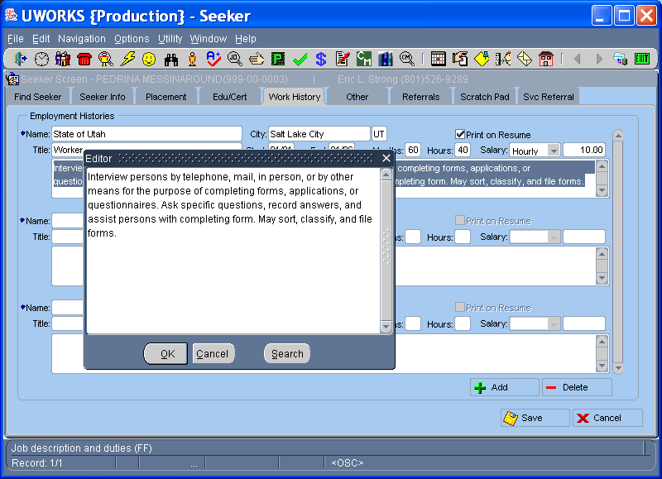
Edit Box (Double Click)
Users pull up the edit box for a field by putting their cursor in that field and double clicking. Example: “When a user wants to view a field that has a lot of text written they double click in that field and the edit box will display all the text. Not all fields will have an edit box. When your cursor is in a field that has an edit box the Hint Text will show the letters FF to indicate that the field is a free format. Generally free format fields have spell check available by right clicking your mouse button while you are in the field.

NAVIGATION OF UWORKS: Quick Guide (Page 1)
Version 1/20/07

Function (default tab) | Speed Button | Menu/Menu Item | Quick Keys
Close the current set of tabs (left side of screen) |  | File / Exit | N/A
Exit M-WORKS (the proper way to exit system) |  | File / Exit All | N/A
Open your Schedule (Daily Schedule) | | | Navigation / Daily Schedule | Ctrl+D
Open the Employers set of tabs (Emp Query¹) |  | Navigation / Employerz | Ctrl+Z
Open the Job Order set of tabs (Employer Query¹) |  | Navigation / Job Orders | Ctrl+J
Open the Seeker Matching set of tabs (Searches) |  | Navigation / Seeker Matching | Ctrl+M
Open the Quick Referral screen |  | Navigation / Quick Referral | Ctrl+Q
Open the Seeker Data Entry set of tabs (Basic) |  | Navigation / Seeker Entry | Ctrl+K
Open the Seeker set of tabs – first tab (Find Seeker¹) |  | Navigation / Find Seeker | Ctrl+F
Jump directly to the Seeker Info tab for the currently opened seeker (it will take you to the Find Seeker tab if you have not already opened a job seeker’s record) |  | Navigation / Seeker Employment | Ctrl+S
Open the Testing set of tabs (Test Summary) |  | Navigation / Testing | Ctrl+T
Open the Individual Job Order Search set of tabs (Individual Job Search) |  | Navigation / Individual Job Search | Ctrl+I
Open the Initial Interview set of tabs (Initial Interview) |  | Navigation / Initial Interview | Ctrl+N
Open the PACMIS/TANF set of tabs (Eligibility Information) |  | Navigation / PACMIS/UWORKS Interface | Crtl + U
Open the Intake form (Intake) |  | Navigation / Intake | N/A
Open the Assessment set of tabs (Employment) |  | Navigation / Assessment | Ctrl+A
Open the Eligibility set of tabs (Eligibility) |  | Navigation / Eligibility | Ctrl+Y
Open the Employment Plan set of tabs (Enrollment) |  | Navigation / Employment Plan/Enrollment | Ctrl+E
Open the Customer (Seeker) Misc. set of tabs |  | Navigation / Customer Seeker Misc. | Ctrl + O
Open the Seeker History set of tabs (Seeker Services) |  | Navigation / Seeker History | Ctrl+H
Open the Case Management Search Screen |  | Navigation / Case Management Search | Ctrl+G
Open the Content Manager Imaging System |  | Navigation / Content Manager | N/A

NAVIGATION OF UWORKS: Quick Guide (Page 2)
Version 1/20/07

F Keys
Access Help Text pop-up screen for the current field (the one that is highlighted or has the cursor in it) | N/A | N/A | F1
Access LOV (List of Values) pop-up screen for the current field (the one that is highlighted or has the cursor in it) | N/A | N/A | F2
Set field to “on” or “off” (used in individual Job Search screen). You may also set a field “on” or “off” by holding down the Ctrl key and left clicking the field. | N/A | N/A | F4
Go back one tab | N/A | N/A | F7
Go forward one tab | N/A | N/A | F8
Will jump to corresponding tab | N/A | N/A | Shift+  F1-F8
Bring up next seeker, job order, employer etc. in the search results list (any time the speed buttons are blue) |  | N/A | F9
Bring up previous seeker, job order, employer etc. in the search results list (any time the speed buttons are blue) |  | N/A | Shift+  F9
Pulls down the Options Menu | N/A | Options | F12
Cancels anything entered into current field | N/A | N/A | Esc
Check the spelling of the current field (the one that is highlighted or has the cursor in it). You may also right click in a field to start the spell checker. | N/A | N/A | Alt+S
¹ The default tab changes once you have opened a customer’s record

NAVIGATION OF UWORKS: Quick Guide (Page 3)
Version 1/20/07

Options Menu
Option menu items change depending on which set of tabs you are currently viewing. The screens menu items listed below are only available from the options menu when you are viewing the indicated set of file tabs.

Function (default tab) | Speed Button | Menu/Menu Item | Quick Keys
Create Appointment (Opens the UWORKS Schedule pop-up screen) |  | Options²/Create Appointment | Alt+A
Create Task (Opens the Task pop-up screen) |  | Options²/Create Task | Alt+T
Create Notes (Opens the Create Note pop-up screen) |  | Options²/Notes | Alt+N
Create Referral (Opens the Create Referral pop-up screen) |  | Options²/Create Referral | Alt+R
Create Scratchpad | N/A | Options³/Create Scratchpad | Alt+P
Mass Referrals/Scratchpads | N/A | Options³/ | Alt+Z
Create Seeker Correspondence |  | Options⁴/Correspondence | Alt+C
Create Service Referral |  | Options⁴/Service Referral | Alt+L
Copy Job Order | N/A | Options⁵/Copy Job Order | Alt+J
Open Job Order Mailbox | N/A | Options⁵/Job Order Mailbox | Alt+M
Open Job Order Inbox/Outbox | N/A | Options⁵/Job Order Inbox/Outbox | Alt+I
Perform a Count of qualified seekers | N/A | Options⁵/Qualified Seeker Count | Alt+Q

² Available in Options menu from all screens in the system
³ Available in Options menu from Job Order and all Seeker screens
⁴ Available in Options menu from all Seeker screens
⁵ Available in Options menu from Job Order screens

The following Options menu items do not have quick keys or corresponding speed buttons, i.e. they can only be accessed through the Options menu when you are viewing the specified set of tabs.

Job Order Set of Tabs | Employer Set of Tabs | Job Seeker Set of Tabs
Print Transcript  Print Referrals  Print Verification Letter  Print Job Board Display  Print Scratch Pad List | Red Flag  Print Employer Transcript | Counselor Information  Send Info Card  Activate/Inactivate Seeker  Security Risk  Print Transcript  Print Resume

NAVIGATION OF UWORKS: Quick Guide (Page 4)
Version 1/20/07

Utility Menu
The Utility menu holds menu items for pop-up screens that do not fit elsewhere. You may see additional items added to the Utility menu by the time the system comes up.

Function (default tab) | Speed Button | Menu/Menu Item | Quick Keys
Move Employer | N/A | Utility/Move Employer | N/A
Employer Letters | N/A | Utility/Employer Letters | N/A
Move Job Order | N/A | Utility/Move Job Order | N/A
Information Cards | N/A | Utility/Information Cards | N/A
Seeker Partial Entry | N/A | Utility/Seeker Partial Entry | N/A

UWORKS SEEKER: Find Seeker
Version 1/20/07

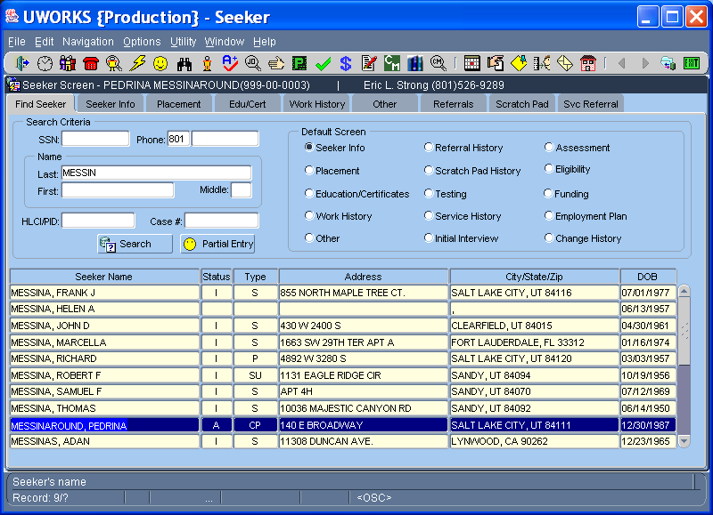
- Search for a seeker by SSN, Phone Number, or Last Name/First Name/Middle Initial
- Set the Default screen by selecting one of the Radio Buttons
- If name search is not a precise match, possible Seeker Names will display in the grid. Select the name you want by double clicking the name or highlighting and hitting Enter key.
- The Status column in the grid shows the seeker status - “I” for inactive or “A” for active
- The Type column in the grid shows the type of seeker – “S” for employment exchange seeker; “U” for seeker on unemployment; “C” for case management seeker and “P” for seeker interfaced with PACMIS
- The Address, City/State/Zip and DOB (date of birth) columns show information to help select the correct seeker

UWORKS SEEKER PARTIAL ENTRY

Version 1/20/07

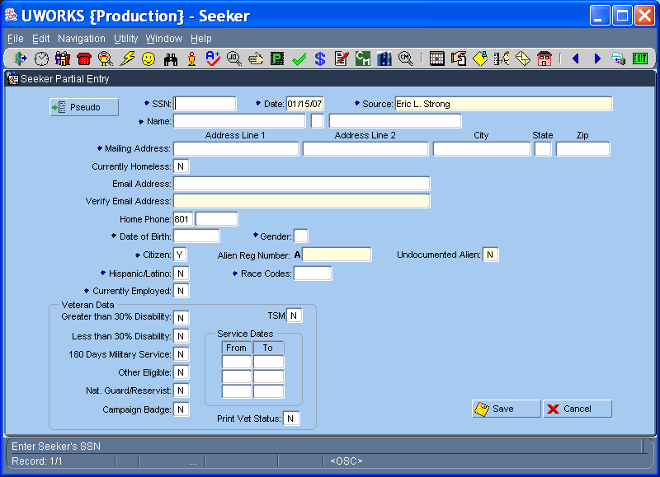

Seeker Partial Entry is a quick way to get a job seeker into the system.
- The Partial entry screen consists of the basic seeker information like SSN, Name, Address, Phone, Date of Birth, Gender, Citizenship, Ethnicity and Race. Employment and veteran information is also included.
- It is best to enter a full seeker record. However, workers may enter a partial record to provide a referral to a job seeker.

UWORKS SEEKER DATA ENTRY: Basic

Version 1/20/07

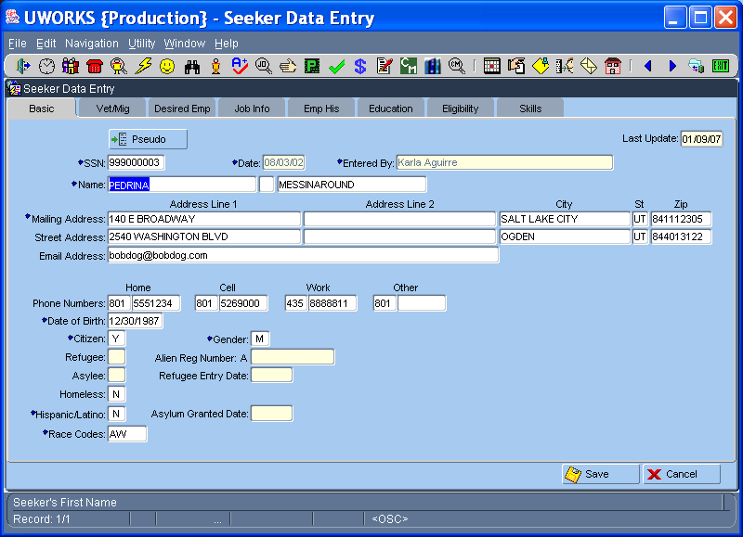

Seeker Entry is used to data-enter seeker records into the system.
- Generally a seeker will complete a written registration form and a worker will use it to enter the seeker information into the system.
- System auto-searches by SSN when it is entered. If no match, begin entering new seeker record. For seekers that do not have SSN’s use the Pseudo button.
- Enter information about the seeker. (Name, Address, Email, Phone Numbers, Date of Birth, Gender, Citizenship, and Race)

UWORKS SEEKER DATA ENTRY: Vet/Mig

Version 1/20/07

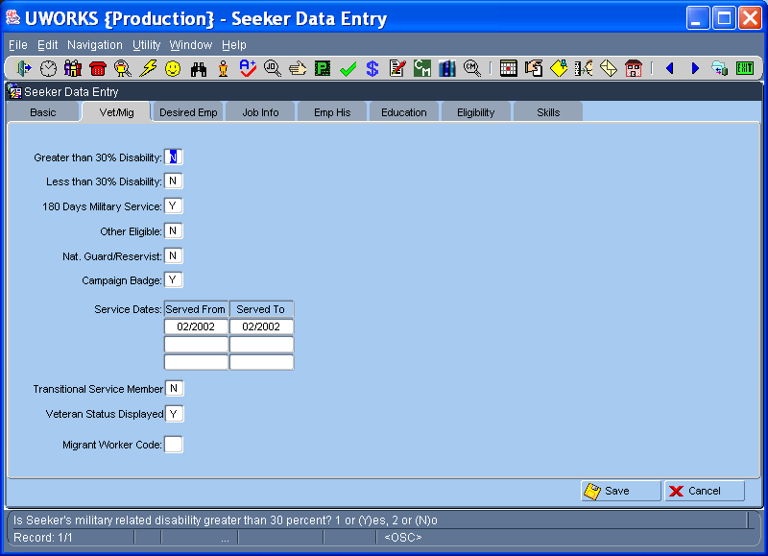

The Veteran & Migrant Worker tab is used to enter veteran status information and migrant worker codes:
- Enter “Y” in the veteran fields that apply. For veterans with active service history, list the dates of service.
- There are 3 types of Migrant workers. Enter the correct type when applicable.

UWORKS SEEKER DATA ENTRY: Desired Emp

Version 1/20/07

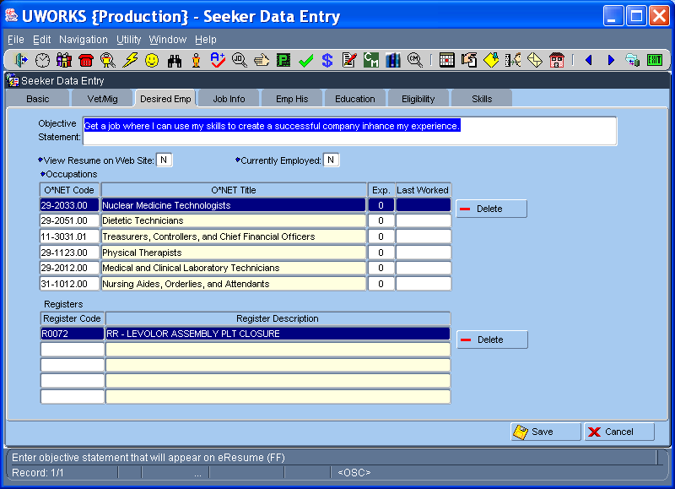

The Desired Employment tab is used to enter O*NET titles and work experience. Registers are used to link seekers with employers they would like to work for:
- Enter the seeker Objective Statement.
- Enter up to 6 O*NET Titles of jobs the seeker would like to have. Include experience if applicable.
- Enter any Registers that the seeker desires.

UWORKS SEEKER DATA ENTRY: O*NET Search
Version 1/20/07

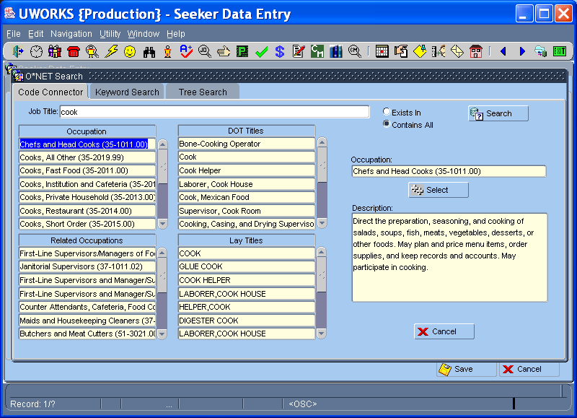

A major part of completing the desired employment is selecting occupation (ONET) Job Titles. The ONET Search pop-up includes:
- Three different screens to help you select an ONET. The Code Connector, Key Word Search and Tree Search.
- Code Connector allows the worker to enter a job title and see Occupations, Related Occupation, DOT Titles and Lay Titles.
- Keyword search allows the worker to enter key words to help find the ONET title.
- Tree search allows workers to look for ONET’s within the ONET families using a tree.

UWORKS SEEKER DATA ENTRY: Job Info
Version 1/20/07

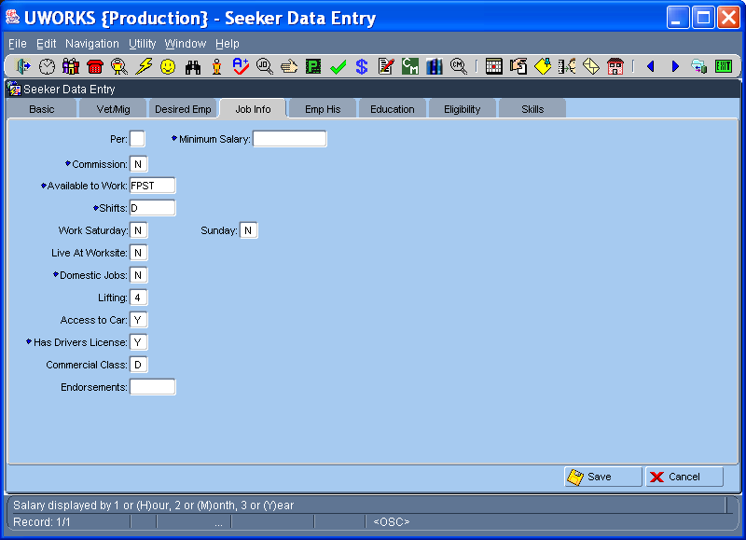

The Job Information tab is used to set the seeker desired work requirements.
- Set the Minimum Salary, Commission, Work Availability, Desired Shifts and Willing to Work Sat or Sun.
- Is the seeker is willing to Live at the Worksite, Work Domestic Jobs, What is their Lifting Capacity, do they have Access to a Car.
- Does the seeker have a Drivers License? If they do is it a Commercial Class? Enter any Endorsements.

UWORKS SEEKER DATA ENTRY: Emp His
Version 1/20/07

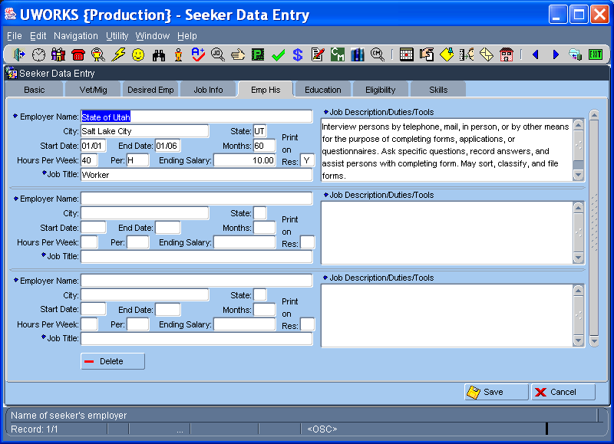

Use the Employment History tab to enter information about jobs the seeker has had.
- Enter the seeker employment information for every job they have had in the past.
- Enter Employer Name, City and State.
- Enter the employment Start and End Dates, Months Worked, Hours Worked Per Week and the Ending Salary.
- Select “Y” in the (Res) field if the seeker wants the job to display on their resume. Enter the Job Title and a Description of the job duties the seeker performed while at that job.

UWORKS SEEKER DATA ENTRY: Education
Version 1/20/07

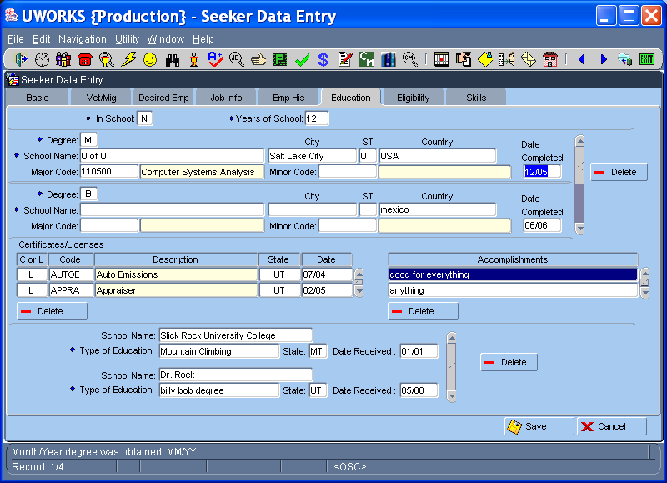

The Education tab is used to enter Schooling/Education History, Licenses & Certificates, Accomplishments and Other Education Info.
- Specify if the seeker is still in school and how many years of schooling they have completed.
- For each education record list the Degree Type, School Name and Address, the Major/Minor and the Completion Date.
- Enter any Certificates or Licenses. Specify “L” or “C” and then pick from the List of Values.
- Enter any seeker Accomplishments.
- Enter any other Education received at the bottom of the screen.

UWORKS SEEKER DATA ENTRY: Eligibility
Version 1/20/07

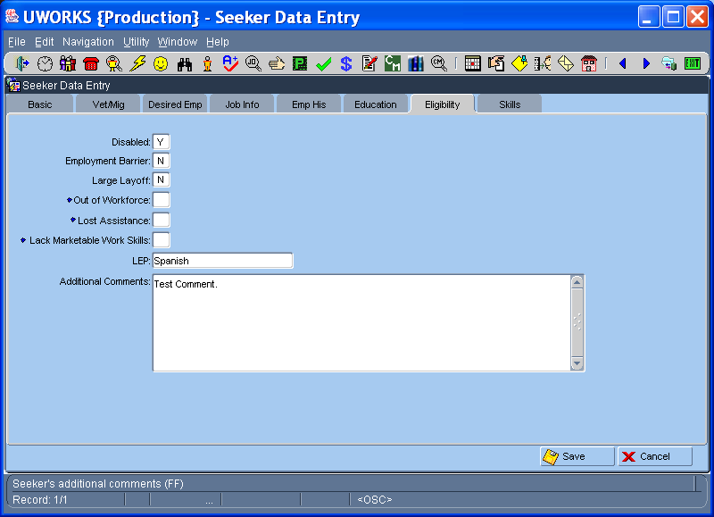

The Eligibility tab is used to enter information that may create barriers to employment.
- Is the seeker Disabled? If yes, is their disability a barrier to employment?
- Enter “Y” if the seeker has been involved in a Large Layoff, been Out of the Workforce for more than 8 years, or Lost Assistance.
- Enter “Y” if the seeker Lack Marketable Work Skills.
- If the seeker has Limited English Speaking skills, enter their primary Language. Add any Additional Comments.

UWORKS SEEKER DATA ENTRY: Skills
Version 1/20/07

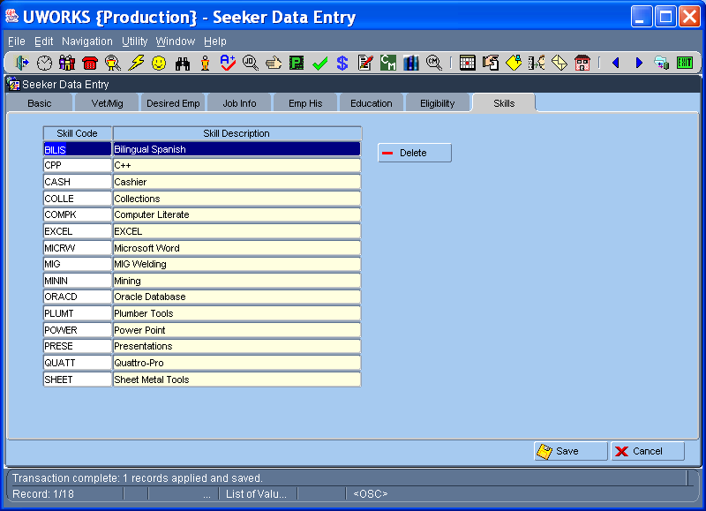

The Skills tab is used to enter skills that the job seeker has:
- If the Seeker has completed an employment registration form and entered Skill Codes use them to enter their skills.
- The List of Skills can be found by double clicking in the Skill Code column.

UWORKS SEEKER: Seeker Info
Version 1/20/07

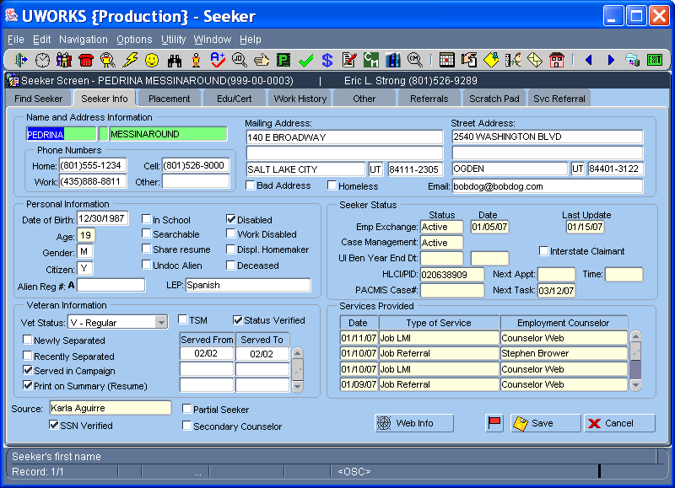

The following information is found on the Seeker Info tab:
- The seeker Name and Address
- There is a section for Personal Information
- Seeker Status (Combination of the Status and Type columns on the Find Seeker tab)
- Veteran Information (The veteran type, service dates and DD214 verification)
- Services Provided (Shows the date, service type and worker that provided the service)
- The Source shows the worker that first entered this seeker record

UWORKS SEEKER: Placement
Version 1/20/07

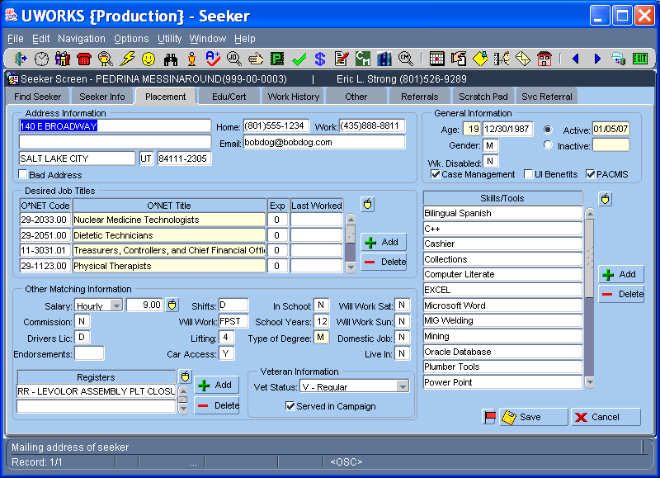

Placement screen data is used to match qualified job seekers to open jobs. The following information is found on the Placement tab:
- Address Information
- General seeker information
- Desired Job Titles (Job Titles are displayed using ONET classifications)
- Skills and Tools
- Other Matching Information (provides much of the seekers work preferences)
- Testing Results (provided by office testing centers)
- Registers (link job seekers to specific employer job openings)

UWORKS SEEKER: Edu/Cert
Version 1/20/07

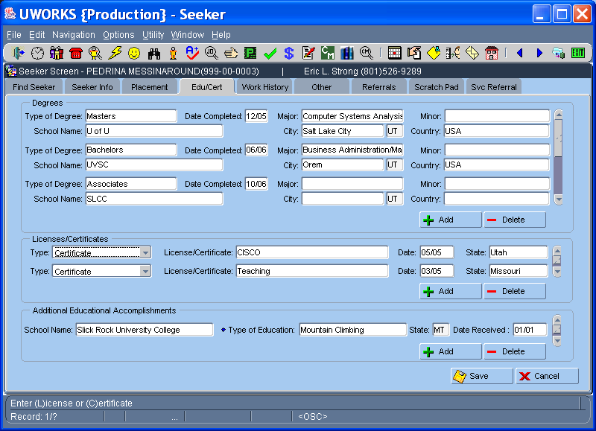

The following information is found on the Edu/Cert tab:
- Degrees (Includes Type of Degree, Date, Major/Minor, School Name, City, State and Country)
- Licenses/Certificates (Select License/Certificate from an LOV followed by the State and date)
- Additional Education Accomplishments is used to display Education or Licenses/Certificates that are not included in the Degrees or Licenses/Certificates sections
- Information entered on this screen may be used to create an electronic Resume

UWORKS SEEKER: Work History
Version 1/20/07

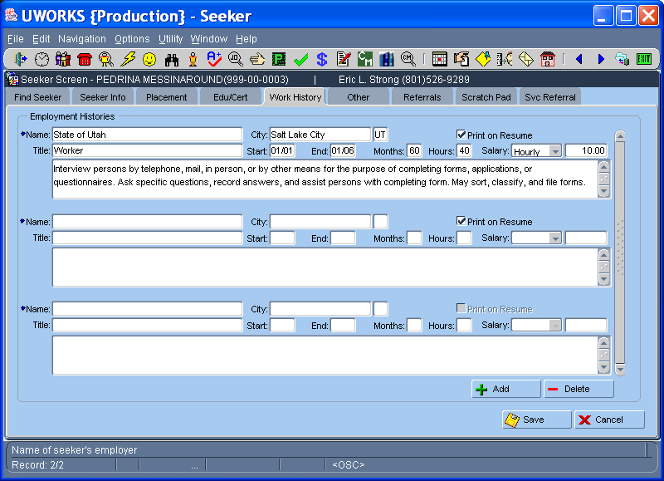

The following information is found on the Work History tab:
- Employment History (Employer Name, City, State, ONET Job Title, Actual Job Title, Job Start Date, Job End Date, Months worked in this position, Hours worked per week, Salary per hour/month/year and the job description.
- There is also a “Print on Resume” button that will show the job on the seeker resume if checked or exclude it if unchecked.
- Information entered on this screen may be used to create an electronic Resume

UWORKS SEEKER: Work History/Spell Check

Version 1/20/07

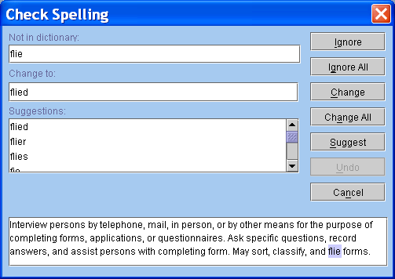

The spell checker is available in any free format field.
- Right-click with your mouse in the field that you want to spell check.
- Some Free Format fields bring up the spell check automatically.
- The spell checker will show the word that may be spelled incorrectly; it then shows possible suggestions to replace the word.
- You can ignore the suggestion, change the misspelled word or cancel the spell check.

UWORKS SEEKER: Other
Version 1/20/07

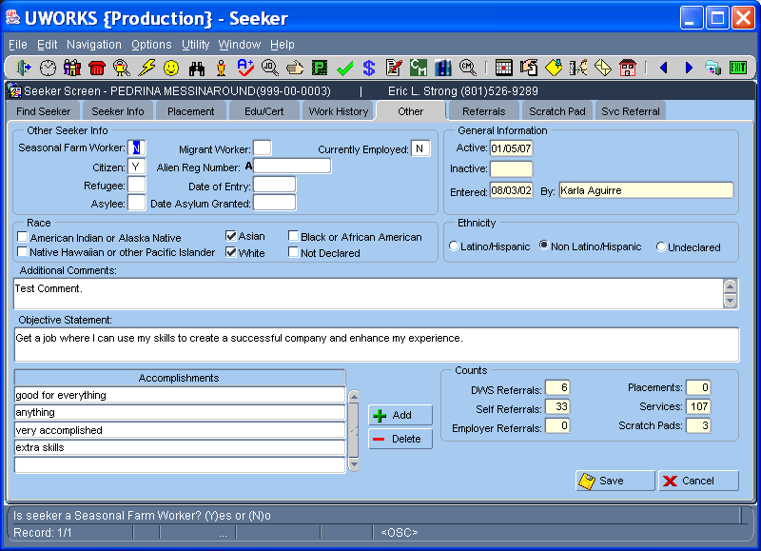

The following information is found on the seeker Other tab:
- Other Info (Alien information is reported in this section)
- Race & Ethnicity
- Objective Statement (Used on the electronic resume)
- Accomplishments (Used on the electronic resume to highlight special accomplishments)
- Counts (Brief display of job searching information)

UWORKS SEEKER: Referrals
Version 1/20/07

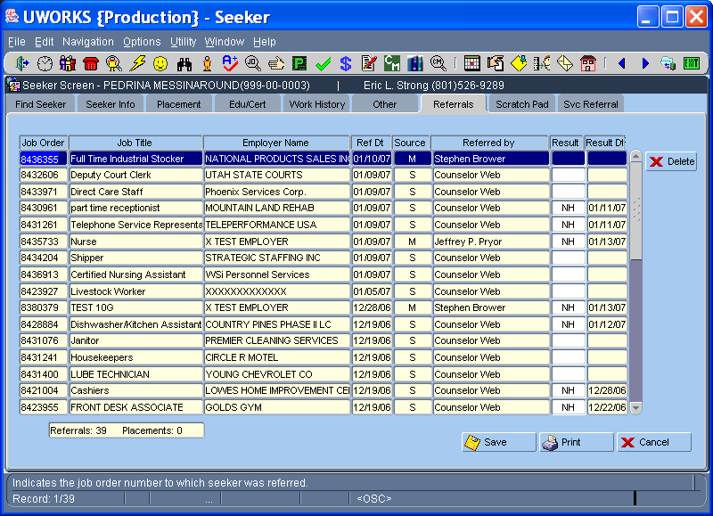

The following information is found on the Referrals tab:
- Listing of all of the jobs that the job seeker has been Referred (Job Order number, Job Title, Employer and Referral Date show)
- Source (Shows “M” for mediated and “S” for self service)
- Referred By (Worker name is mediated or “Counselor Web” if self referred)
- Result & Result Date (Shows hire results like “H” for hire, “NH” for not hired etc…)
- Count of Referral & Placements (Total of all referrals and any placements / hires)
- Print (Basically prints a copy of the referrals screen)

UWORKS SEEKER: Scratch Pad
Version 1/20/07

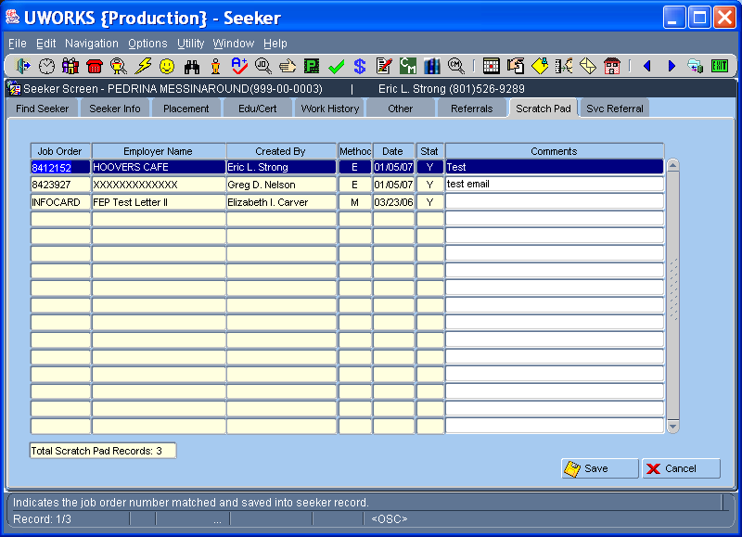

The following information is found on the Scratch Pad tab:
- Listing of all of the jobs where job info has been sent to the seeker
- Method (Shows “E” for employer and “M” for mediated/staff-assisted)
- Stat (The status of the Call-in card “Y” = Sent; “P” = Pending; “N” = No card sent)
- Total Scratch Pad Records (Total of all jobs that the seeker has received information on)
- Scratch Pads are created when a search is completed, when seeker meets the qualifications, and when a call-in card is sent. They may also be referred by the worker with the call-in card.

UWORKS SEEKER: Svc Referrals
Version 1/20/07

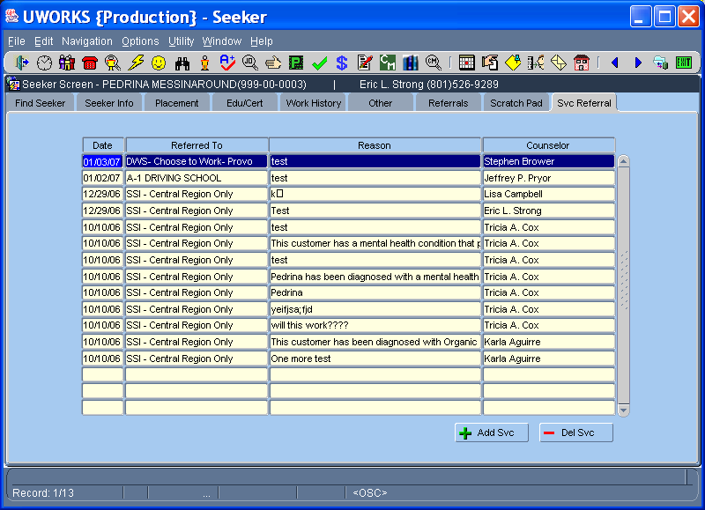

The Service Referrals screen shows a history of the internal and external referrals that a job seeker has been referred to. These referrals are not job referrals but may be referrals to agencies that can help meet basic needs or physical or mental health problems.
- Creating Service Referrals is done on the Service Referral pop-up screen (Access the Service Referral pop-up by clicking the “Add Svc” button or by selecting “Options – Service Referrals” in the Menu Bar.

UWORKS SEEKER OPTIONS: Service Referral
Version 1/20/07

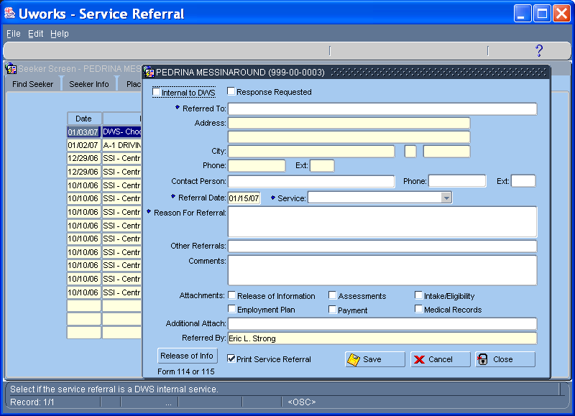

The Service Referral pop-up is used to record referrals to other workers in the department or agencies outside of the department that provide services to the job seeker.
- Referred To is selected from an LOV of possible providers
- The referral agency/person information is entered along with the referral date, reason and any additional comments
- The worker can print a copy of the referral to give to the job seeker.

UWORKS SEEKER OPTIONS: Appointments Pop-up
Version 1/20/07

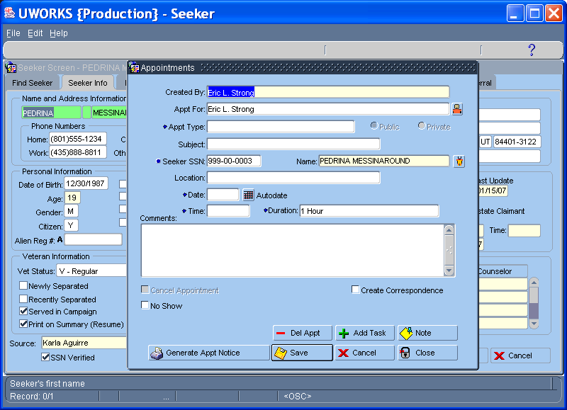

The Appointments pop-up is used to schedule a seeker appointment.
- The Appt For field is pre-populated with the worker name that is logged in. The icon to the right of the field can be clicked to bring up an LOV that will allow multiple workers to be selected.
- Appt Type is an LOV field and Subject is a free format field.
- The Seeker SSN and Name are pre-populated with the seeker social security # and name of the seeker record you are on.
- Enter the Date, Time and Duration of the appointment. Comments can also be entered as needed.
- Use the Generate Appt Notice to print out a hard copy of the appointment information for the job seeker.
- The other Buttons allow for additional worker functions. When saved, the appointment will show in the workers schedule.

UWORKS SEEKER OPTIONS: Tasks Pop-up
Version 1/20/07

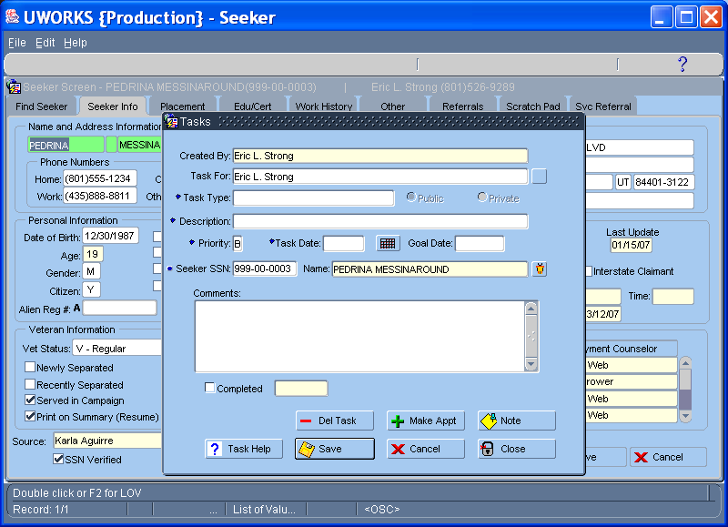

The Tasks pop-up is used to schedule a seeker task
- The Task For field is pre-populated with the worker name that is logged in. The icon to the right of the field can be clicked to bring up an LOV that will allow multiple workers to be selected.
- Task Type is an LOV field and Description is a free format field.
- Enter the task Priority, Task Date and Goal Date of the task.
- The Seeker SSN and Name are pre-populated with the seeker social security # and name of the seeker record you are on. The icon to the right of the field can be clicked to bring up an LOV that will allow another seeker to be selected.
- The other Buttons allow for additional worker functions. When done the task will show in the workers schedule.

UWORKS SEEKER OPTIONS: Create Note for Seeker Pop-up
Version 1/20/07

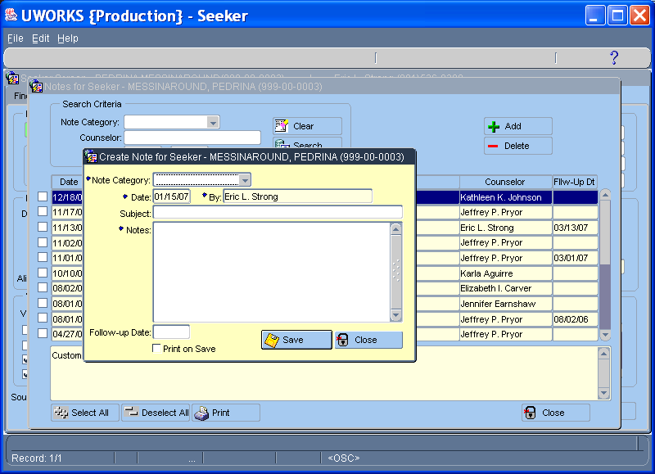

The Create Note for Seeker pop-up is used to make notes on a seeker record
- The type of note is selected from the Category pull down
- Enter the note Date and Subject.
- The Notes field is a free format field that consists of the details of the note
- A Follow-up Date can be entered. This will create a task for the worker.

UWORKS SEEKER OPTIONS: Create Referral Pop-up
Version 1/20/07

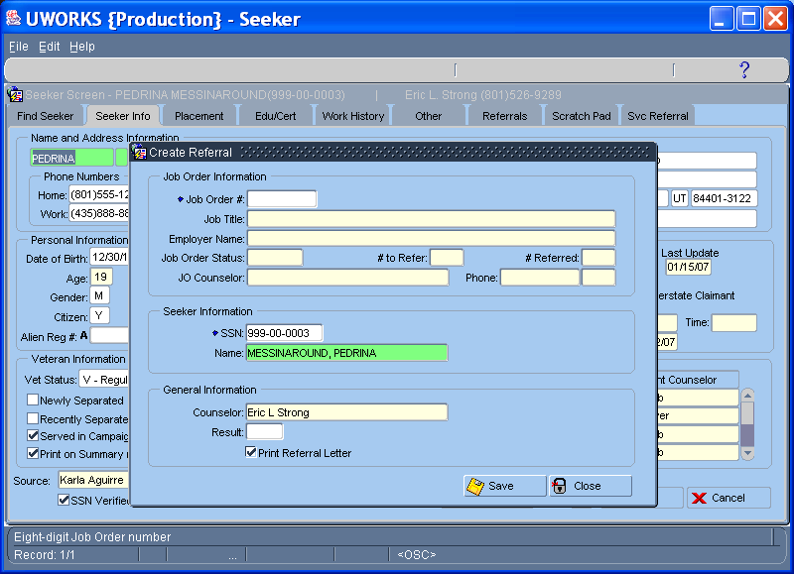

The Create Referrals pop-up is used to create a job order referral for the seeker
- Enter the Job Order # and the job order information will pre-populate in the fields below. If the worker has a job order already pulled up from the job order screen then the job order # and information will pre-populate when the pop-up is opened.
- Seeker SSN and name will be pre-populated with current customer. However, user can enter a different seeker SSN and the new seeker name will populate.
- If result of referral is known, it can be entered in the Result field. (This is an LOV field)
- When the Print Referral Letter check box is checked (default) a referral letter will print and can be given to the job seeker.

UWORKS SEEKER OPTIONS: Create Scratch Pad Pop-up
Version 1/20/07

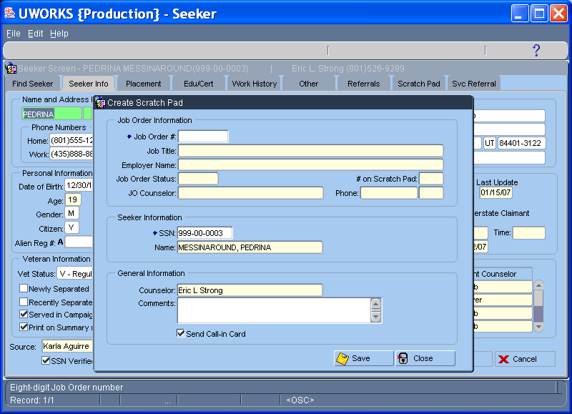

The Create Scratch Pad pop-up is used to create a job order scratch pad for the seeker
- Enter the Job Order # and the job order information will pre-populate in the fields below. If the worker has a job order already pulled up from the job order screen then the job order # and information will pre-populate when the pop-up is opened.
- Seeker SSN and name will be pre-populated with current customer. However, user can enter a different seeker SSN and the new seeker name will populate.
- Comments can be entered in the Comments field.
- When the Print Call-in Card check box is checked a call-in card will print and can be given to the job seeker.

UWORKS SEEKER OPTIONS: Correspondence (Case Mgt)
Version 1/20/07

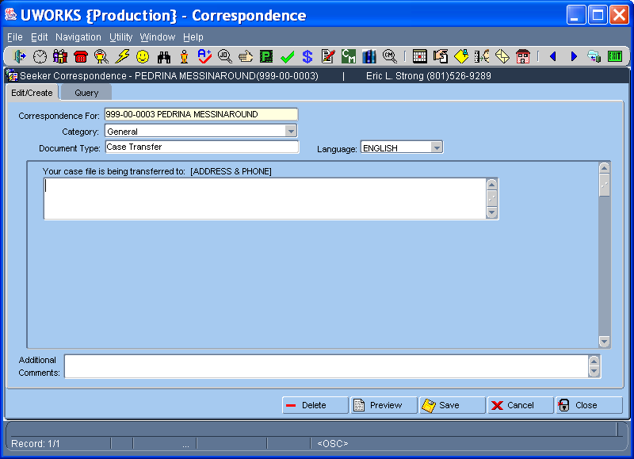

The Seeker Correspondence pop-up is used to create a letter for the job seeker
- The SSN and Name of the seeker you are on will pre-populate in the Correspondence For field
- Select the letter Category from the pull down list then select the Document Type from the LOV
- The customized information required to complete letter will populate in the Letter Text field. The worker will need to complete any entries in this section. Additional Comments can be entered at worker discretion
- The worker can look at the letter they created by selecting the Preview button. The customized info can be edited, deleted or saved.

UWORKS SEEKER OPTIONS: Counselor Information (Case Mgt)
Version 1/20/07

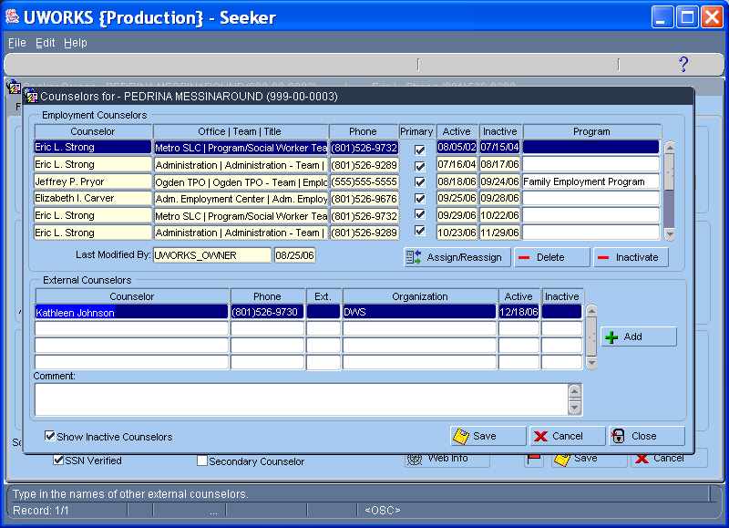

The Counselor Information pop-up is used to assign job seekers to workers (for case management)
- The Employment Counselors section of the screen shows a history of assigned counselors. The grid is view only and actions can only be taken by using the Assign/Reassign, Delete and Inactivate buttons.
- Assigned counselor, office/team/title, phone, primary counselor yes or no, and the active start and end dates is displayed.
- A history of External Counselors can also be seen. (Counselor, Phone, Organization, Active and Inactive dates are displayed)
- Workers can make Comments on this pop-up as needed.
- Both Employment Counselors and External Counselors will display only active counselors unless the Show Inactive Counselors check box is checked.

UWORKS SEEKER OPTIONS: Activate/Inactivate Seeker
Version 1/20/07

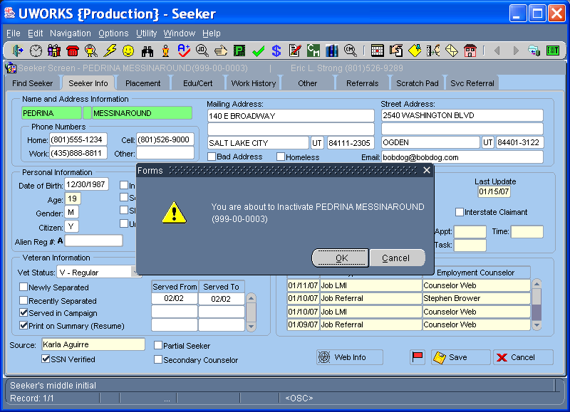

Activate/Inactivate Seeker will allow the worker to inactivate active employment exchange seekers or activate inactive employment exchange seekers.

UWORKS SEEKER OPTIONS: Reset Employment Exchange
Version 1/20/07

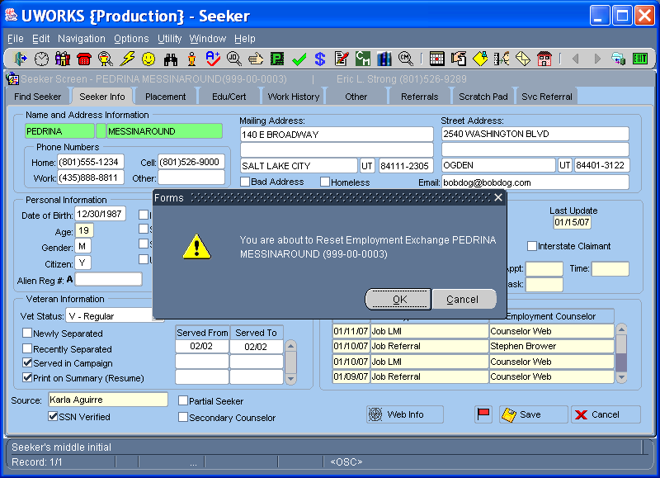

Reset Employment Exchange will allow the worker to set the job seekers active date to today’s date. Searches are done by “Last In First Out” so resetting the seekers employment exchange will help this seeker come up higher in the search results.

UWORKS SEEKER OPTIONS: Activate/Inactivate Case Management
Version 1/20/07

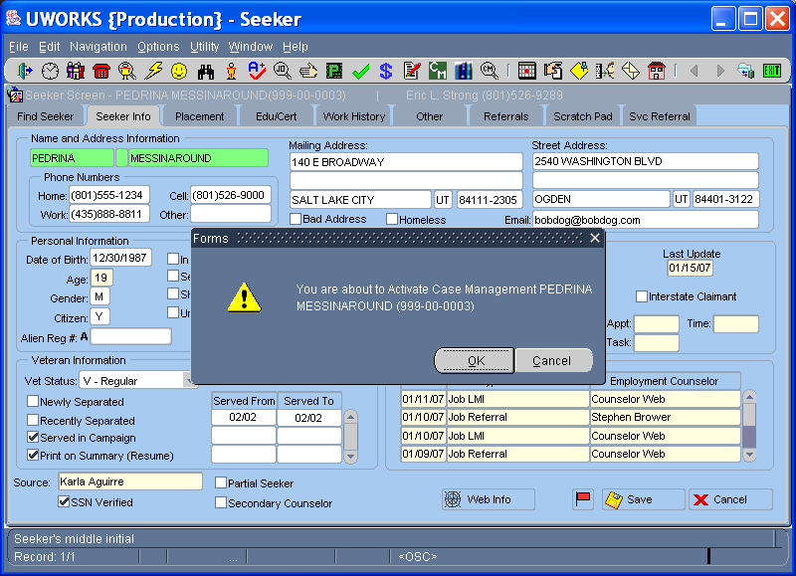

Activate/Inactivate Case Management Seeker will allow the worker to inactivated active case-managed seekers or activate inactive case-managed seekers.

UWORKS SEEKER OPTIONS: Red Flag
Version 1/20/07

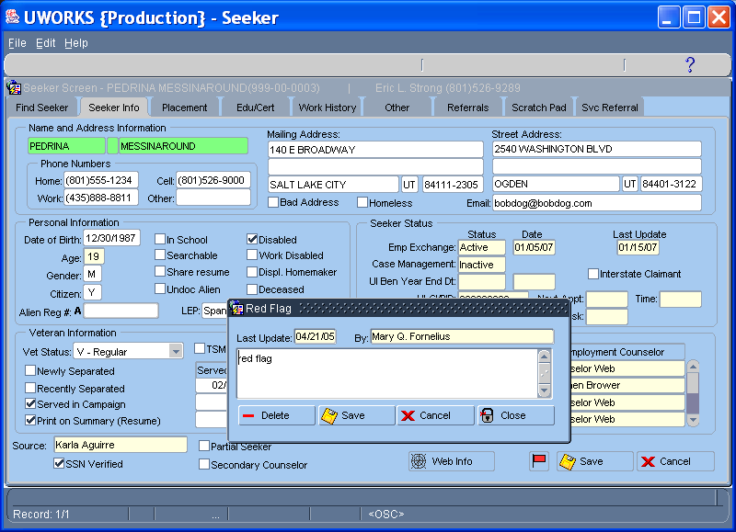

Red Flag is used to set special alerts on seeker records. When the flag is set the Red Flag icon will display at the bottom of the Seeker Info screen next to the Save button.
- The Red Flag can be modified or deleted by clicking on the Red Flag icon.
- If customer is case-managed, task will be sent to the worker’s supervisor

UWORKS SEEKER UTILITY: Information Cards

Version 1/20/07

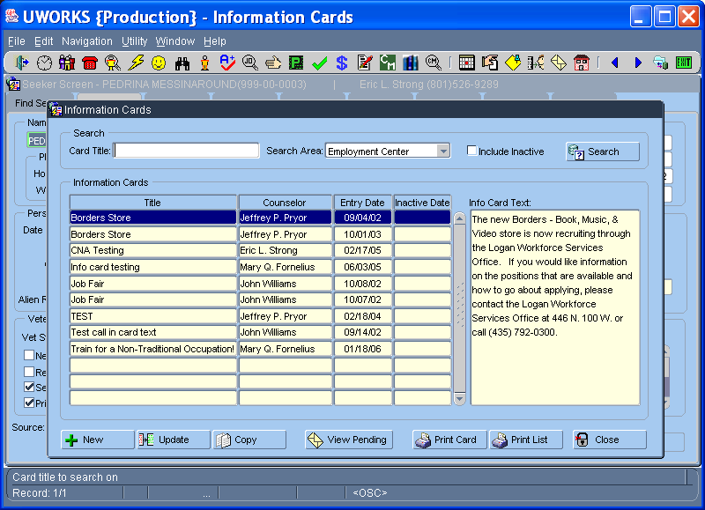

The Information Cards utility is used to find an existing information card or create a new one.
- The Search section allows the worker to search for an existing Information Card by Counselor, Office or Statewide.
- The list of Information Cards will show in the Information Cards section of the pop-up after a search is completed.
- Workers can create New cards, Update, or Copy existing cards by selecting the buttons at the bottom of the pop-up.
- View Pending button will display a list of all seekers that are scheduled to receive the information card

UWORKS SEEKER UTILITY: Info Card Mass Entry

Version 1/20/07

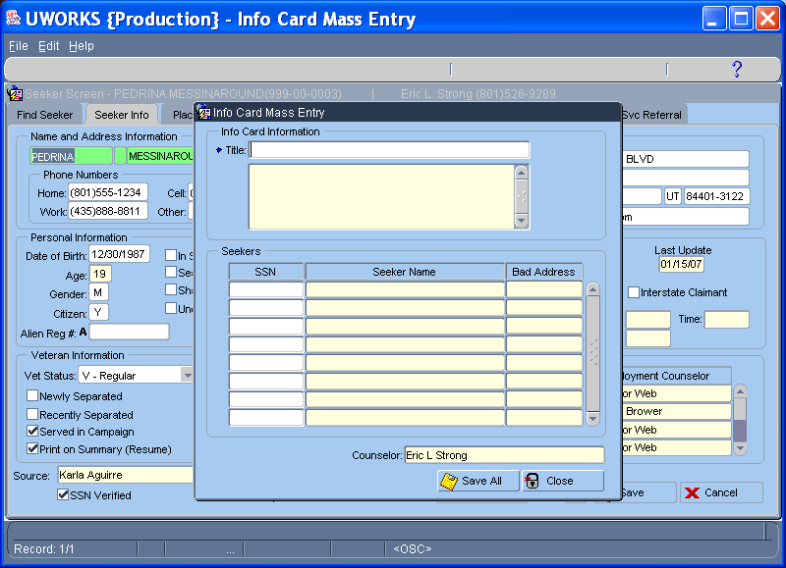

The Info Card Mass Entry utility is used to add multiple job seekers to an information card.
- The desired information card can be selected from an LOV in the Title field. Double clicking this field bring up a search for the desired card. The search includes searching for cards by Counselor, Office or Statewide.
- Once the Information card is selected the worker can begin entering the SSN’s of the job seekers they want to send the information card to.
- After the SSN’s are entered the worker selects the Save All button to save the selected seekers to send the card to.

UWORKS SEEKER HISTORY: Seeker Services
Version 1/20/07

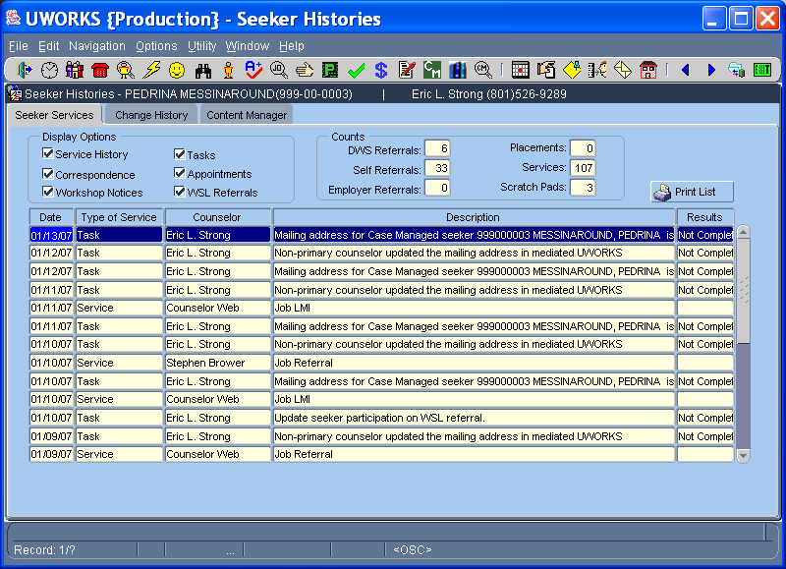

The Seeker Services tab shows a history of services provided to the job seeker.
- When Display Options check boxes are checked those services will be shown in the grid if any exist. For example if you only want to see tasks and appointments you would only have the Tasks and Appointments boxes checked.
- The Counts section allows you to see staff-assisted, Self, and Employer Referrals. You can also see Job Placements, Services and Scratch Pad counts.
- Print List allows you to print out a list of all of the services shown on the screen.

UWORKS SEEKER HISTORY: Change History
Version 1/20/07

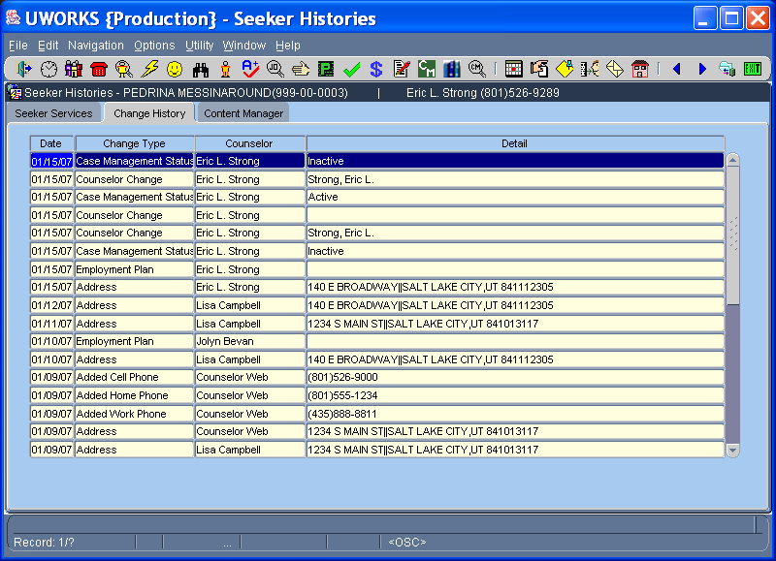

The Change History tab shows a history of some of the important changes that have been made.
- Change history will show the Date of the change, Change Type, Staff (Worker that made the change) and the Details.

UWORKS SEEKER HISTORY: Content Manager
Version 1/20/07

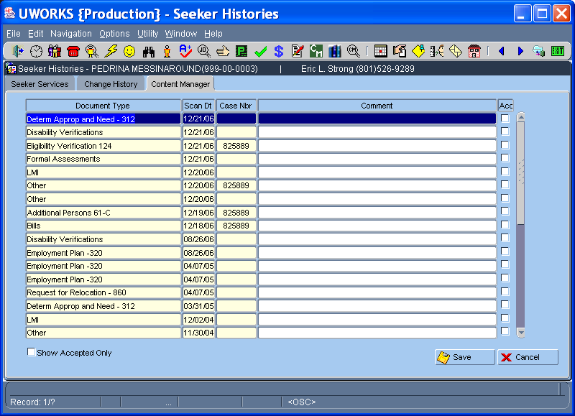

The Content Manager screen shows the documents that have been scanned into the content manager imaging system.
- Document Type shows the name of the document that was imaged, the Date it was scanned in, the eligibility Case Number and any Comments that may have been entered related to the document.
- Double- click on the document and it opens up the content manager system and displays the imaged document.

UWORKS NOTES: Notes for Seeker
Version 1/20/07

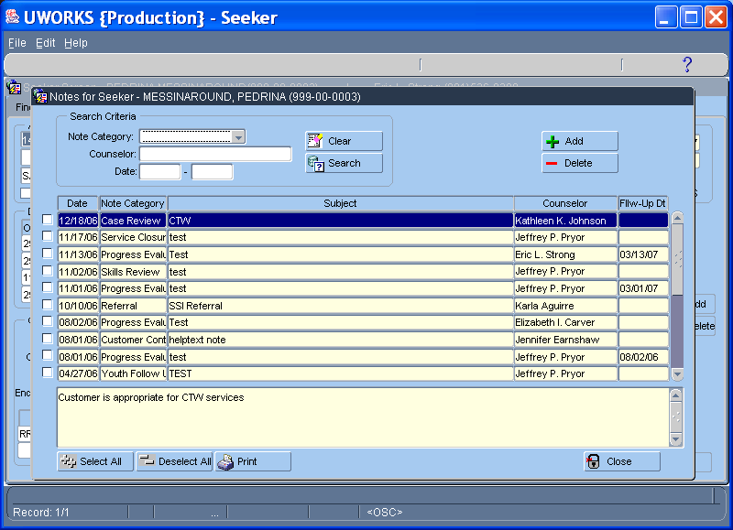

Notes are shown on a pop-up screen.
- Notes for Seeker show a History of all of the notes entered for the job seeker.
- The Category is a pull-down of the different note categories and can be used to view only the notes in a specific category.
- Workers can also search for notes by Staff (worker that entered the note) or by Date range. The Date search can be used in conjunction with the category and/or staff.
- The note text displayed below corresponds with the highlighted note.
- Workers can print notes by checking the box to the left of the note and then selecting Print.
- To create a new note from this screen click on the Add button for the Create Note pop-up.

UWORKS NOTES: Create Note for Seeker
Version 1/20/07

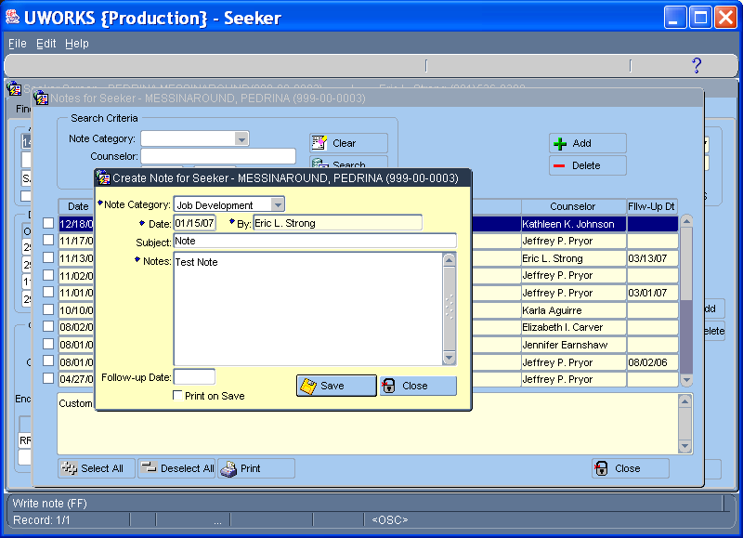

Create Note for Seeker pop-up is used to add a new note.
- To create a note select the Category from the pull-down list
- Enter the note Date (the “By” field will populate with the worker name that is logged in)
- Enter the Subject (This is a free format field)
- Type in the Note details.
- A Follow-up Date can be entered that will create a task for the worker on the date entered.
- Checking the “Print on Save” checkbox will print the note when the worker clicks on the save button.

UWORKS TESTING: Test Summary
Version 1/20/07

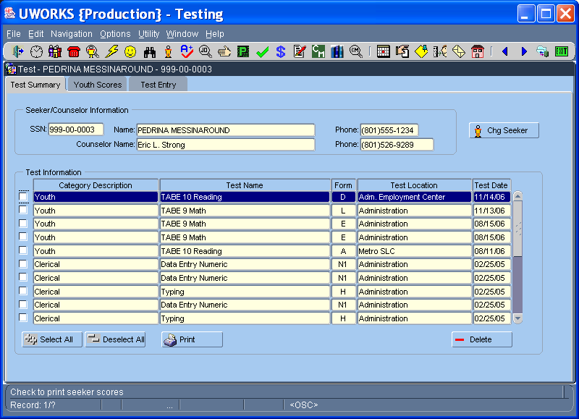

The Test Summary screen lists the tests that the seeker has taken. (Clerical Testing was removed from the system but it can be added back.)
- The Test Information section shows the Category, Test Name, Form, Location and Test Date.
- Selecting the Chg Seeker button will bring up a pop-up that will allow the worker to enter an SSN to change seekers.
- Selecting the Delete button will confirm / delete the highlighted score.
- Checking the box to the left of the test in the grid and then selecting the Print button will print out test certificate(s) for selected tests.

UWORKS TESTING: Youth Scores
Version 1/20/07

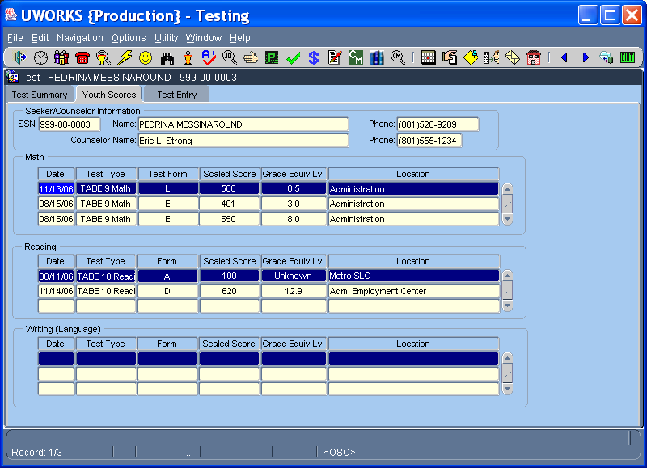

The Youth Scores tab gives detailed information about Math, Reading and Writing tests taken / entered into the UWORKS system.
- The information in of the grids shows the Date, Test Type, Form, Scaled Score, Grade Equiv Lvl and Location.
- Youth Scores allow the worker to see how the Youth customer is progressing in their Math, Reading and Writing/Language proficiency.

UWORKS TESTING: Test Entry
Version 1/20/07

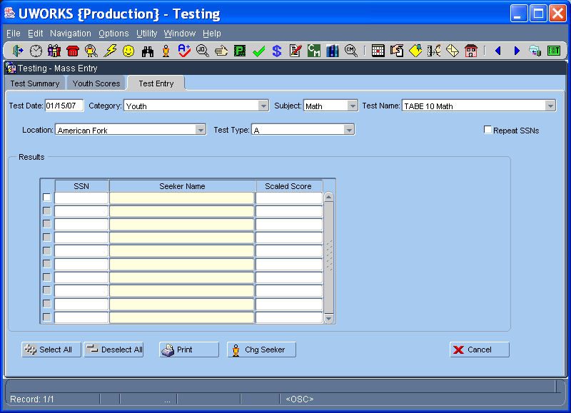

The Test Entry tab allows testers to enter scores after tests have been administered.
- To enter test scores the test category is selected from the Category pull-down.
- The test subject is selected from the Subject pull-down.
- The test name is selected from the Test Name pull-down.
- The Location defaults to the office of the worker logged in but can be changed.
- The test type is selected from the Test Type pull-down.
- Repeat SSN’s check box allows the worker to enter several different tests without having to retype the seeker SSN.
- Enter Test scores by typing the seeker SSN and then entering the scores.
- Checking the box to the left of the test in the grid and then selecting the Print button will print out test certificates.

UWORKS EMPLOYER: Emp Query
Version 1/20/07

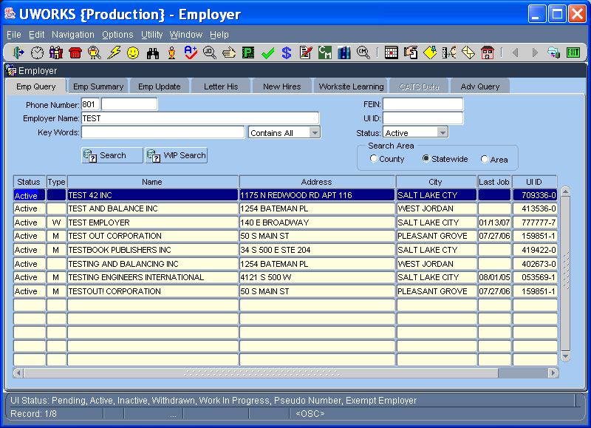

The Employer Query screen is used to find employers or add new employers to the system.
- Search for an Employer by Phone Number, Employer Name, Key Words or entering the UI ID. You can search against active or all employers.
- Search Area can be used to search for employer records in your County, Area or Statewide.
- If the search is not a precise match, Employer Names will display in the grid. Select the one you want by double-clicking on the name or highlighting the name and selecting Enter.
- To add a new employer to the system select Add Employer button.

UWORKS EMPLOYER: Add Employer
Version 1/20/07

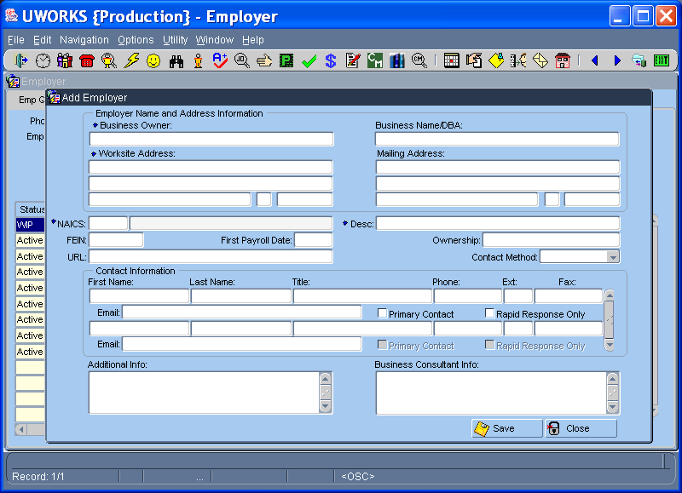

The Add Employer screen is used to enter an employer into UWORKS after determining in a search that they aren’t yet in the system.
- Required fields include Business Owner, Worksite Address, NAICS code, Status (default ‘1’), Description, and UI ID / Worksite ID.
- Additional data fields help to further clarify / define the employer information, including contact information, ownership info, and notes for future reference.

UWORKS EMPLOYER: Emp Summary
Version 1/20/07

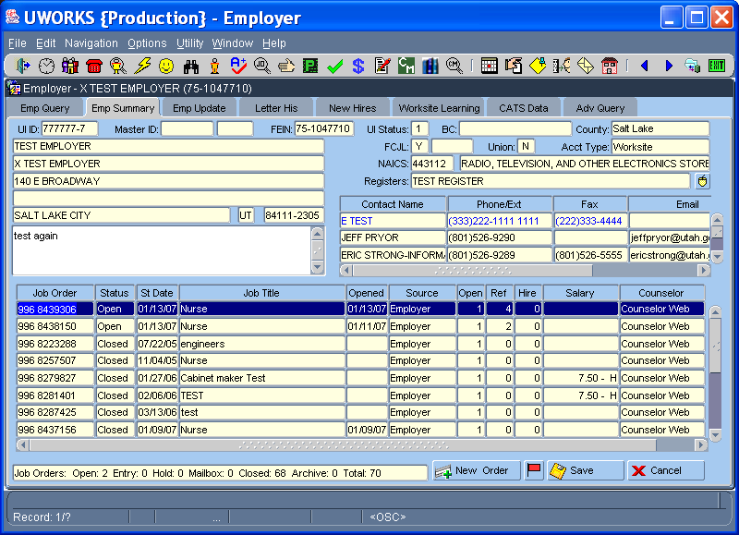

The following information is found on the Employer Summary tab:
- Employer Name, DBA Name (doing business as), Address, and Employer Contact information.
- The grid displays all job orders listed under the employer record.
- The job order info includes Job Order Number, Status, Start Date, Job Title, Opened Date, Source, Number of Openings, Number of Referrals, Number of Hires, Salary Offered and the worker Assigned.
- The counts at the bottom of the screen show the number of job orders in each status type.
- New Job Orders can be created from this screen by selecting the New Order button.

UWORKS EMPLOYER: Emp Update
Version 1/20/07

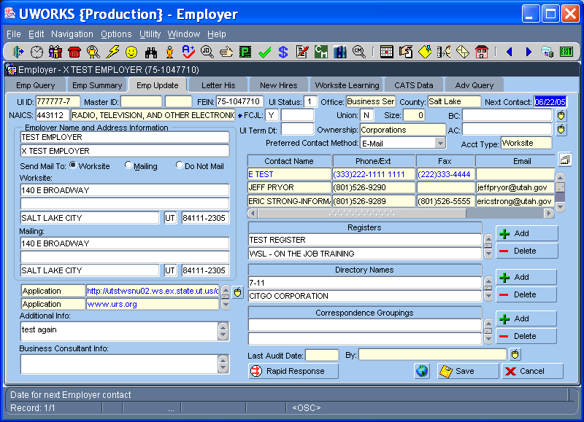

Emp Update allows you to add information to the employer record or make changes to the information.
- Employer Name, DBA name, Worksite Address and Mailing Address is found in the Employer Name and Address Information.
- Several different employer URL’s can be entered.
- A list of Employer Contacts is shown but to change or add contacts click the small button next to contacts.
- Employers can be added to Registers, Directory Names and Correspondence Groupings.
- The Rapid Response button brings up the Rapid Response pop-up.

UWORKS EMPLOYER: Employer Notes
Version 1/20/07

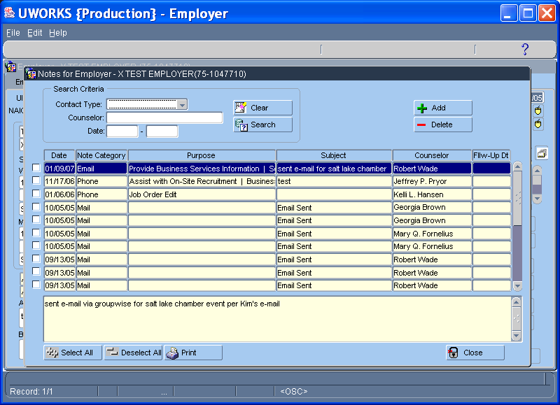

Notes are shown on a pop-up screen.
- Notes for Employer show a History of all of the notes entered for the job seeker.
- The Contact Type is a pull-down of the different note types and can be used to search only the notes in a specific category.
- Workers can also search for notes by Staff (worker that entered the note) or by Date range. The Date search can be used in conjunction with the category and/or staff.
- The note text displayed below corresponds with the highlighted note.
- Workers can print notes by checking the box to the left of the note and then selecting Print.
- To create a new note from this screen click on the Add button for the Create Note pop-up.

UWORKS EMPLOYER: Create Employer Note
Version 1/20/07

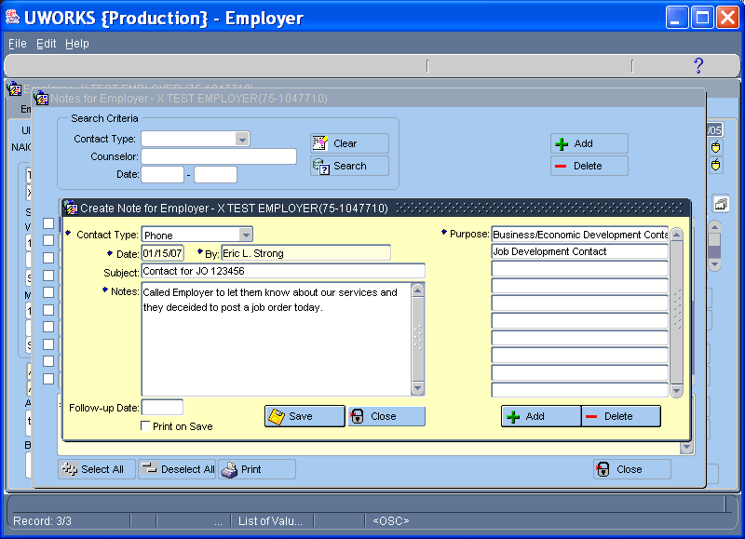

Create Note for Employer pop-up is used to add a new note.
- To create a note select the Contact Type from the pull-down list
- Unless ‘Note Only’ selected, system will require Purpose(s) (of the contact) to be entered
- Enter the note Date (the “By” field will populate with the worker name that is logged in)
- Enter the Subject (This is a free format field)
- Type in the Note details.
- A Follow-up Date can be entered that will create a task for the worker on the date entered.
- Checking the “Print on Save” checkbox will print the note when the worker clicks on the save button.

UWORKS EMPLOYER: Emp Update: Contacts
Version 1/20/07

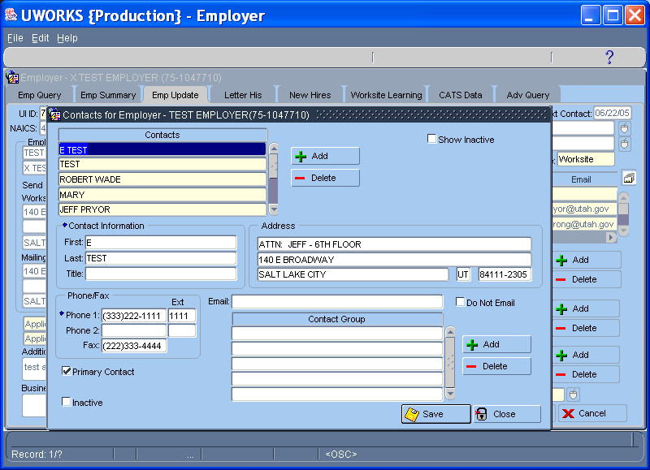

Emp Update Contacts pop-up allows you to add new employer contacts or make changes to the contact records.
- Highlight the contact name in the Contacts list to see all of the contact information in the other sections.
- Click the Add button to add a new employer contact.
- Contact information includes Name, Address/email, Phone Numbers and Fax Number.
- The contact can be added to a Contact Group.

UWORKS EMPLOYER: Emp Update (Rapid Response)
Version 1/20/07

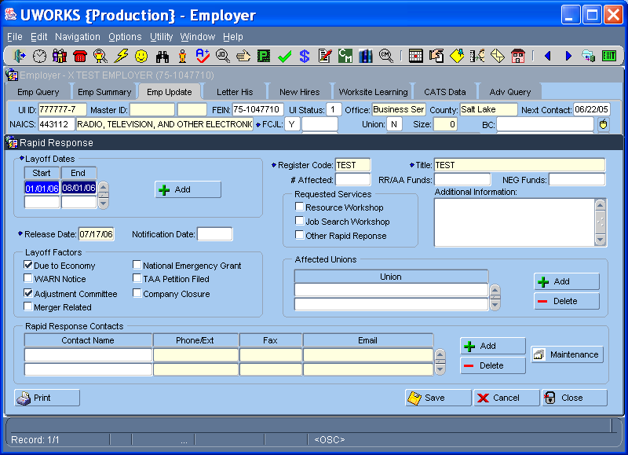

Rapid Response is used to quickly assess / resource pending layoffs of employees by the employer.
- Key date(s) are specified along with Layoff Factors and Rapid Response contacts
- Registers are created/attached to the employer and seekers that are affected
- Services to be provided the employer are also specified along with affected unions

UWORKS EMPLOYER: Letter History
Version 1/20/07

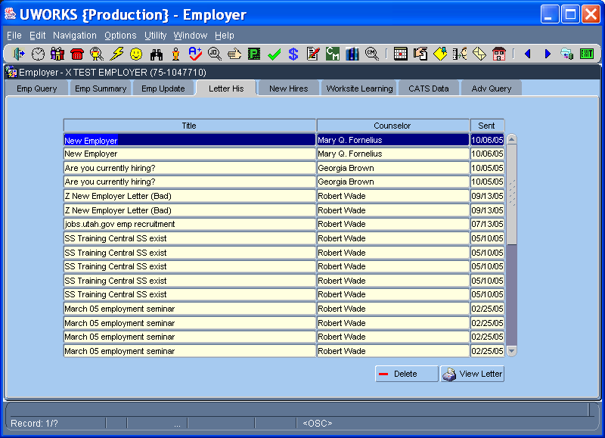

Employer Letter History shows a history of all of the letters sent to the employer.
- The letter Title, Counselor that created the letter, and date Sent are displayed in the grid.
- Highlighting and double-clicking on the letter or selecting the View Letter button will bring up a display the actual letter.

UWORKS EMPLOYER OPTIONS: Employer Letters
Version 1/20/07

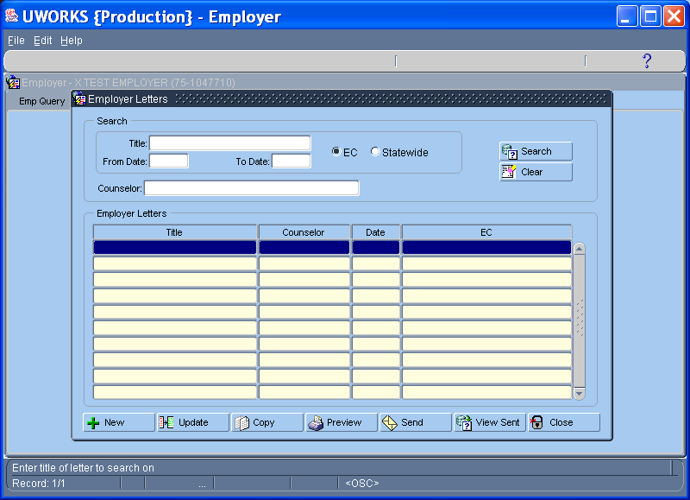

Employer Letters popup is used to create (new letter), update, copy, & select letters to send to employers.
You can also do the following:
- Search for letters by title, date range, counselor, and/or assigned office (or statewide).
- Search returns the Title, Counselor, Date, & EC where the letter is “assigned”
- User can view a list of employers to whom the letter was sent

UWORKS EMPLOYER OPTIONS: New Letter Pop-up
Version 1/20/07

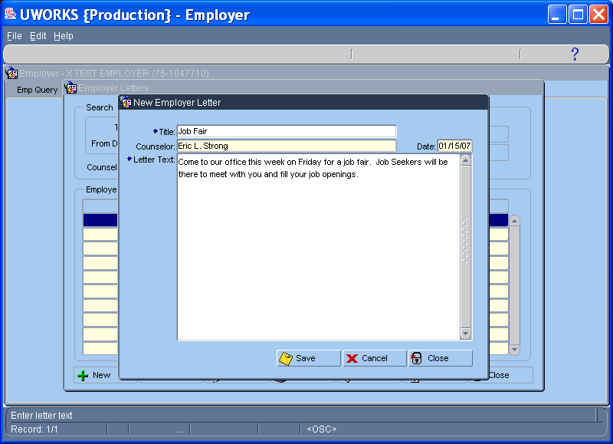

New Employer Letter popup (comes up when “New” is selected) allows you to create a new letter
- Enter title of Letter in Title provided
- Counselor name/Date will be auto-filled (based person logged into the system)
- Enter Letter Text to be sent to the employer

UWORKS EMPLOYER: New Hires

Version 1/20/07

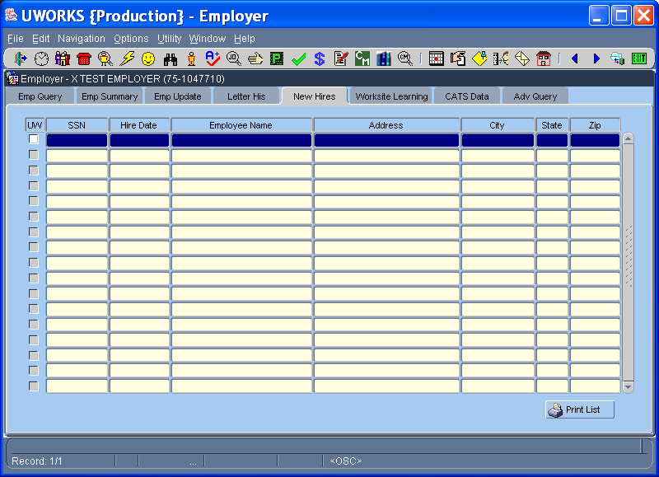

The New Hires screen is used to find Job Seekers that this employer has hired. Seekers are added to the screen through an interface process with the state New Hire listing.
- When this employer hires a job seeker it will show some of the seekers basic information.
- If the Job Seeker is in the UWORKS system the “UW” box next to the seekers SSN will be checked.
- Double clicking on the seekers name will take you to the Seeker Info screen in UWORKS.

UWORKS EMPLOYER: Worksite Learning (Agreement)
Version 1/20/07

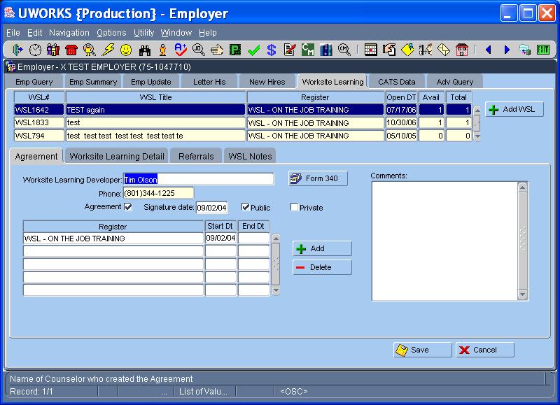

Worksite Learning (WSL) is a special program providing opportunities to receive training on work readiness or work skills that takes place in an employer’s place of business.
- Agreement must first be completed and signed by the employer
- Register(s) are set to indicate employers participating in the WSL program

UWORKS EMPLOYER: Worksite Learning (Worksite Learning Detail)
Version 1/20/07

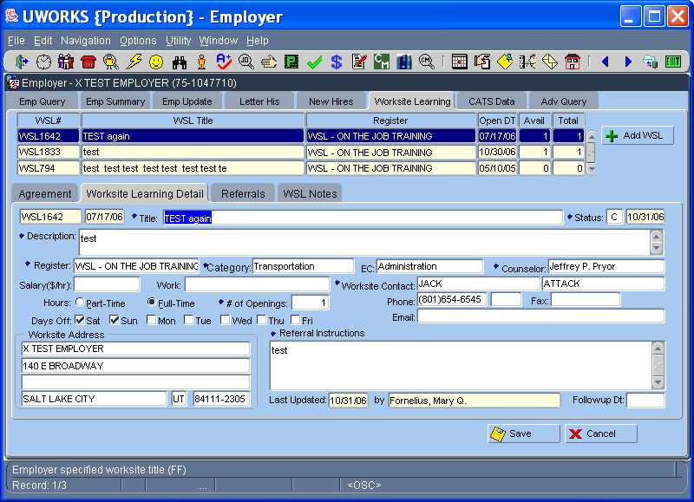

Worksite Learning Detail is used to detail WSL orders entered for potential referrals
- Criteria for potential “trainees” is specified in the indicated fields

UWORKS EMPLOYER: Worksite Learning (Referrals)
Version 1/20/07

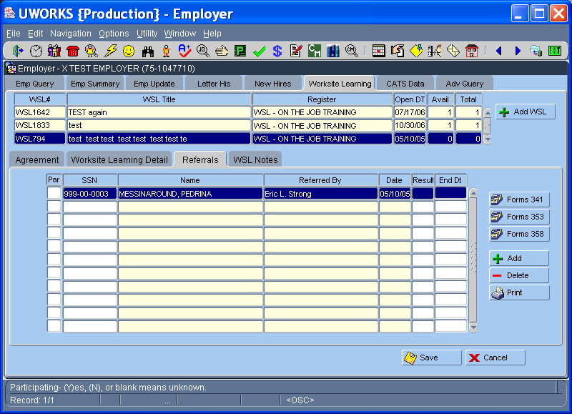

WSL Referrals allows user to enter “trainees” that have been referred to the WSL site
- Grid shows listing of individuals that have been referred
- Participation field affects # of “positions” available for the job
- Result / End Date ends user participation and re-opens available position(s)

UWORKS EMPLOYER: Worksite Learning (Notes)
Version 1/20/07

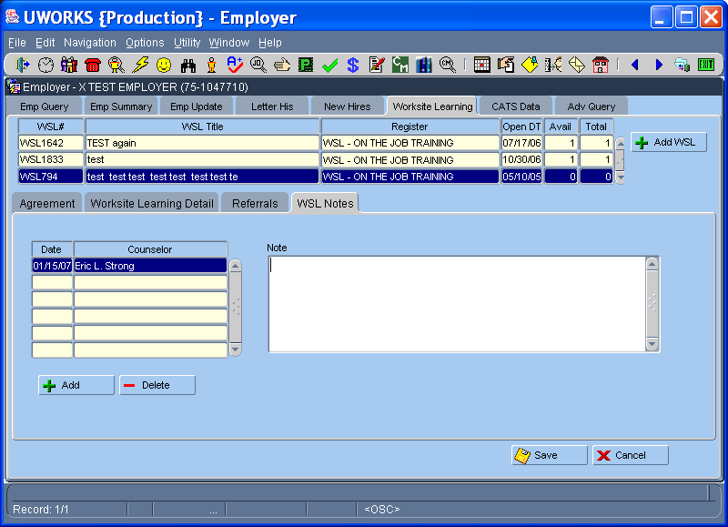

WSL Notes is used to document information about the worksite learning job and employer
- Starting a Note will auto-enter Date and Worker name
- Enter details of meeting/job in the Note field

UWORKS EMPLOYER: Adv Query
Version 1/20/07

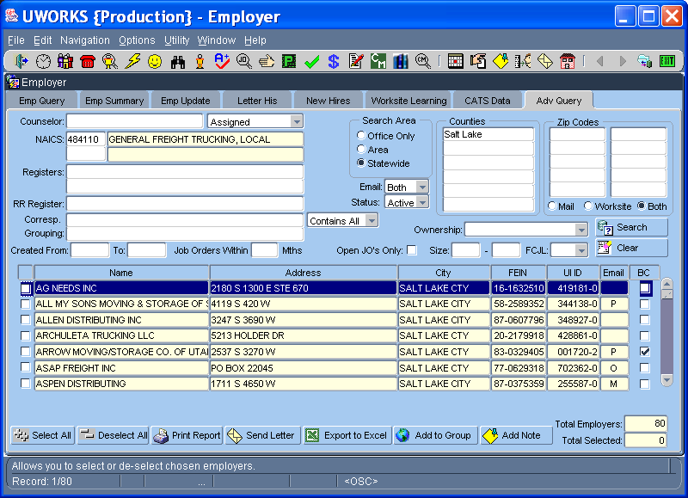

The Employer Adv Query tab is an advanced search screen to help workers find employer records using different criteria.
- Search for employers using Assigned Staff, NAICS, Registers, Rapid Response Register, Correspondence Groupings, Date Range, Ownership, Employer Size Range and FCJL.
- Searches can also be done using the Search Area options, Counties and Zip Codes.
- Using the check boxes, the worker can select employers to send Letters, Print Report(s), or Export (list) to Excel.
- Selected employers can also be added to Correspondence Grouping(s).
- Employer Notes can also be added to the selected employer records.

UWORKS EMPLOYER UTILITY: Correspondence Groupings
Version 1/20/07

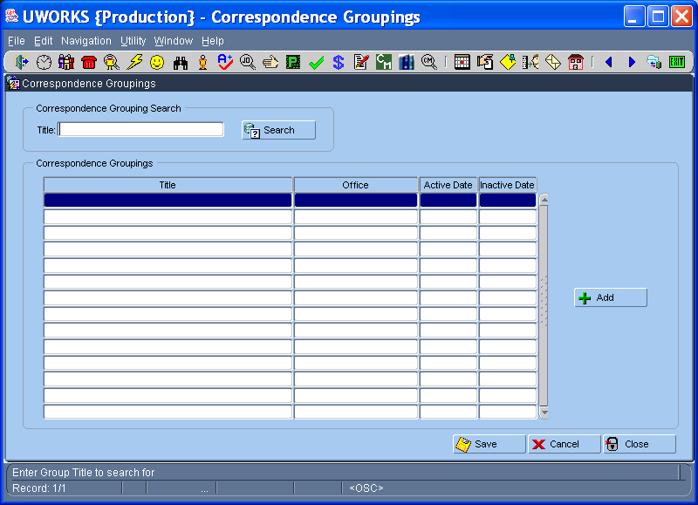

Correspondence Groupings are used to “group” employers into specified classifications for later correspondence. Using the utility, user can:
- Search for groupings based on title
- See Title of the grouping and Office where it is assigned
- Add to existing list of groupings

UWORKS EMPLOYER UTILITY: Registers
Version 1/20/07

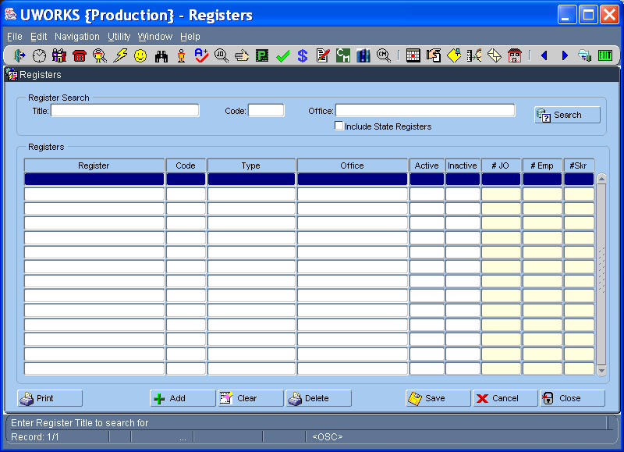

Registers utility allows user to list registers in the system based on specified criteria (Title, Code, Office, and/or Statewide indicator). Registers listed include:
- Register name, Code, and Type of register (LOV).
- Office to which it is assigned is also shown (blank indicates statewide register).
- Form also shows total job orders, employers, and seekers that have register assigned

UWORKS JOB ORDER: Employer Query
Version 1/20/07

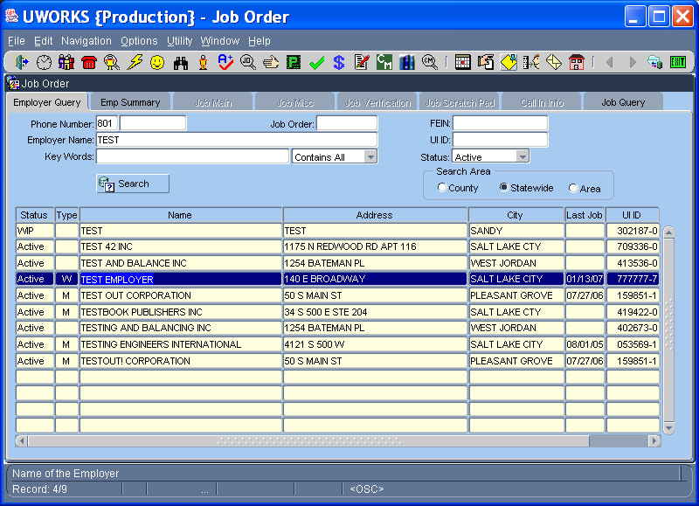

The Employer Query screen (in Job Order) is used to find employers and corresponding job orders in the system.
- Search for an Employer by Phone Number, Employer Name, Key Words or entering the UI ID. You can search against active or all employers.
- Search Area can be used to search for employer records in your County, Area or Statewide.
- If the search is not a precise match, Employer Names will display in the grid. Select the one you want by double-clicking on the name or highlighting the name and selecting Enter.

UWORKS JOB ORDER: Employer Summary
Version 1/20/07

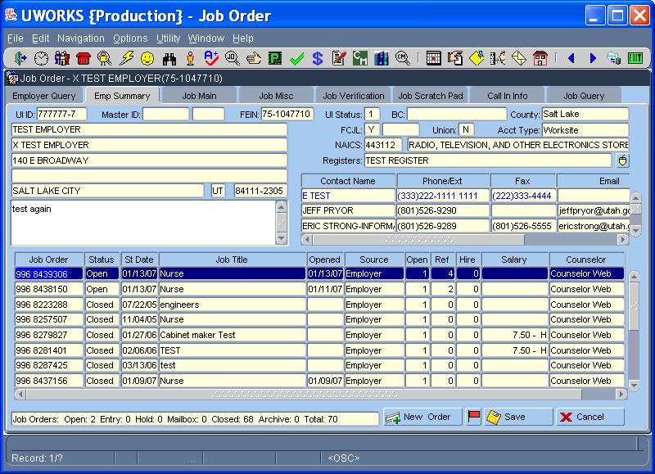

The following information is found on the Employer Summary tab:
- Employer Name, DBA Name (doing business as), Address, and Employer Contact information.
- The grid displays all job orders listed under the employer record.
- The job order info includes Job Order Number, Status, Start Date, Job Title, Opened Date, Source, Number of Openings, Number of Referrals, Number of Hires, Salary Offered and the worker Assigned.
- The counts at the bottom of the screen show the number of job orders in each status type.
- New Job Orders can be created from this screen by selecting the New Order button.

UWORKS JOB ORDER: Job Main
Version 1/20/07

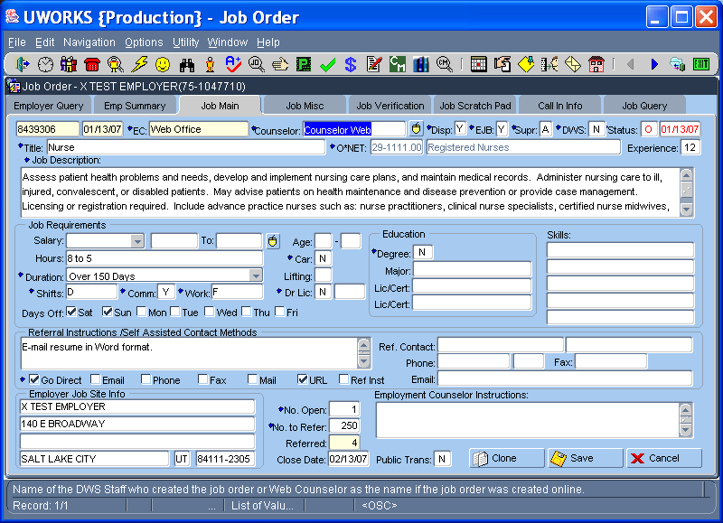

The following information is found on the Job Main tab:
- Primary Job Requirements, Referral Instructions, Contacts and Employment Counselor Instructions are entered on this page. The majority of job orders entered can be completed using only this screen.
- When creating new job orders the other job order tabs will not be available until job order is saved.
- Selecting the Clone button will allow you to clone existing Job Orders.

UWORKS JOB ORDER: ONET Search
Version 1/20/07

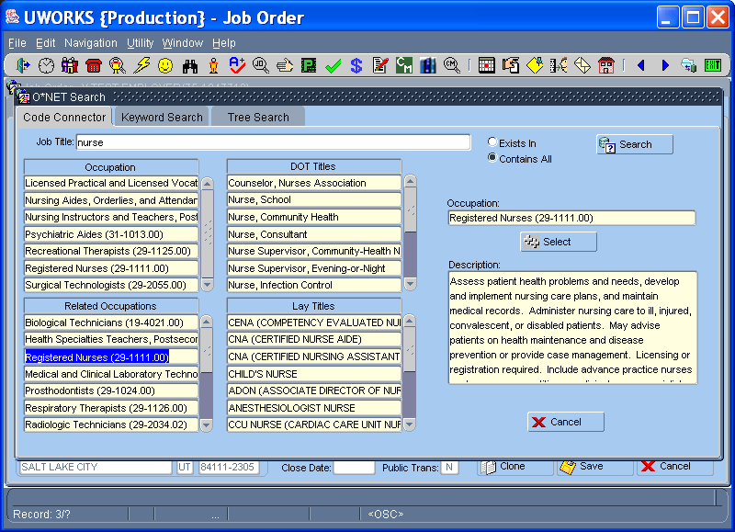

A major part of completing the Job Order is selecting the correct ONET Job Title. The ONET Search pop-up helps you select the correct ONET title:
- There are three different screens to help you select an ONET. The Code Connector, Key Word Search and Tree Search.
- Code Connector allows the worker to enter a job title and see Occupations, Related Occupation, DOT Titles and Lay Titles.
- Keyword search allows the worker to enter key words to help find the ONET title.
- Tree search allows workers to look for ONET’s within the ONET families using a tree.

UWORKS JOB ORDER: Open Job Order
Version 1/20/07

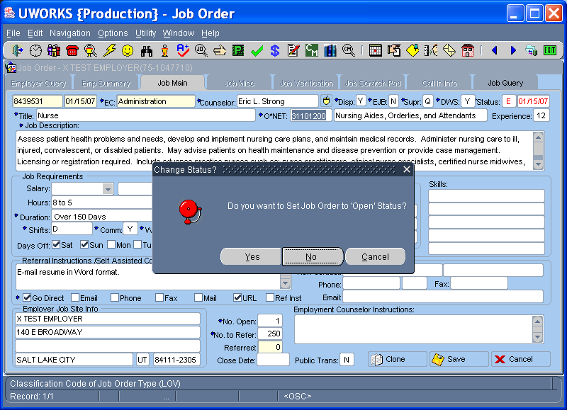

- After completing the information on the Job Main screen you will be given the option to set the Job Order status to Open.
- Selecting Yes will open the job and selecting No will set the job order status to Entry. Sometimes the job order is not ready to open until information is entered on the Job Misc screen.
- When workers have job orders in entry status the system will prompt them to finish completing the job every time they go into the job order screen.

UWORKS JOB ORDER: Job Misc
Version 1/20/07

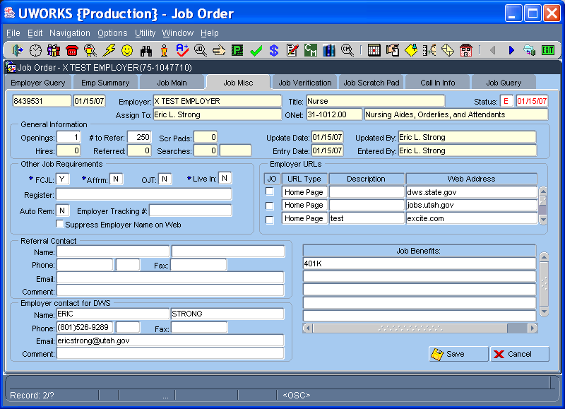

The following information is found on the Job Misc tab:
- General Information (some information is also on the Job Main screen and the other information consists of counts.)
- Misc Requirements (most of the information in the section is seldom used.)
- Testing (Very few jobs require testing but testing requirements can be entered in this section.)
- Referral Contact is the person that job seeker may contact and Employer Contact is the person the worker can contact.
- Job Benefits is used to list benefits that the employer offers to its employees.

UWORKS JOB ORDER: Job Verification
Version 1/20/07

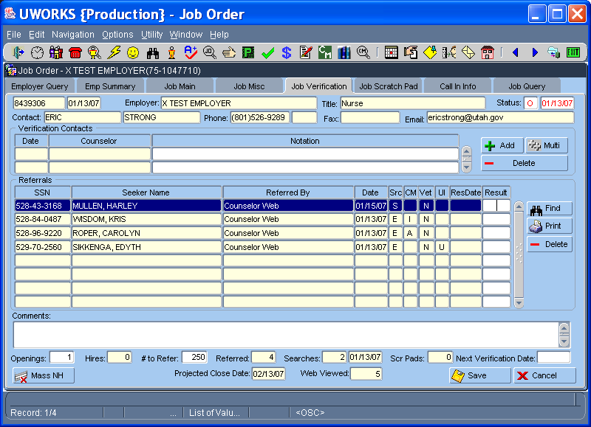

The following information is found on the Job Verification tab:
- Verification Contacts is used to enter notes about contact(s) with the employer. The Date and Staff name populate when the worker clicks in the Notification field. Enter additional notes by clicking the “Add” button.
- The Referrals section shows the job seekers that have been referred to this job. Referral information is listed in the grid. The Find button brings up an SSN/Name search to find specific seekers in the grid. Worker can post Results like “H” for hired or “NH” for not hired. Mass hires or no hires can be posted in the result field by selecting the Mass Hire and Mass NH buttons.
- The bottom section of the screen allows worker comments to be entered and lists counts related to the job.

UWORKS JOB ORDER: Job Scratch Pad
Version 1/20/07

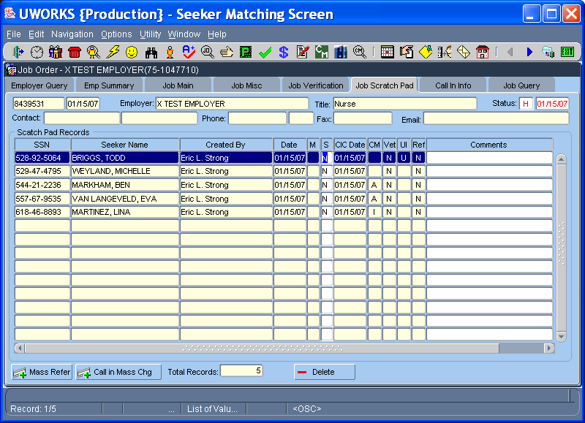

- Scratch Pad Records are listed in the scratch pad grid. Generally job seekers that are on the scratch pad will be sent call-in cards to give them job information.
- The “M” (Method) column displays “E” for email or “M” for mail.
- The “S” column shows the status of the call-in card and CIC Date shows the date the call-in card was sent.
- The “CM” column stands for Case-Managed, “Vet” stands for Veteran, “UI” stands for Unemployment and “Ref” shows if the seeker has been referred.
- All seekers in the grid can be mass-referred by selecting the Mass Refer button. The call-in card status can be changed for all seekers in the grid by selecting the Call in Mass Chg button.

UWORKS JOB ORDER: Call In Card
Version 1/20/07

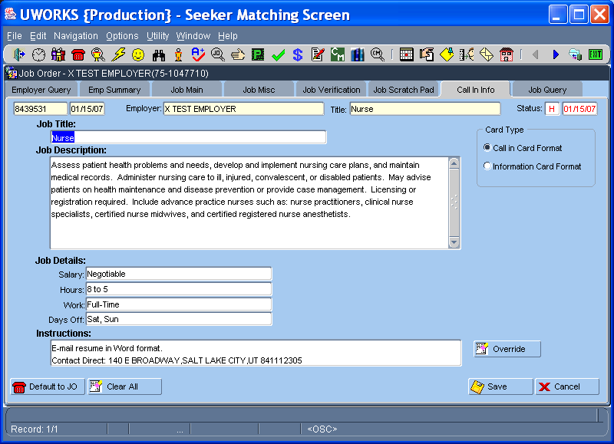

- The Call-in Card screen shows the basic information that will be sent in the call-in card. The worker can modify the information.
- The Card Type can be changed to an Information Card Format. Doing this clears all of the fields except the Job Description.
- Selecting the Clear All button will clear the call-in card information and selecting the Default to JO button will change the information back to the original call-in card defaults.
- The Override button clears the referral instructions and gives the job seeker the local office phone number to call for information about the job.

UWORKS JOB ORDER: Job Query
Version 1/20/07

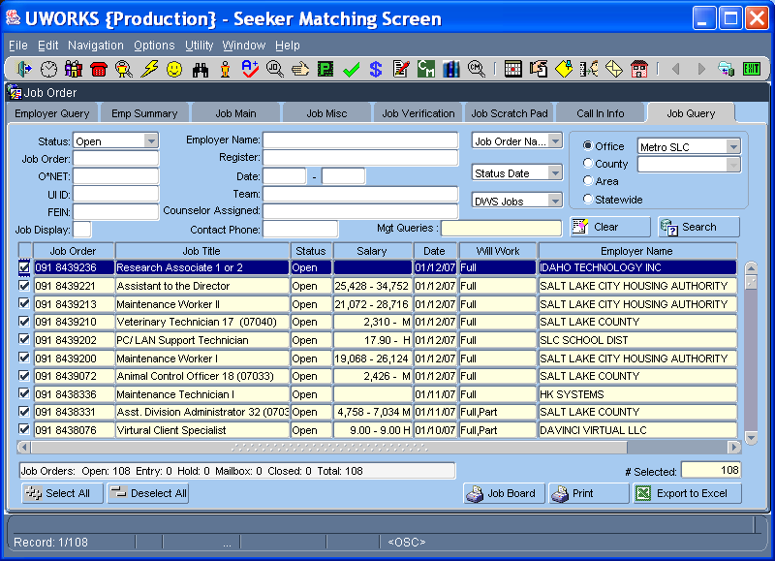

The Job Query screen is a search screen that can be used to find job orders.
- Status, Job Order Number, ONET, UI ID, Employer Name, Register, Team, and Assigned Staff can be used to do queries to find specific job orders.
- A Date Range, Office/County/Area/Statewide can be used in conjunction with the search criteria above to conduct a search.
- Using the Select All or Deselect All buttons will check or uncheck the boxes in the first column of the grid.
- Selected Job Orders can be printed and posted on office job boards by selecting the Job Board button.
- The selected list can be printed using the Print button or exported by selecting the Export to Excel button.

UWORKS JOB ORDER OPTIONS: Clone Job Order
Version 1/20/07

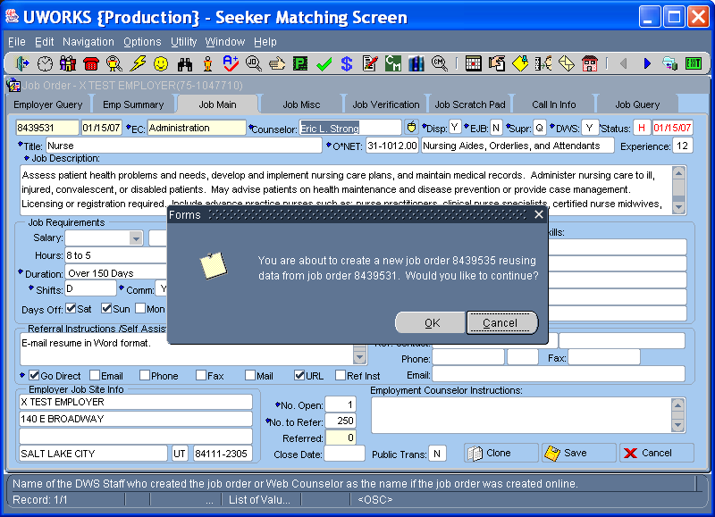

Finding a desired job order and selecting the Clone button will clone the existing job order.
- When this is done a box will pop up letting the worker know that they are creating a new job order based on the information from the old job order.
- Clicking OK will clone the information and allow the worker to make any changes before opening the job order.

UWORKS JOB ORDER OPTIONS: Job Order Mailbox (Step 1)
Version 1/20/07

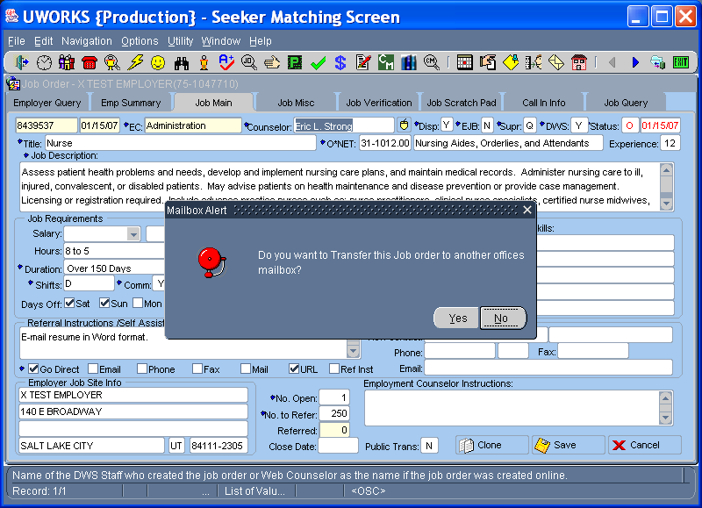

The Job Order Mailbox option allows the worker to transfer a job order from one office to another.
- When this option is selected a box will display asking if the worker would like to transfer the job to another offices mailbox.
  - Note: Job orders that have referrals or scratch pads attached cannot be mail-boxed.
- Clicking “Yes” will open the box on the following page.

UWORKS JOB ORDER OPTIONS: Job Order Mailbox (Step 2)
Version 1/20/07

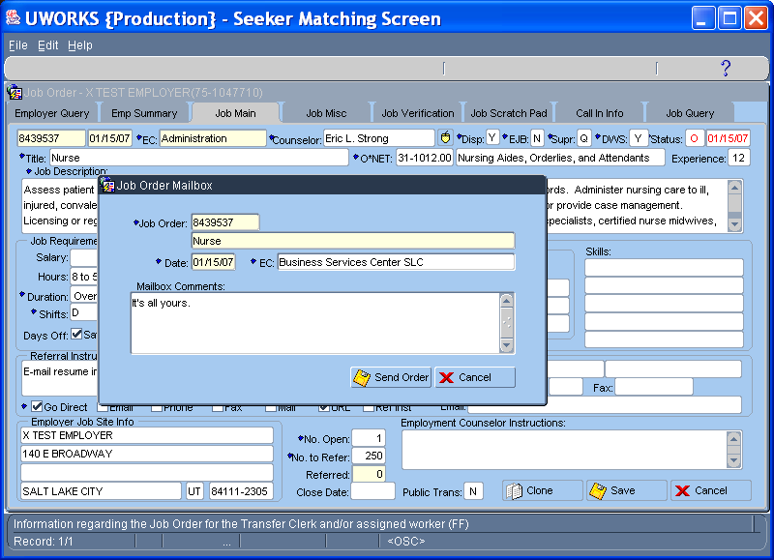

If user wants to mailbox order, selecting “Yes” will display the Job Order Mailbox popup.
- The pop-up displays the Job Order Number, Job Title and Date.
- The worker selects the Office from an office LOV in the “EC” field.
- Make Comments (if needed), then mailbox the order by pressing the Send Order button.

UWORKS JOB ORDER OPTIONS: Job Order Inbox/Outbox

Version 1/20/07

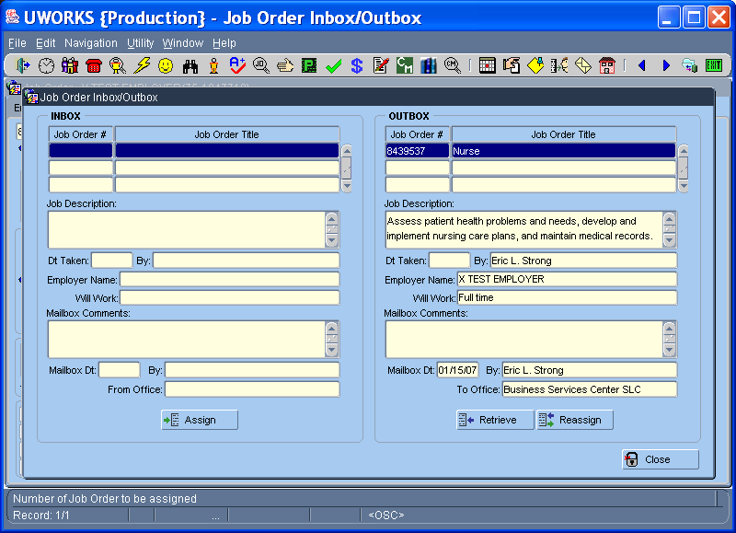

The Job Order Inbox/Outbox is used to Retrieve / Assign / Reassign job orders that have been mailboxed.

Job orders that have been mailboxed to receiving office are seen in the Inbox until they are assigned to a worker in the office
- Job orders that have been mailboxed to another office are seen in the Outbox until receiving office has assigned job order to a worker.
- Selecting Assign will allow user to select worker (LOV) to whom job order can be assigned.
- Selecting Retrieve will allow sending office to “re-acquire” the job order
- Selecting Reassign will allow sending office to “re-acquire” job order to send to a different office

UWORKS JOB ORDER OPTIONS: Qualified Seeker Count

Version 1/20/07

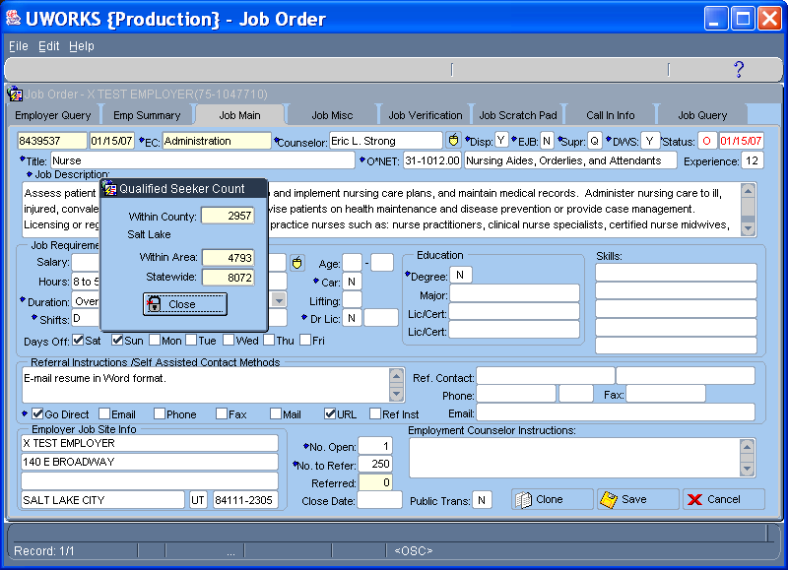

The Qualified Seeker Count is used in connection with selecting an ONET job title.
- The Qualified Seeker Count will do a search Within the County, Within the Office Area and Statewide.
- The counts will show the number of job seekers in each field that have the same ONET title as the one selected for the job.

UWORKS JOB ORDER OPTIONS: Reassign Counselor

Version 1/20/07

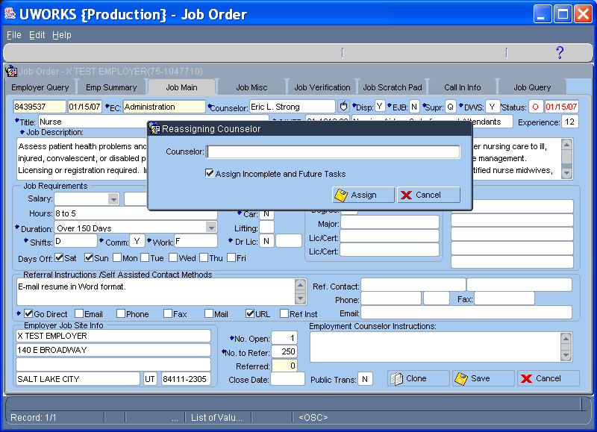

Reassign Counselor option is used to change the assigned counselor for a job order.
- To reassign the counselor enter the name or double click to bring up an LOV of counselors.
- The LOV will only have counselors within the office.
- If you want to reassign a job to a counselor outside the office, the Mailbox option will need to be used.

UWORKS JOB ORDER UTILITY: Move Job Order

Version 1/20/07

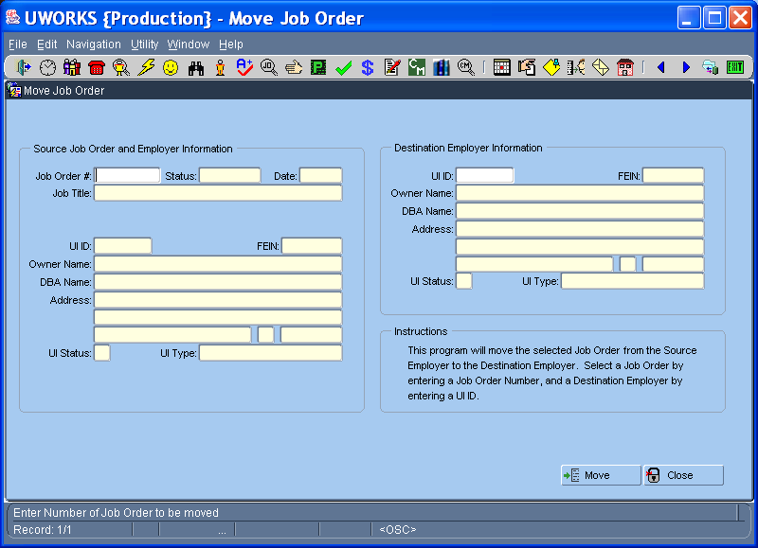

Move Job Order utility is used to move a job order from one employer to another employer.
- From the Source Job Order and Employer Information section enter the Job Order Number to be moved. When the number is entered the information in the section will populate.
- Enter the UI ID of the employer the job order will be moved to in the Destination Employer Information section. When the number is entered the information in the section will populate.
- Select the Move button and the job order will be moved from the source employer to the destination employer.

UWORKS JOB ORDER UTILITY: Delete Job Order

Version 1/20/07

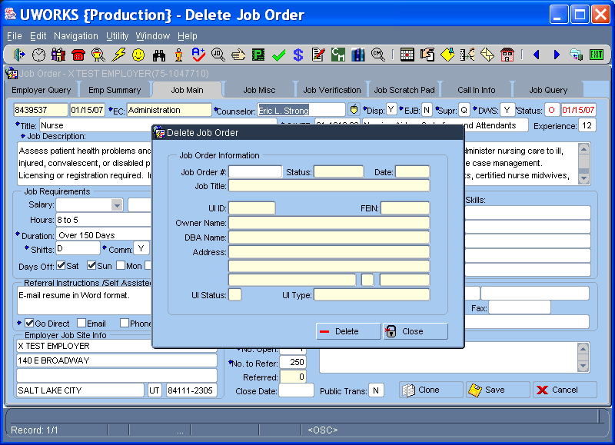

Delete Job Order utility is used to delete a job order.
- From the Delete Job Order pop-up enter the Job Order Number.
- When the number is entered the job order information will populate.
- Select the Delete button to delete the job order.
- If referrals or scratch pads are attached to this job order the job order cannot be deleted.

UWORKS JOB ORDER UTILITY: Daily Job Order Report

Version 1/20/07

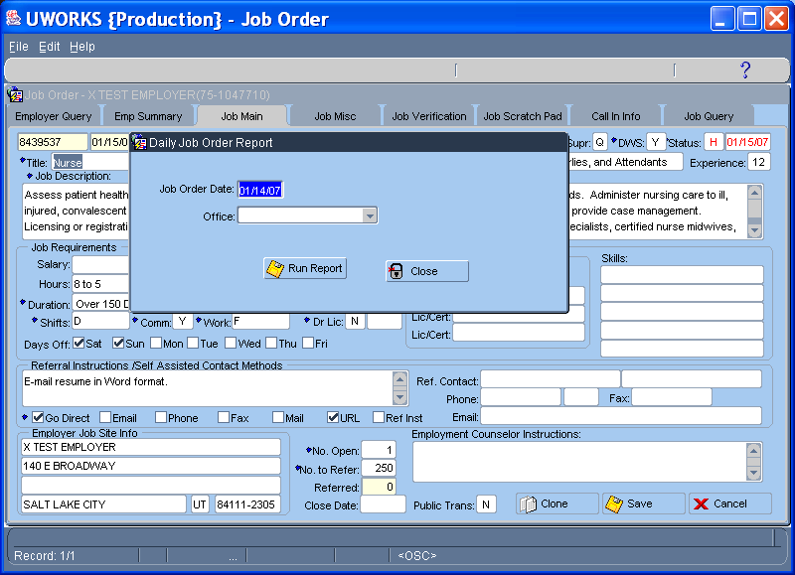

The Daily Job Order Report allows you to print a report of job orders entered in a given day.
- Enter the Job Order Date for the date desired.
- Select the Office from the pull-down list of offices.
- Select Run Report to get a printout of all of the jobs entered in the system in the office on the specified date.

UWORKS SEEKER MATCHING: Searches
Version 1/20/07

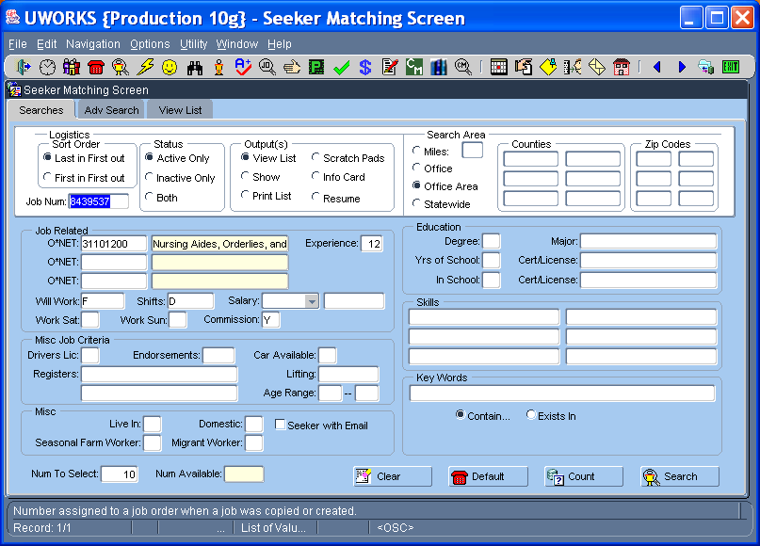

Seeker Matching Searches are used to match qualified job seekers to job orders.
- The Logistics section allows the worker to select the Sort Order, Status, Outputs and Job Num.
- Search Area is used to pick the area of the state to select job seeker from. (Miles from, Office, Area, Statewide, Counties or Zip Code)
- If a job order number is entered in the logistics section the job order details will display in the Job Related, Education, Misc Job Criteria, Skills and Testing sections.
- Information can be added, deleted, or modified in any of the search criteria fields. Modifying the fields will return either a greater or smaller number of job seekers.
- When Search is selected the number of job seekers that match the job criteria will show in the Num Available field.

UWORKS SEEKER MATCHING: Adv Search
Version 1/20/07

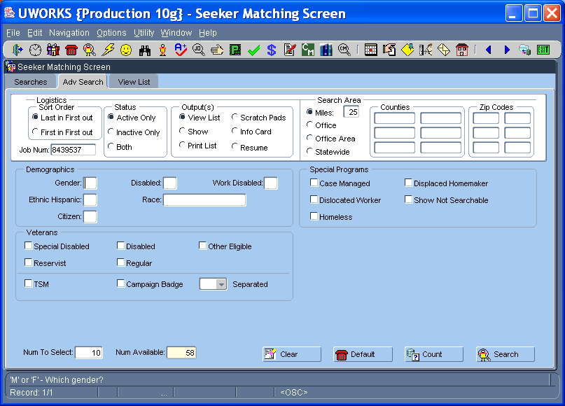

Advanced Search allows searches that are not specific to a job order.
- Search for seekers by Demographic information.
- Search for Veterans by different veteran information.
- Search for seekers using other Misc criteria or using Special Program selections.
- Combinations of search criteria can be used to find seekers you are looking for.
- The buttons on the bottom of the screen can be used to Clear the fields, change the fields back to the original Defaults, display a Count of the number of seekers the meet the criteria or show seekers that match the criteria by selecting Search.

UWORKS SEEKER MATCHING: View List
Version 1/20/07

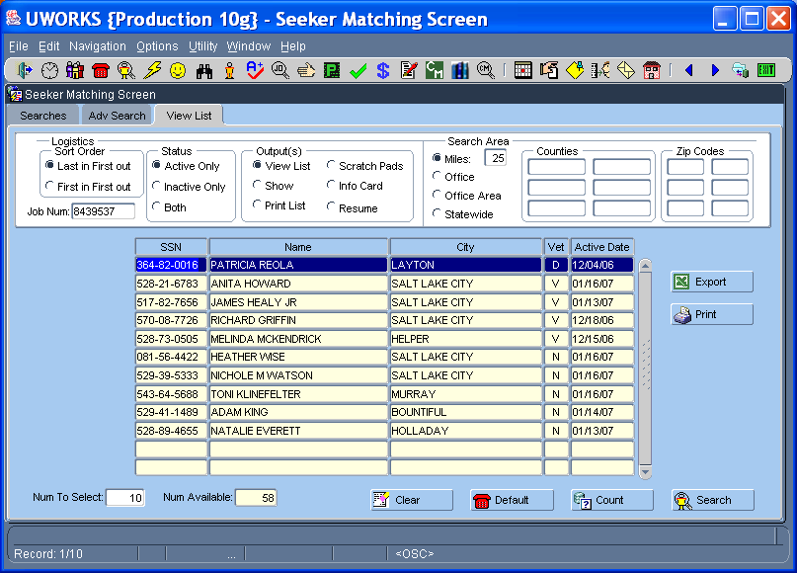

View List allows you to see the seekers that match the search criteria in the output format that was selected.
- This screen is an example of the View List output.
- Show output take you to the seeker Placement tab and you use the Blue arrows to look at seekers that meet the criteria.
- Print List is a printout of the seekers that match the criteria.
- Scratch Pads output allows seekers that meet the qualifications to be added to a job order scratch pad.
- Info Card output creates an information card for the seekers that meet the qualifications.
- Resume output allows you to look through the resumes of the seekers that meet the qualifications.

UWORKS QUICK REFERRAL

Version 1/20/07

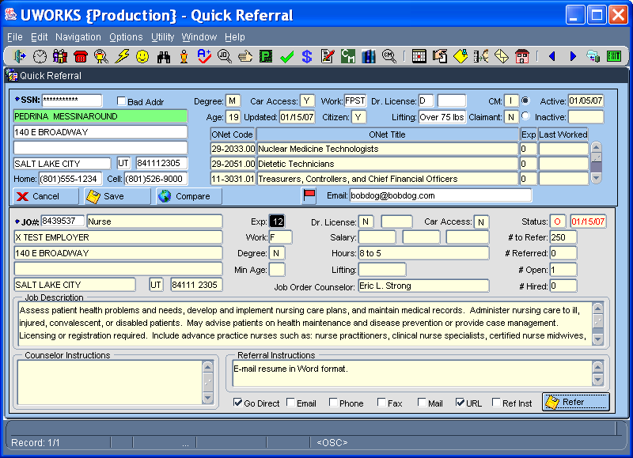

The Quick Referral is used to see if job seekers qualify for jobs and then make referrals. Often job seekers find job orders they are interested in while looking at office job boards. They will bring the job order number to an office worker to get a referral letter. The Quick Referral screen is the easiest way to do this.
- When the job seeker SSN and the JO# (job order number) are entered the seeker and job order information populates.
- The fields in the Job Order section where the job seeker does not meet the qualifications will show in Black.
- When fields in the Seeker section are changed select the Save button to save the changes.
- Click on the Compare button to see a list of all seeker information that does not match the job order qualifications.
- Selecting the Refer button will refer the seeker to this job and allow the worker to print a referral letter to give to the job seeker.

UWORKS INDIVIDUAL JOB ORDER SEARCH: Individual Job Search (Page 1)
Version 1/20/07

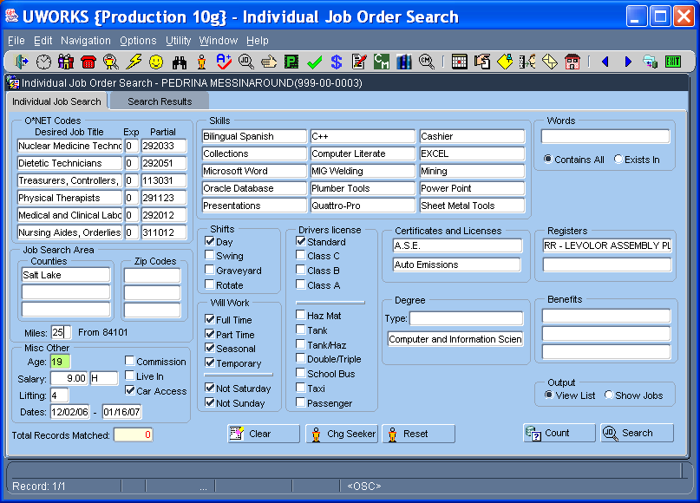

The Individual Job Order Search will help job seekers complete a custom search for jobs.
- All the fields are populated with the job seeker default information. This data comes from the seeker record.
- Searches can be done by ONET job title, Skills, Key Word searches, Shifts, Will Work, Drivers Licenses Class/Endorsements, Certificates and Licenses, Degree, Benefits, Testing, Registers and Misc Other criteria.
- Only fields that are highlighted are active as search criteria. Age is the only search criteria that auto defaults.
- Highlight/un-highlight a field by selecting F4 or Ctrl/Click (Hold down the Ctrl key and click the curser in the field.)
- Search Output results can be created by selecting View Lists or Show Jobs radio buttons.

UWORKS INDIVIDUAL JOB ORDER SEARCH: Individual Job Search (Page 2)
Version 1/20/07

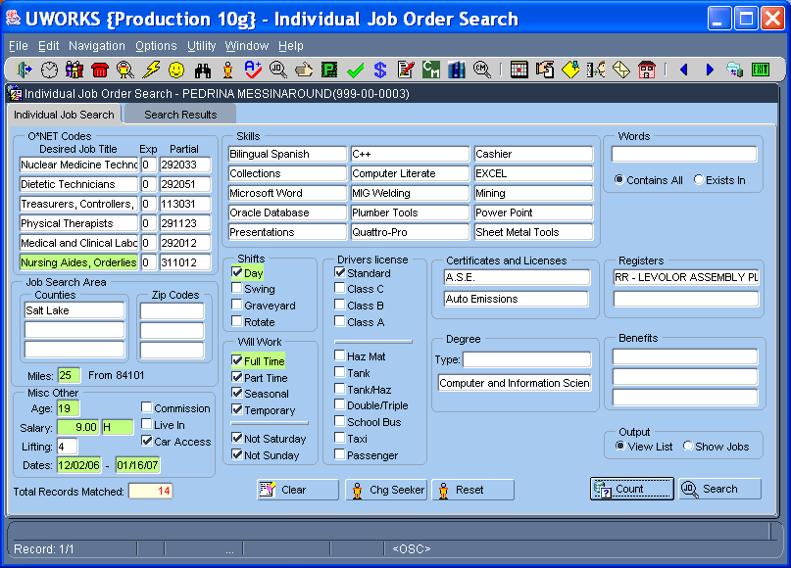

- Selecting the Clear button will clear data from all fields so searches can be done from scratch.
- Selecting the Chg Seeker button will bring up a pop-up that will allow the worker to enter an SSN to change seekers.
- The Reset button will change all information back to the original defaults.
- The Count button will do a search and show the number of matches in the Total Records Matched field.
- Selecting the Search button will do a search and open the Search Results tab.

UWORKS INDIVIDUAL JOB ORDER SEARCH: Search Results
Version 1/20/07

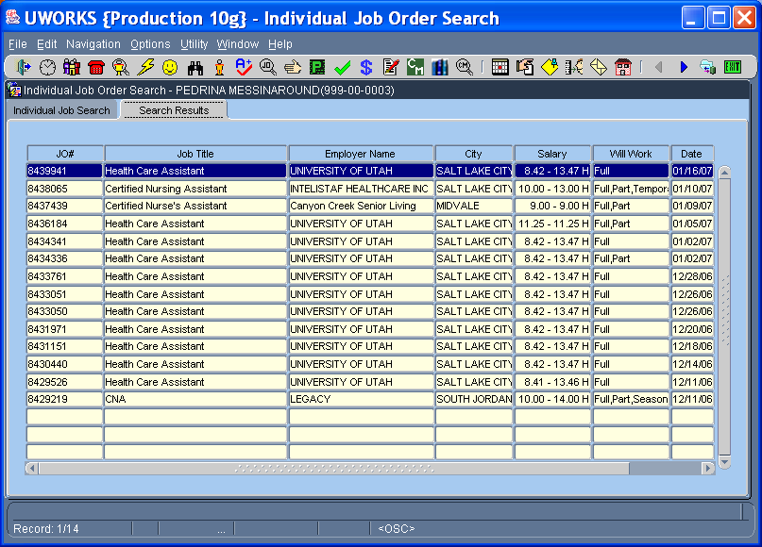

The Search Results tab will show a list of all of the job orders in the system that matched the highlighted search criteria from the Individual Job Search tab. (This is when the Output selection is View List.)
- Matching job orders are listed in the grid with limited information about the job.
- Double-clicking on the job order in the grid will open the Job Order Main screen for the highlighted job order.
- When the Output selection is Show Jobs the search results will open the first job order and then using the blue arrows will move through the job orders.

UWORKS SCHEDULE: Daily Schedule (Page 1)
Version 1/20/07

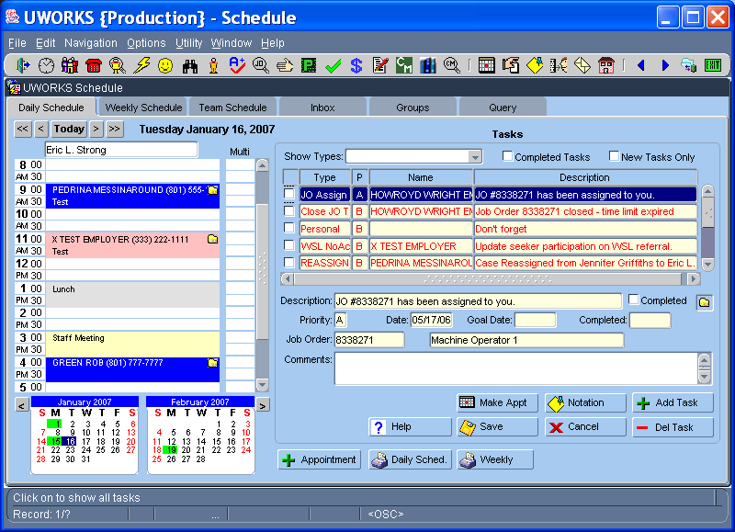

Appointment area allows user to search for / create appointment(s) in any schedule in the office. Functions include:
- Ability to overbook appointments, up to five appointments “deep”
- Ability to quickly scroll through days/weeks/months with buttons & calendars
- “Color coding” on the appointments for quick designation of type
  - Blue – Seeker | Yellow – Office | Pink – Employer | Purple – Intake | Gray – Personal (Private appears black to others) | Red – Cancelled Appointments
- Can double-click on time slot to create an appointment for that time
- Ability to link to seeker / employer / job order records from appt (folder)

UWORKS SCHEDULE: Daily Schedule (Page 2)
Version 1/20/07

Tasks area shows all “alerts” that are assigned to the worker.
- All daily/overdue tasks are shown by default (including both system/worker-generated task), but user can sort/filter list by task Types (dropdown list)
  - Overdue tasks show in red
- User can also filter listed tasks by status (Completed or New)
- Grid shows Type, Priority, Name, & Description
- There are three priorities for tasks: A – Highest importance/urgency | B – Second highest importance/urgency | C – Least importance/urgency
- User cannot delete priority ‘A’ or system-generated tasks – they must be marked ‘Completed’

UWORKS SCHEDULE: Daily Schedule (Page 3)
Version 1/20/07

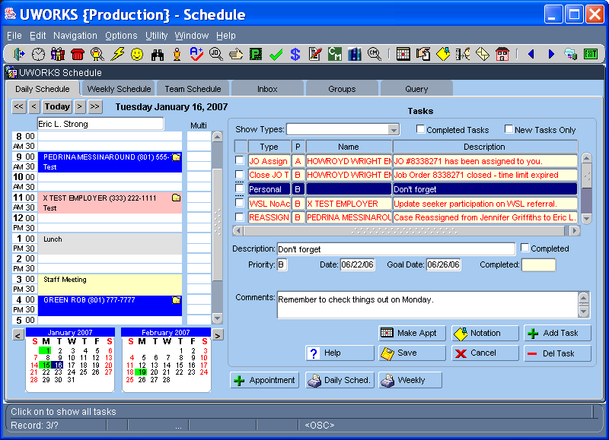

The task detail area shows all pertinent information relating to the highlighted task above, including:
- Folder that will link to seeker / employer / job order when related to it
- Priority / Date of task (non-updateable if priority A)
- Tasks can be completed in the grid or below – completed date is auto-filled
  - Note: Will show completed on date completed, NOT date due!
- Task can be “converted” to appointment or note using buttons
- Help button used to explain task type
- Buttons below to create a new appointment or print the daily / weekly schedule

UWORKS SCHEDULE: Weekly Schedule
Version 1/20/07

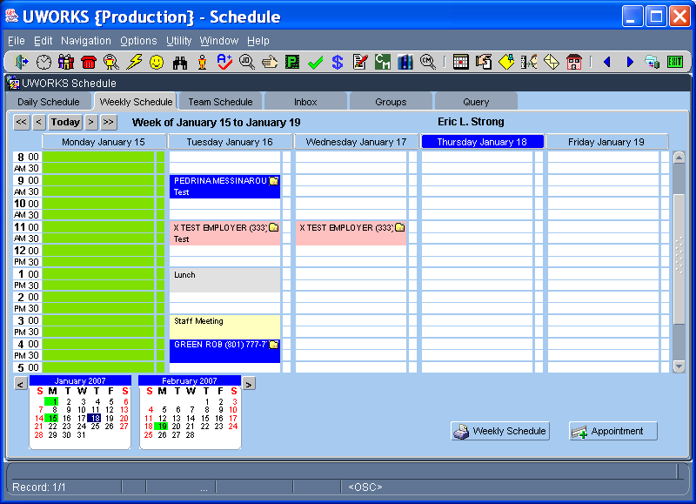

Weekly Schedule gives user ability to quickly see all appointments for the week.
- Based on worker selected, user can get a “Quick Glance” at schedule for the week
- User can also create appointments from this screen (double-click on time or use Appointment button)
- Worker has the ability to quickly scroll days/weeks/months using buttons and calendars
- User can also print a weekly calendar

UWORKS SCHEDULE: Team Schedule
Version 1/20/07

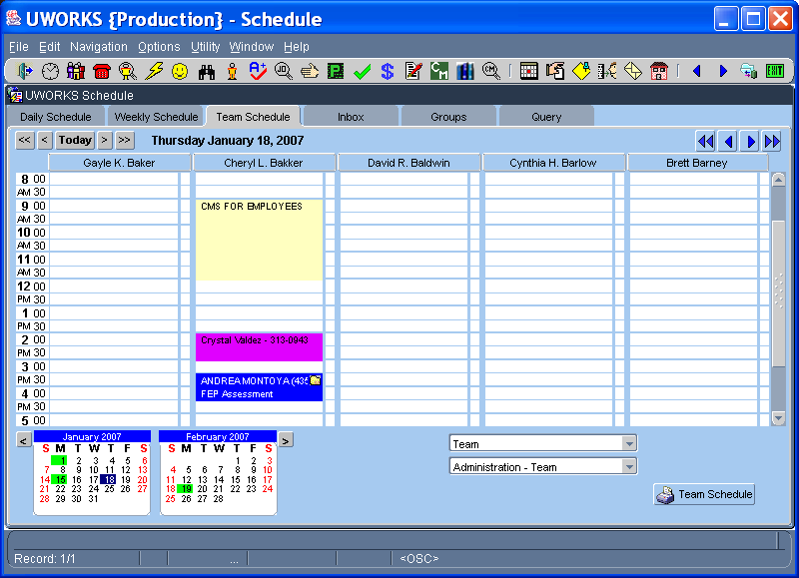

The Team Schedule tab allows user to view the daily schedule for an entire Team or group (created on Groups tab)
- Gives ability to quickly view schedule(s) for entire team(s) or group(s)
- Can also schedule appointments for team or group by double-clicking on time desired or using create appointment button
- Ability to scroll through days/weeks/months quickly with buttons & calendars
- Using blue arrow buttons, can scroll through team members individually (single arrow) or groups of 5 (double-arrow)

UWORKS SCHEDULE: Inbox
Version 1/20/07

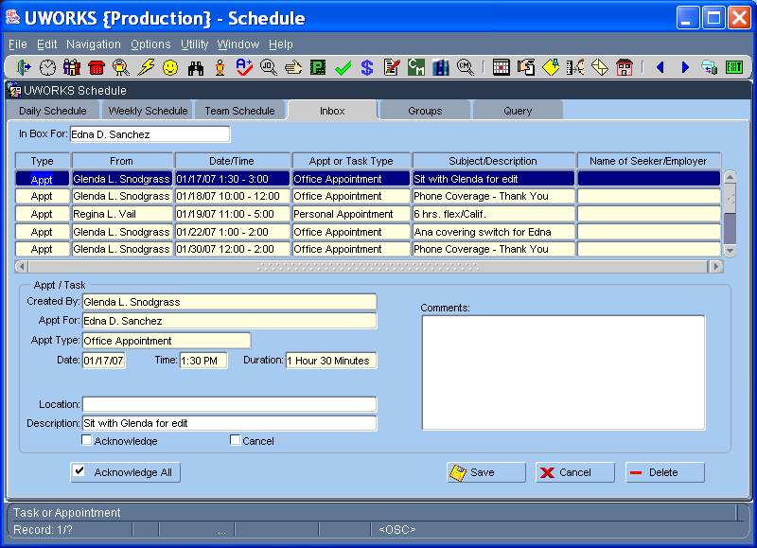

The Inbox tab is used to show user appointments / tasks made by others that have not yet been acknowledged
- Grid gives summary of appointment or task
- Detailed information for highlighted task above is displayed below
- Checkbox to acknowledge receipt of received appointments and/or tasks
  - Can acknowledge individually (checkbox in detail area) or all at one time (Acknowledge All button)
- Use Cancel checkbox to cancel the appointment listed
- When tasks / appointments are placed in the inbox, user is “informed” by displaying a special icon for scheduler
  - Shown only when not in the scheduler
- User can also delete the appointment or task using the Delete button

UWORKS SCHEDULE: Groups
Version 1/20/07

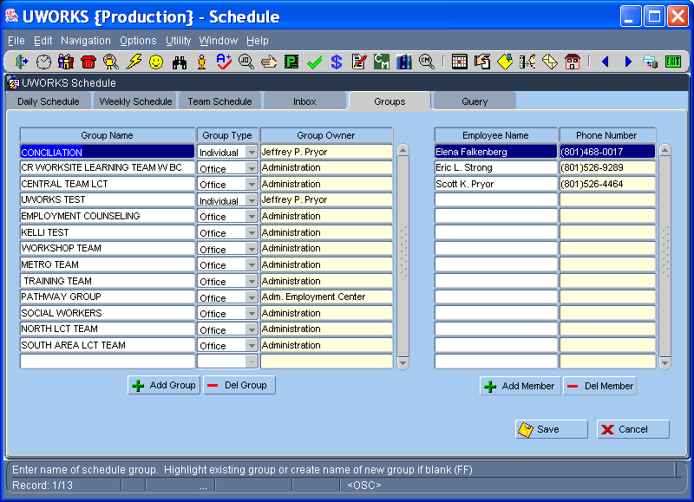
Groups tab is used to create special groupings of workers for ease in scheduling, both for office use and individually.
- After specifying a unique Group Name, user selects the Group Type.
  - Office – all users in office can see and use the group
  - Individual – only those in the group can see and use the group
- Only the Group Owner has ability to alter/delete group
  - If office group is selected, any user in the office can alter the group
- Staff are added to the group in the right grid.
  - Only users in the office can be added to the group (LOV).

UWORKS SCHEDULE: Query
Version 1/20/07

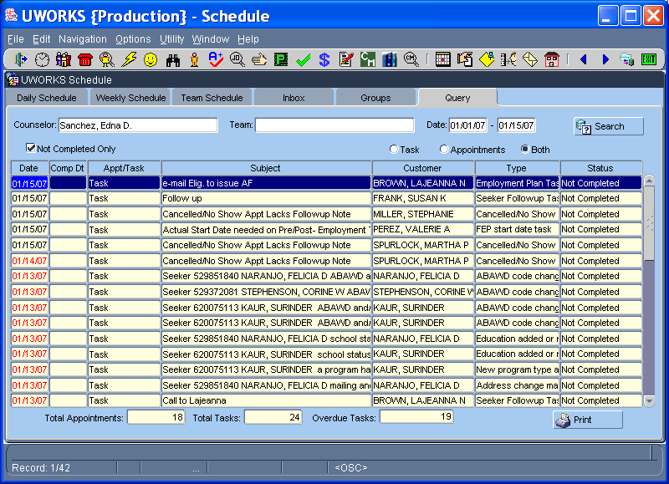

The Query tab is used to search for appointments and/or tasks based on specific search criteria.
- User can search by worker name (Staff), Team, Date range, and/or completed status (default – not completed only.)
- Appointments and/or tasks are displayed below for review.
  - User can double-click on appointment/task to bring up details in appointment/task window.
- Counts of appointments and tasks (both current and overdue) are displayed below
- User can also Print a report for a “hard-copy” of the listing

UWORKS SCHEDULE OPTIONS: Reassign Appointments and Tasks
Version 1/20/07

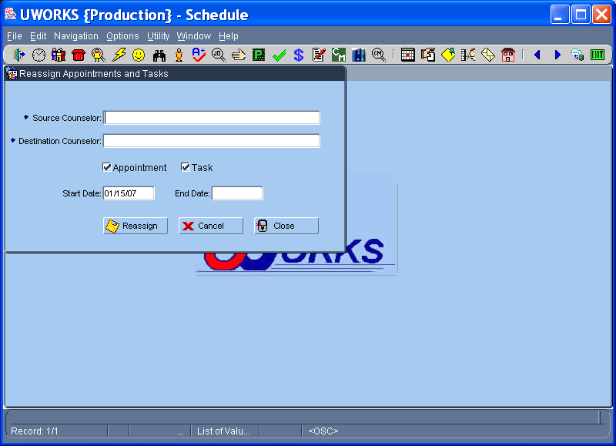

The Reassign option in the scheduler allows the worker to reassign appointments and/or tasks to another worker in the office.
- After specifying Source and Destination Staff, user selects what should be reassigned (appointments, tasks, or both) by selecting the appropriate checkbox(s).
- The Start Date and End Date are then entered to determine the range to reassign.
- Selecting the Reassign button will then reassign the appointments and/or tasks from the source worker to the destination worker.

