jobs.utah.gov

Online Services For Job Seekers



Training Guide

January 2007

Table of Contents

Jobs.Utah.Gov - Log In Page 3

Rules of Use 3

Registration Step 1 (Create Account) 4

Registration Step 2 through Step 11 4 - 10

Job Seeker / Home Page 11

Link to Additional Services 11

Change Password 12

View Job Seeker Information 12

Online Assessment 13

Job Search – Search Results – Save Searches 14 - 16

Job Seeker Referrals & Referral Printout 17 - 18

Seeker Info 19

Employment 20 - 21

Education 22

Skills/Equipment 23

Veteran 24

Login/Logout Page 25

Electronic Job Board Search 25

Forgot User Name / Forgot Password 26

On-Line Help 27

State Map & Offices 27

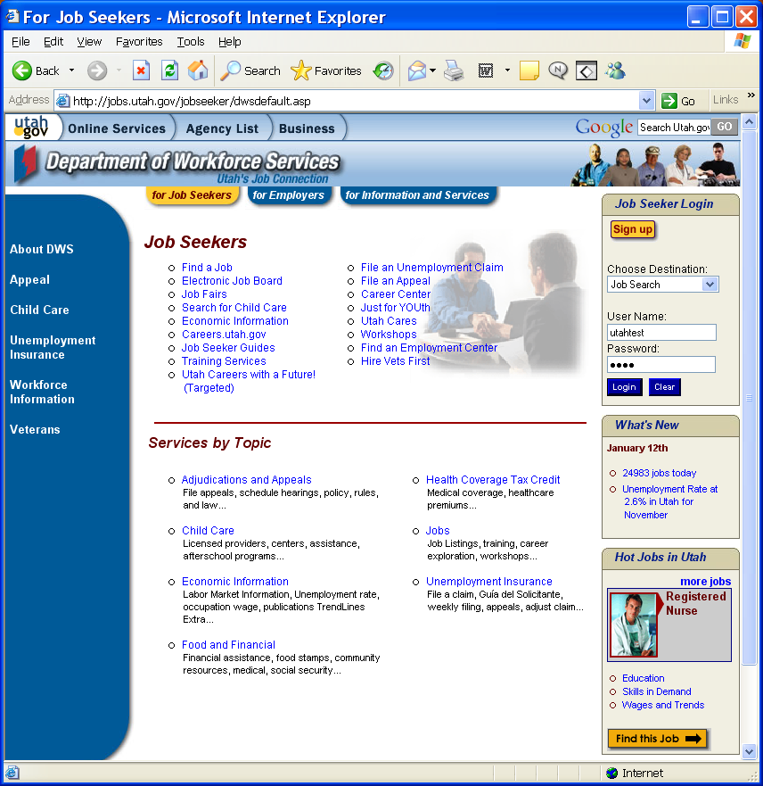
Access jobs.utah.gov to register and set up an online account. First time users should select the Sign Up button to create an account. A Job Seeker will create a unique username and password as one of the steps in the registration process.
Once a Job Seeker has registered, they will enter the username and password they created to login.
If a Job seeker does not want to register they can still search for jobs by clicking the “Electronic Job Board” link. This will allow them to see job openings without registering but will not give them referral instructions.
Job Seekers should use the Job Seekers tab to find job seeker services and information that are provided through this web site. There is also an Employer tab and Information and Services tab.

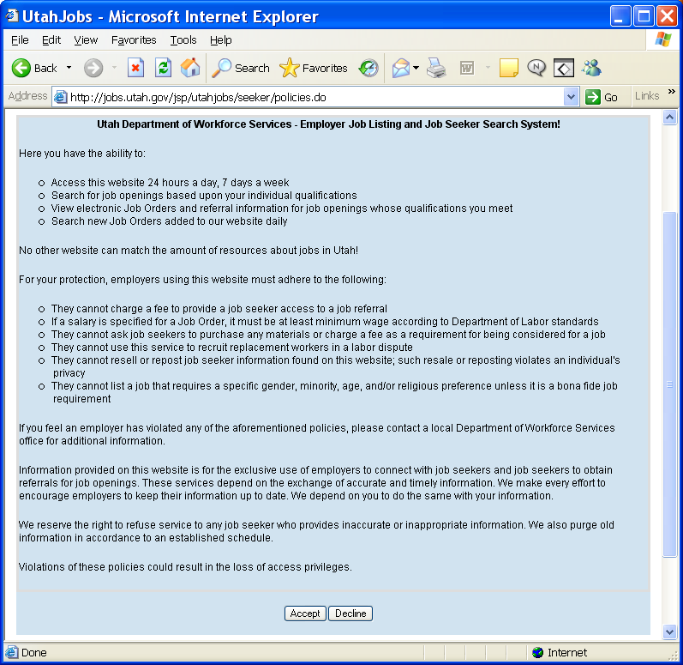
Rules of Use:

This page reviews the benefits of using this site and the rights and responsibilities of the seeker and Employer while using the site.

Seeker will select “Accept” to advance to the next screen.
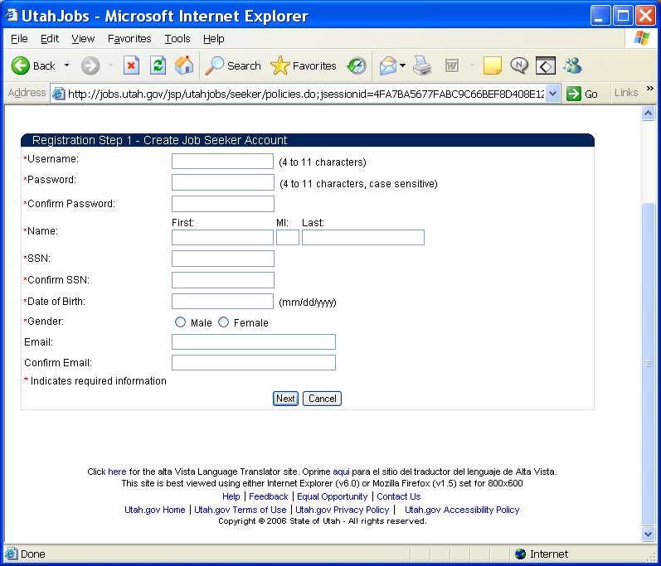
Remember:
Any field noted with a “” is a field that must be completed.
Registration Step 1:

The information a Seeker enters on this page must match the information in the UWORKS system or the Seeker information is validated through an automatic match with Social Security.

The following information must match the existing record in the UWORKS system:
- Name
- SSN
- Date of Birth
- Gender

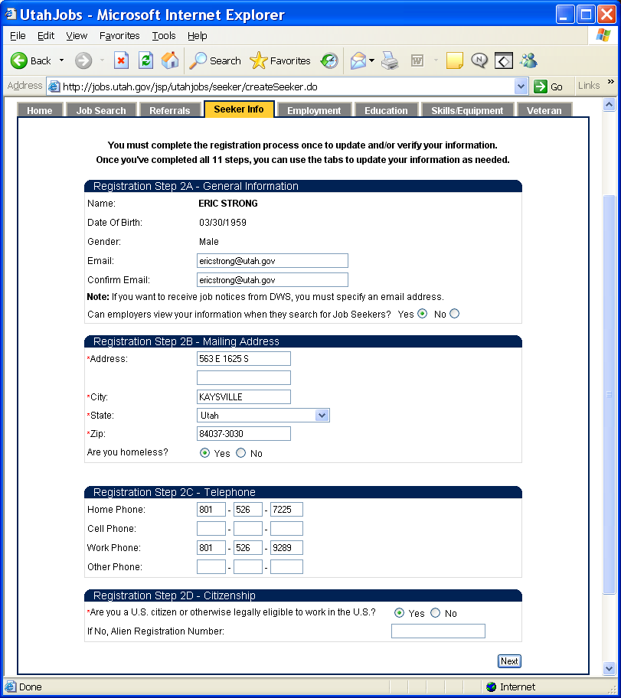
Registration Step 2:

Information provided on this page starts the 11-step registration process.

The seeker must complete all eleven steps of the registration to activate their web account. They are not required to complete all eleven pages at once. If they do not finish the next time they log into the site it will take them to the point where they were before.

Pressing the “Next” button will save the information and take the seeker to Step 3 of the registration process.

Note: All tabs are grayed out and not available until all steps of the registration process are completed.
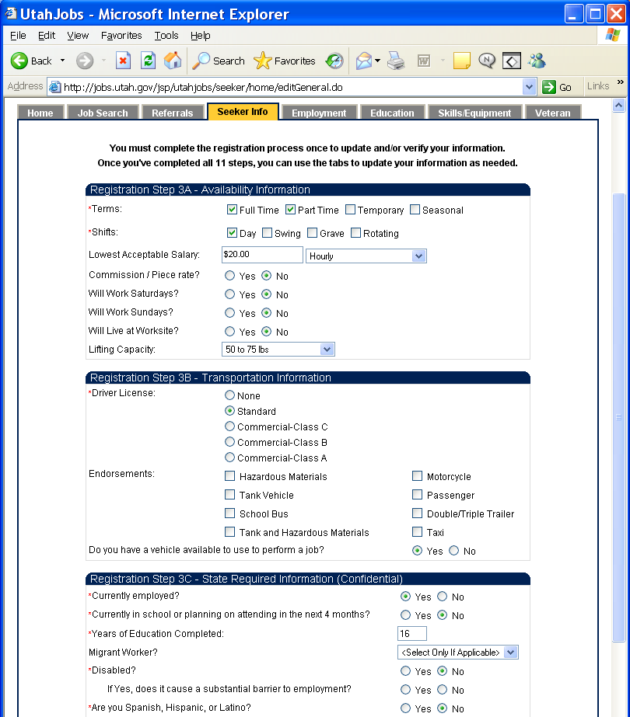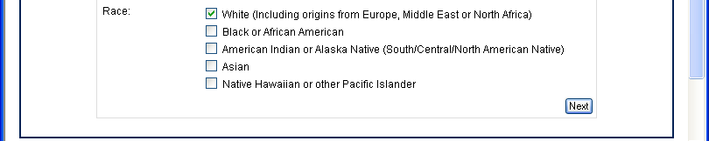
Registration Step 3:

Step 3 allows the Job Seeker to enter information about there Work Availability, Transportation related information and there is a section required for entry of State/Federal required information.

Pressing the “Next” button will save the information and take the seeker to Step 4 of the registration process.

Note: If a Job Seeker has Information already in the UWORKS system that information will populate on each page of the registration process. If the information has changed then the Job Seeker will update the information here and it will also be updated in UWORKS.

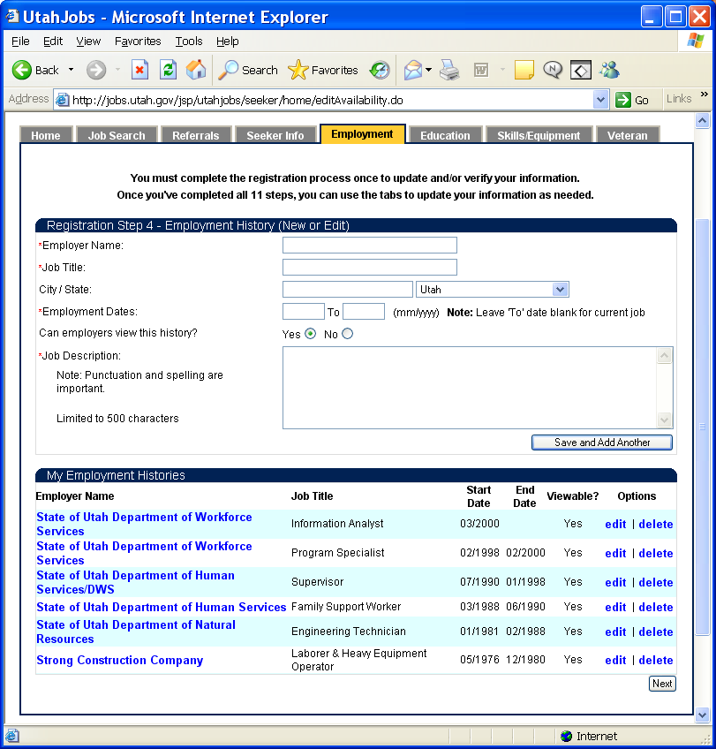
Registration Step 4:

Step 4 allows the Job Seeker to enter their Employment History information. They can enter the employment record and then select the “Save and Add Another” button to add more employment history records.

My Employment Histories section of the page displays the employment history records that have already been entered. Notice that records can be edited or deleted.

Pressing the “Next” button will save the information and take the seeker to Step 5 of the registration process.

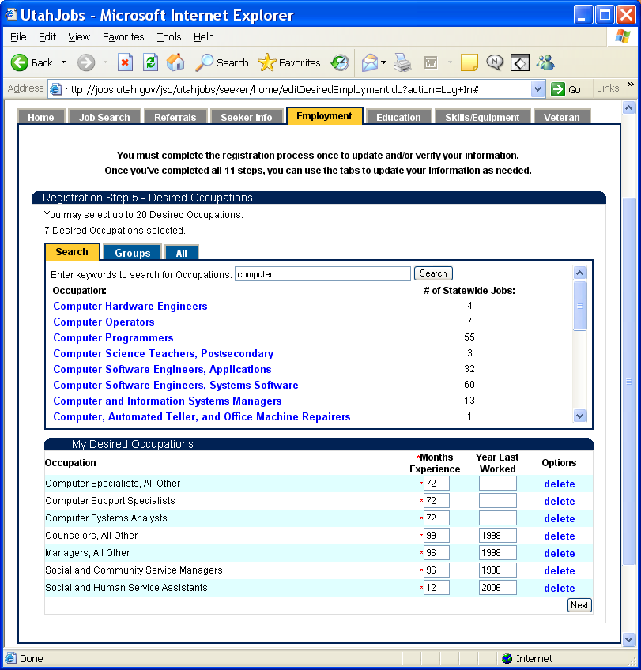
Registration Step 5:

Step 5 allows the Job Seeker to select their Desired Occupation choices. They can select occupations using a Key Word Search, Group search or Listing All Occupations.

My Desired Occupations section of the page displays the occupations records that have already been selected. When an Occupation record is selected the Job Seeker is required to enter the Months Experience that they have for that occupation record and they can also enter the Year Last Worked. Zero can be entered for records with no work experience.
Notice that records can also be deleted.

Pressing the “Next” button will save the information and take the seeker to Step 6 of the registration process.

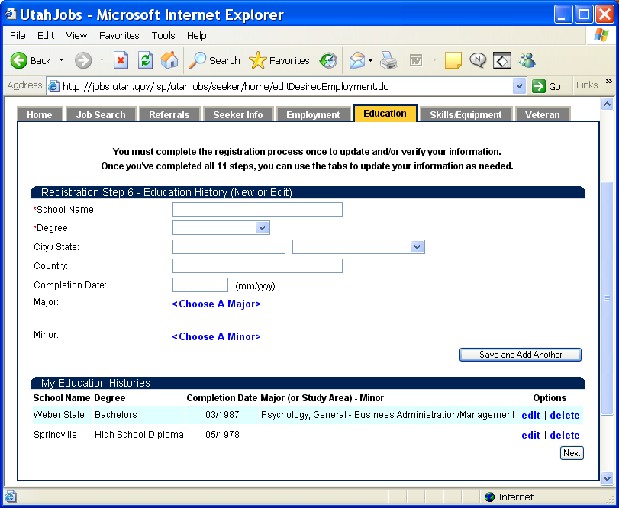
Registration Step 6:

Step 6 allows the Job Seeker to enter their Education History information. They can enter the education record and then select the “Save and Add Another” button to add more education history records.

My Education Histories section of the page displays the education records that have already been entered. Notice that records can be edited or deleted.

Pressing the “Next” button will save the information and take the seeker to Step 7 of the registration process.
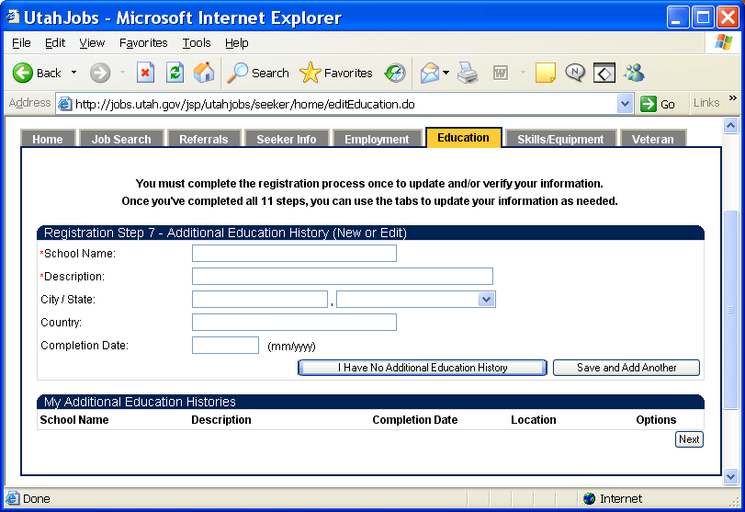
Registration Step 7:

Step 7 allows the Job Seeker to enter their any Additional Education History information. They can enter the education record and then select the “Save and Add Another” button to add more education history records.

My Additional Education Histories section of the page displays the education records that have already been entered.

Pressing the “Next” button will save the information and take the seeker to Step 8 of the registration process.

Note: On pages where no existing records exist and none need to be added you will see the button “I Have No Additional ___ History”.

Registration Step 8:

Step 8 allows the Job Seeker to enter Licenses or Certificates they have. They can select a License or Certificate by clicking <Choose a License/Certificate> and selecting from the list. Use the “Save and Add Another” button to select additional Licenses/Certificates.

My License & Certificate section of the page displays the License/Certificates that have already been entered.

Pressing the “Next” button will save the information and take the seeker to Step 9 of the registration process.

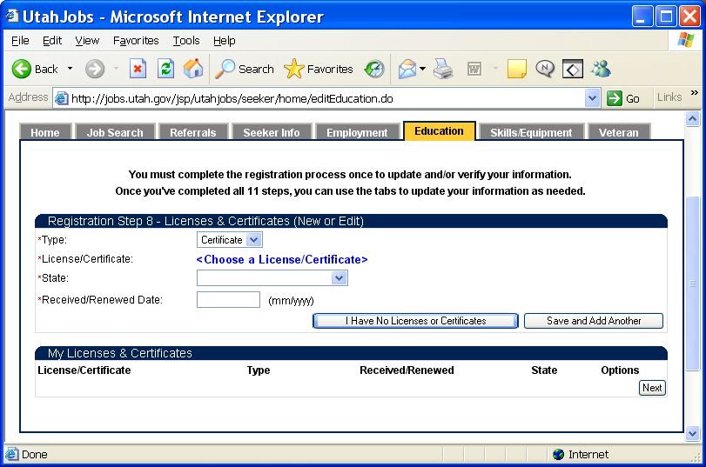
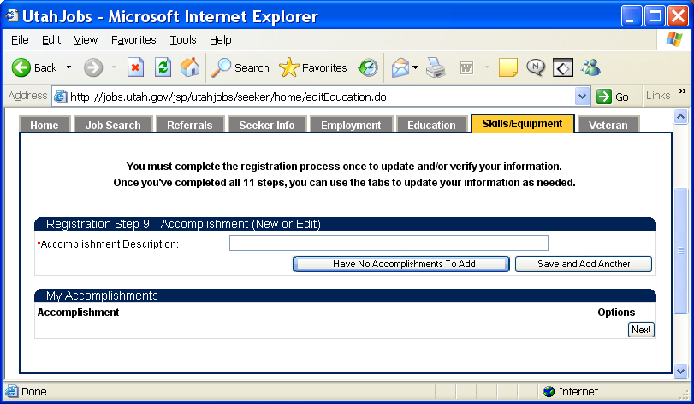
Registration Step 9:

Step 9 allows the Job Seeker to enter their Accomplishments. They can enter an accomplishments and then select the “Save and Add Another” button to add more records.

My Accomplishments section of the page displays the records that have already been entered.

Pressing the “Next” button will save the information and take the seeker to Step 10 of the registration process.

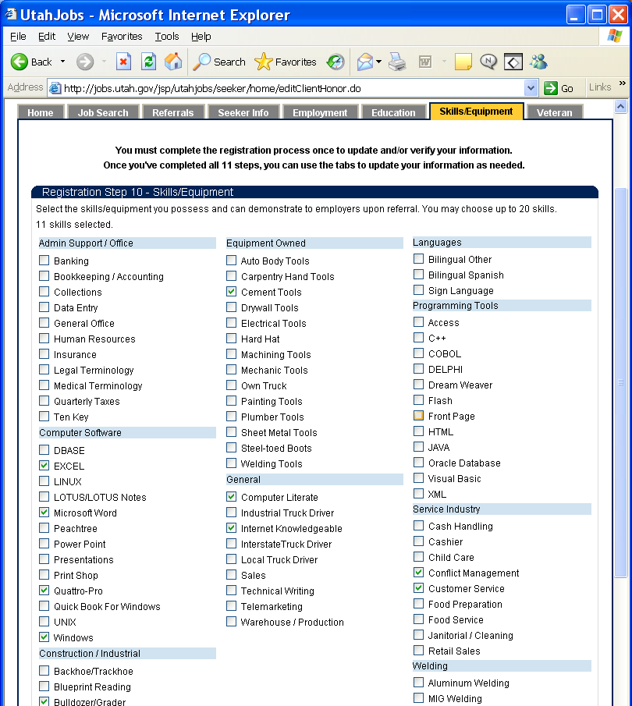
Registration Step 10:

Step 10 allows the Job Seeker to select their Skills/Equipment from the check boxes on the page.

The Job Seeker can select up to 20 of the Skills/Equipment options from the list. There is a counter at the top of the page that shows how many of the boxes have been checked. When someone tries to select more than 20 of the boxes they will get a message letting them know that they are limited to 20.

Pressing the “Next” button will save the information and take the seeker to Step 11 of the registration process.
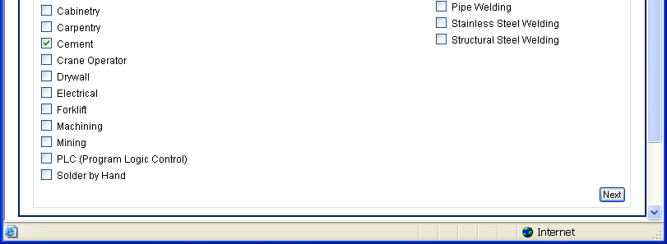
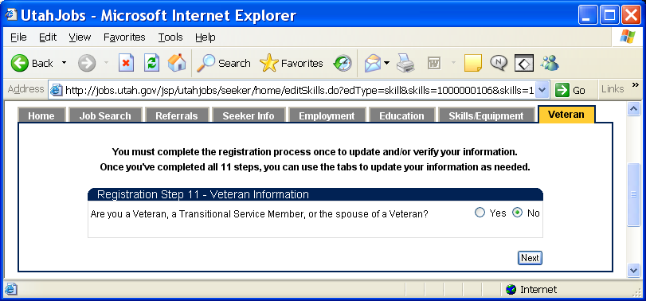
Registration Step 11:

Step 11 allows the Job Seeker to select their Veteran status.

If the Job Seeker is not a veteran they select No and the registration process is complete. If the Job Seeker is a Veteran they should select Yes and click the Next button.

Veteran Job Seekers will need to complete the information on the Veteran page. The blue sentences are links and clicking on them will open pop-ups for detailed descriptions of the question.

Pressing the “Finish” button will save the information and completes the registration process.

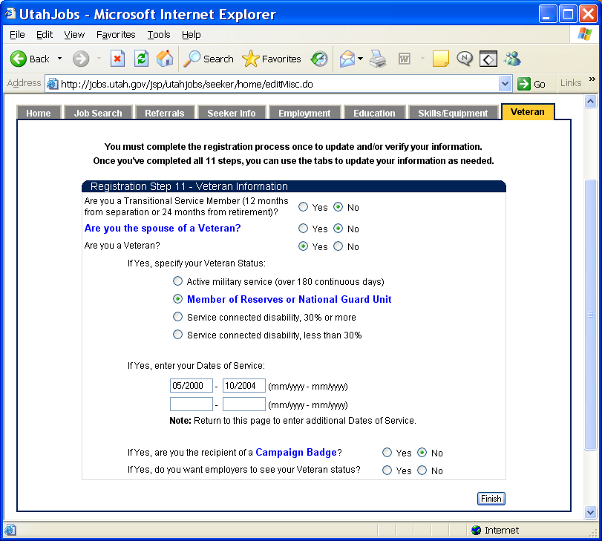

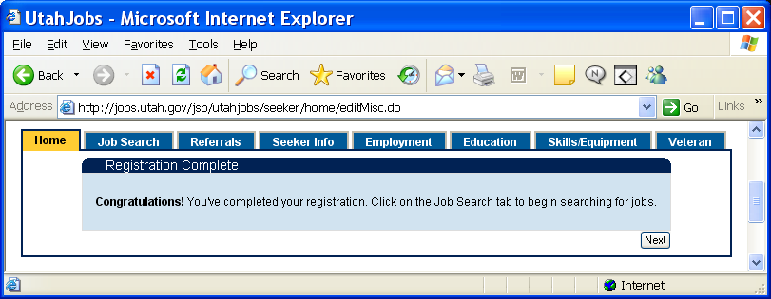
Registration Complete:

When the Registration is complete the page will display a message so the Job Seeker knows they have completed the process. The tabs turn blue and are now accessible. Clicking the Next button will take you to the seeker Home page.
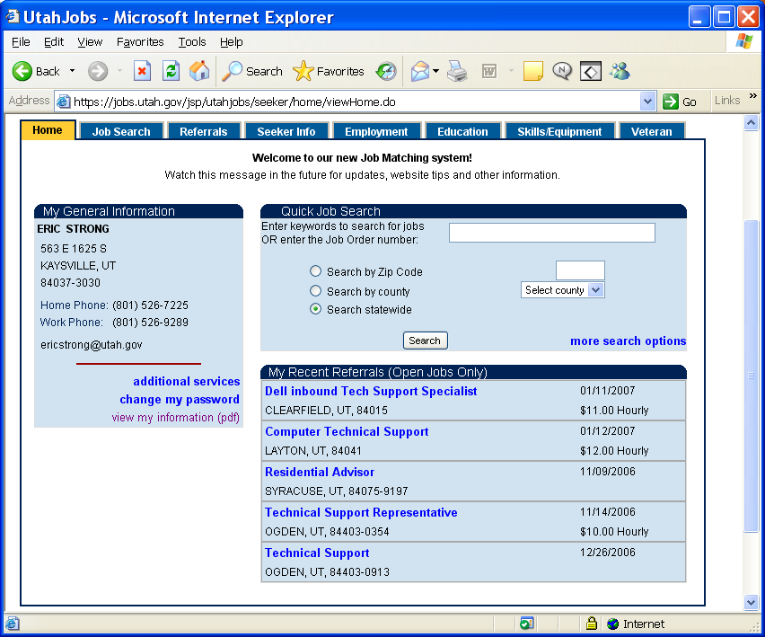
Seeker Home Page:

The Home page allows the seeker to view their General Information, do Quick Job Searches and View some of their recent job referrals. All tabs are available for the seeker to click and make changes to their record.

Clicking the “more search options” link will open the Job Search page and take the seeker to the second tab (Job Search).
There are three links in the “My General Information” section of the page, Additional Services, Change My Password, and View My Information (pdf). The Additional Services link will open the “Preparing To Prosper” page where more information is available (page below). The “Change My Password” link opens the “Change Password” page were the seeker can change their password. The “View My Information” link will open a pdf page and display the job seekers information as it has been entered. This information is what the employer will see when they are searching for job seekers for their jobs.

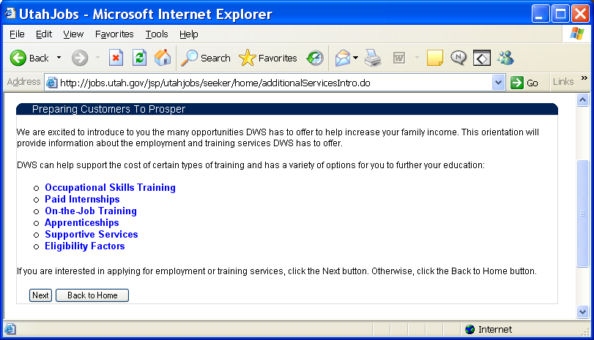
Preparing To Prosper:

From this page job seekers can learn about employment and training services offered by DWS. The six blue links will open pages that provide additional information about programs offered. The Next button will open an application form for additional service. When the application is completed information will be given to the seeker about how to follow through with the application process.
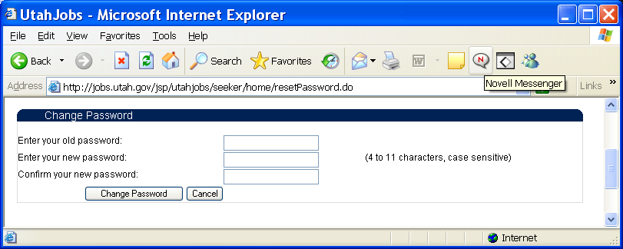
Change Password:

From this page the job seeker can change the password they use to enter the system.

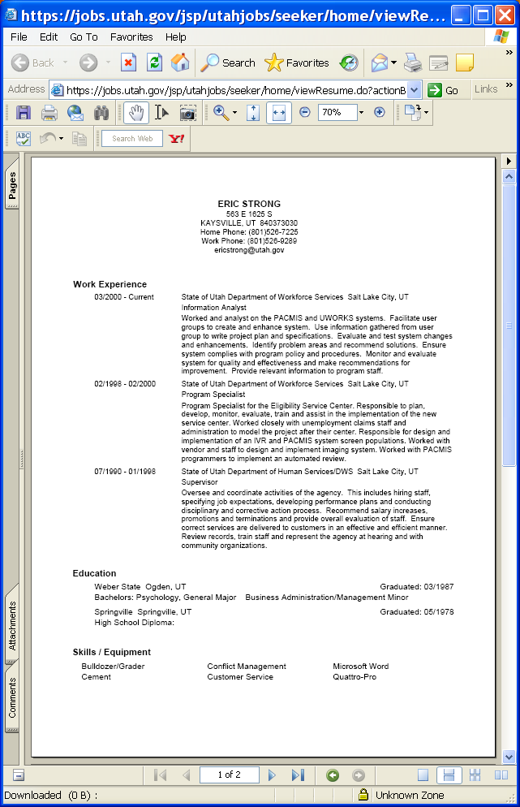
Job Seeker Info:

The Job Seeker Information page is displayed in pdf format so that the seeker can print the information or copy and paste it to another application so that they can use the information to create their resume. The information on this page is displayed in the format that employers will see it when they are searching for job seekers to fill their jobs.
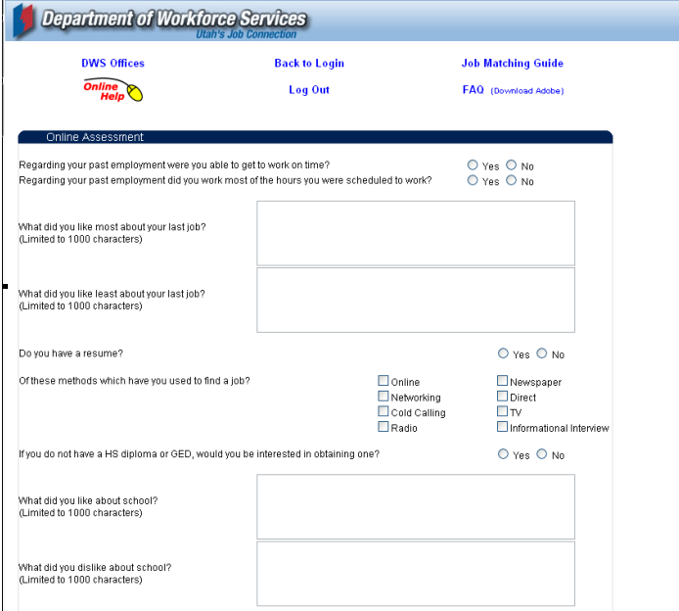
Online Assessment Page:

From this page job seekers can begin the Assessment process. Completing the assessment is one of the steps towards intensive employment services.

Job seekers answer questions about employment, education and training. These questions populate into the UWORKS Assessment where additional questions will be addressed when the job seeker meets with the employment counselor. The assessment information will help the worker determine how best to help the job seeker become more self-sufficient.
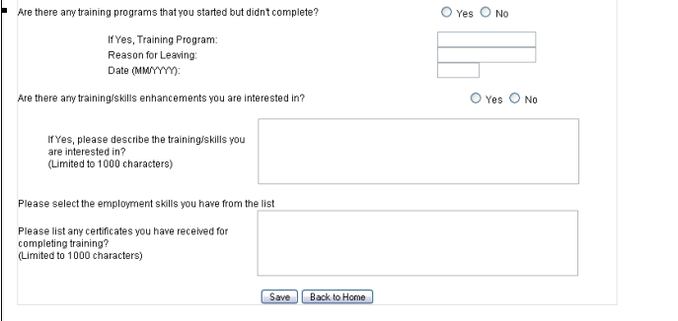
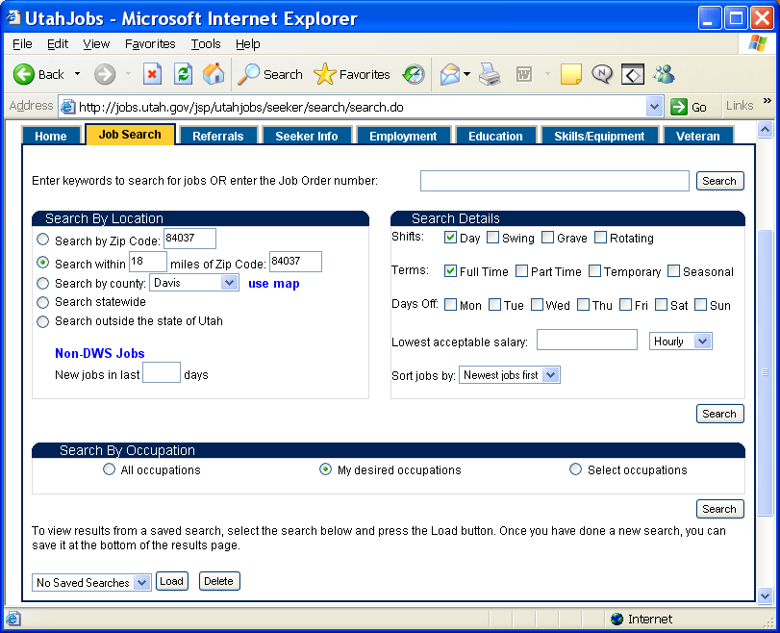
Job Search Page:

This page gives seekers many different options to help them find the job that is right for them.

Search By Location allows searches by zip code, by distance from a zip code, by county (Map), statewide or jobs outside the state.

Search Details allows seekers to select the shift, terms, days off and salary level they desire.

Search By Occupation allows seekers to search by all occupations, their desired occupations or selected occupations of their choice.

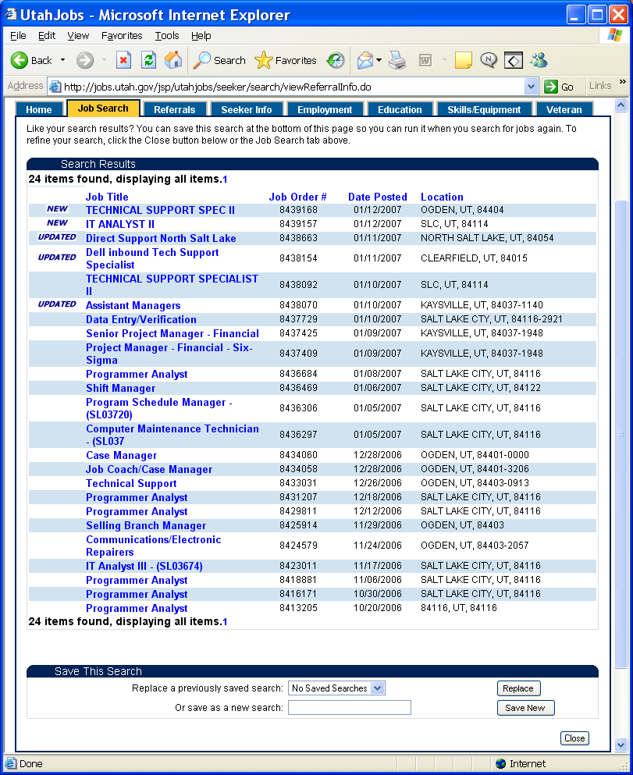
Search Results Page:

After the seekers selects all the options they want and clicks the search button this page show the results of the search.

Jobs that are New or have been Updated in the past two days will show with NEW or UPDATED listed in the first column.

If there are to few or to many jobs in the list select the Close button and modify the search options to bring back more or fewer jobs.

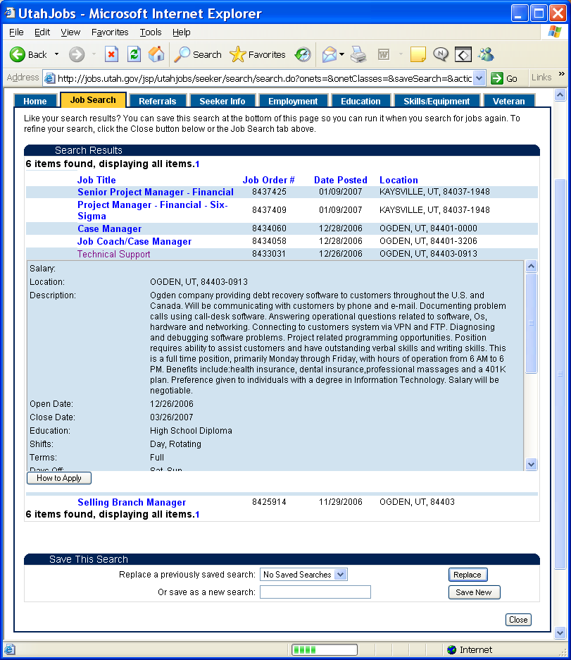
Search Results & How to Apply Page:

To see more information about a job click on the Job Title and the page will expand and show more information about the job. Clicking again on the job title will remove the job information. You can have several different jobs expanded at a time.

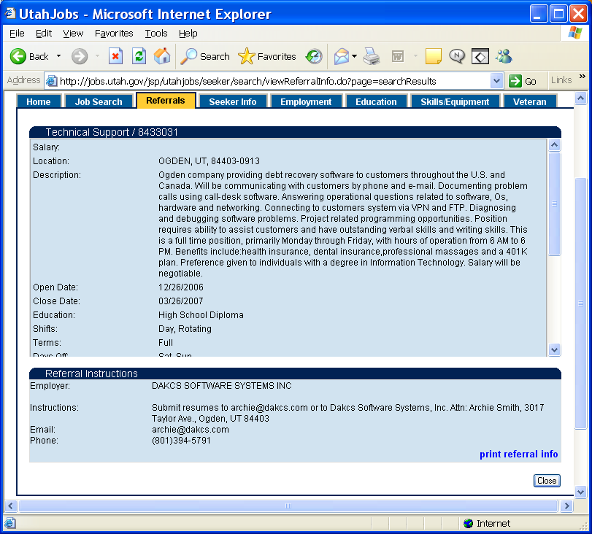
Search Results Referral Instructions:

When you find a job that interests you click on the How to Apply button. If you qualify for the job the page will display the Referral Instructions. If you do not meet the qualifications for the job a page showing why you do not qualify will come up.

Click the Print Referral Info button to get a printout of the referral information (see example on page 17).
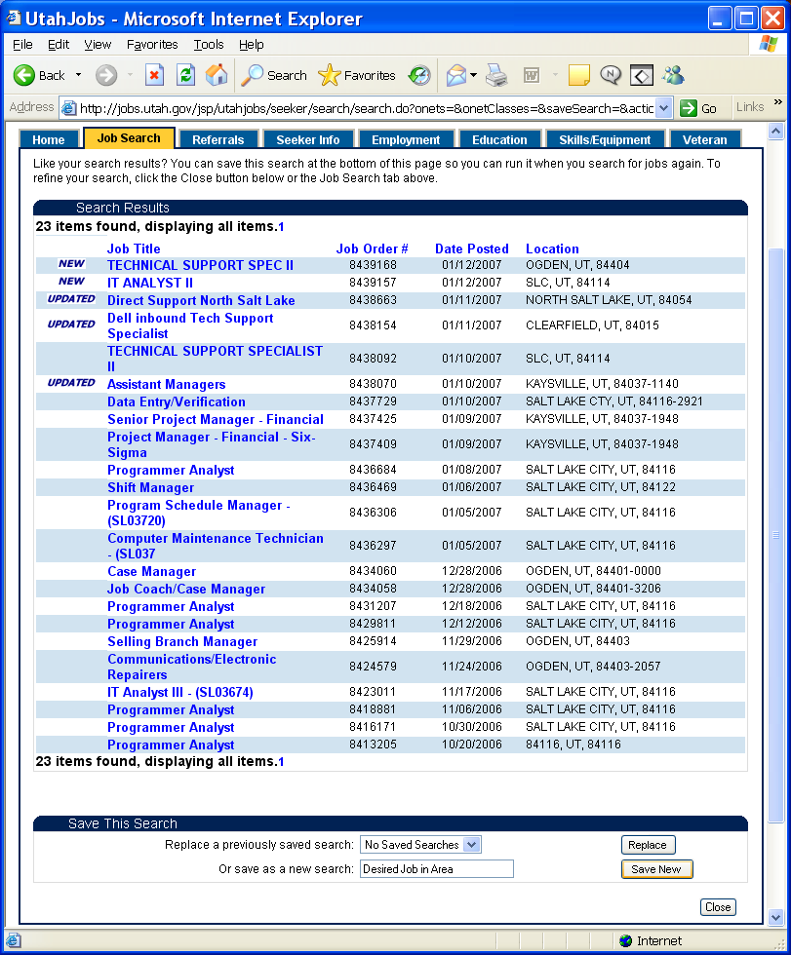
Save Search:

Many job seekers have search options that they like to use every time they come into the website and search for jobs. To accommodate this, searches can be named and saved. At the bottom of this page enter a name for the search and click the Save New button. Several different searches can be saved.

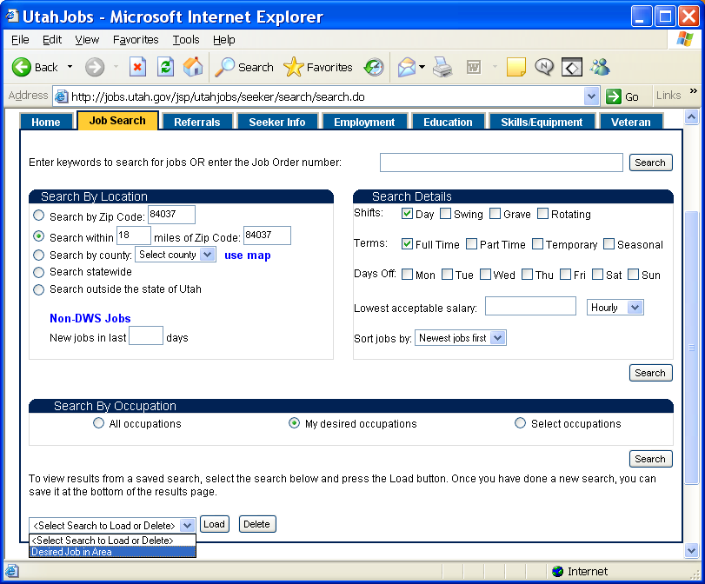
Select Saved Search:

Find saved searches on the bottom of page by clicking <Select Search to Load or Delete>. Your saved search(s) will be in the dropdown list. Click the search you want and select the Load button. This will automatically enter all the options and complete the search.

If you no longer need a search you can select it from the list and then click on the Delete button to delete it.
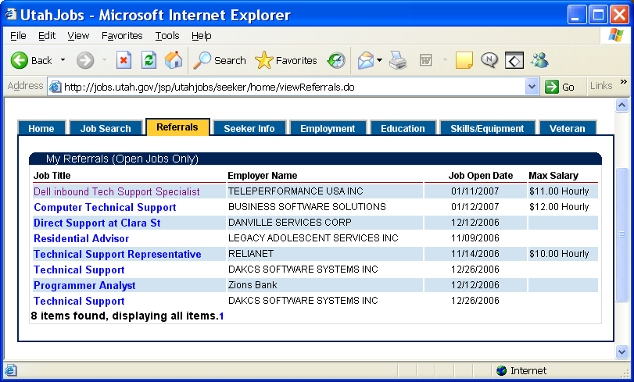
Referrals Page:

The Referrals tab will display all of the jobs that you have received referral information for. Click on a Job Title and it will expand the page and display the job detail information and referral instructions’

Referrals will only show on this page as long as a job is open. Once a job is no longer open the referral will be removed.

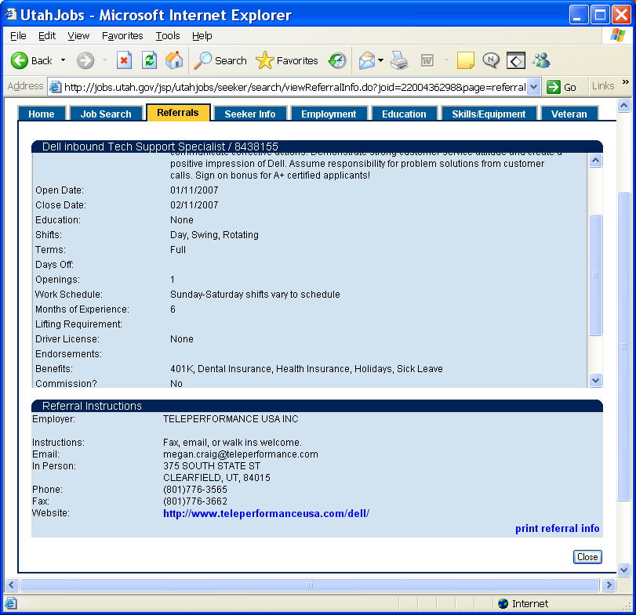
Referral Instructions:

As long as a job listing is open the job seeker can see it and get the Referral Instructions. Job seekers can come to this page to find jobs that they have been referred to but still need to follow up and contact the employer.

Use the Print Referral Info link to print the referral instructions.
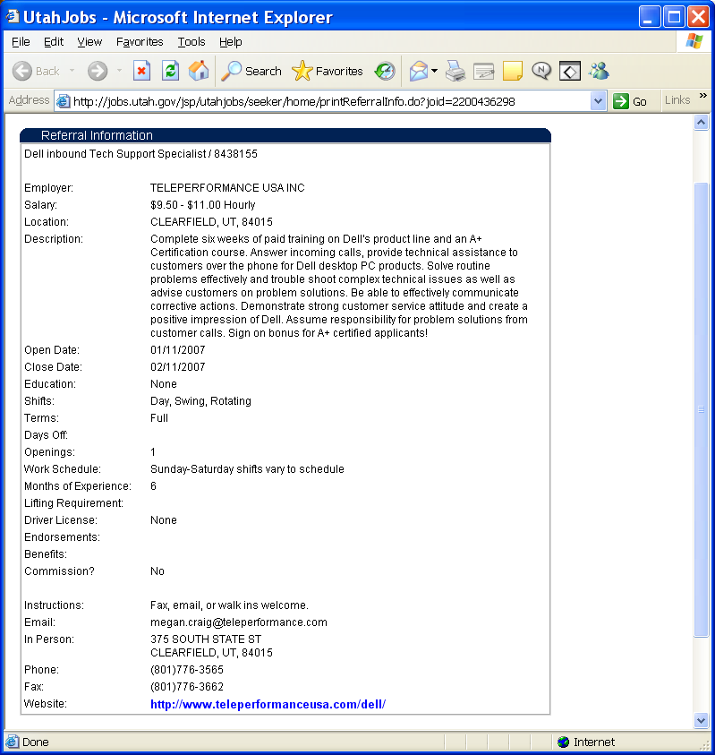
Referral Printout:

When the seeker clicks the Print Referral Info link on the referral instructions page this popup will come up. From this page the seeker can get a printer friendly copy of the job and referral instructions.

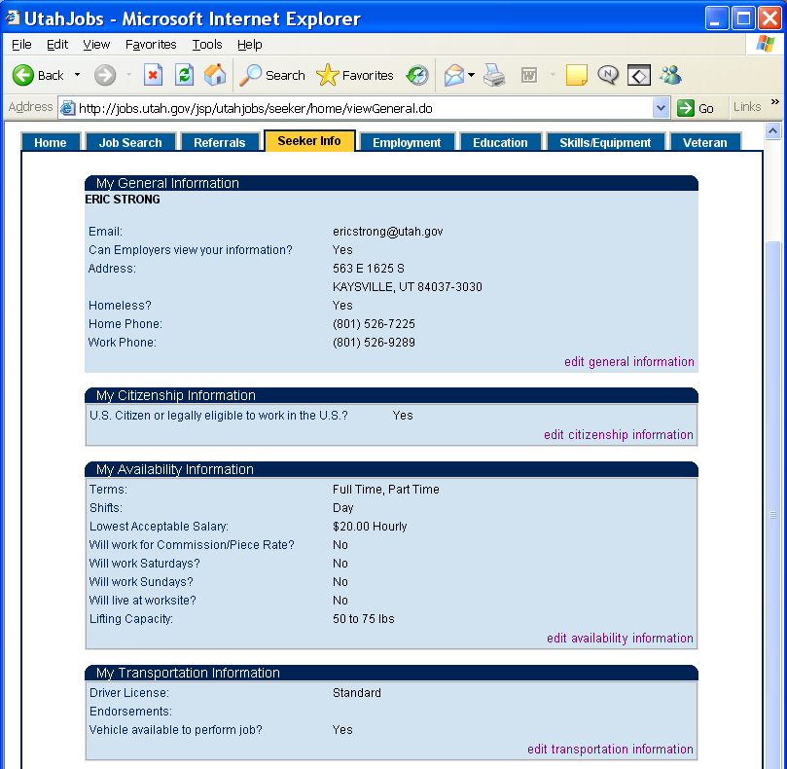
Seeker Info Page:

The Seeker Info tab will display the General Information, Citizenship, Availability, Transportation and State Required information that was entered during the seeker registration process.

Use this page to change or update information that is no longer correct. Click the Edit <blank> Information link to change information in any of the five sections. When you click a link you will see a page that looks much like the page where the information was entered during the seeker registration process.
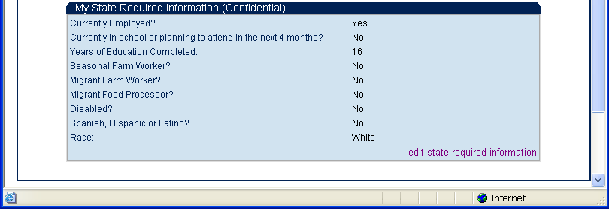

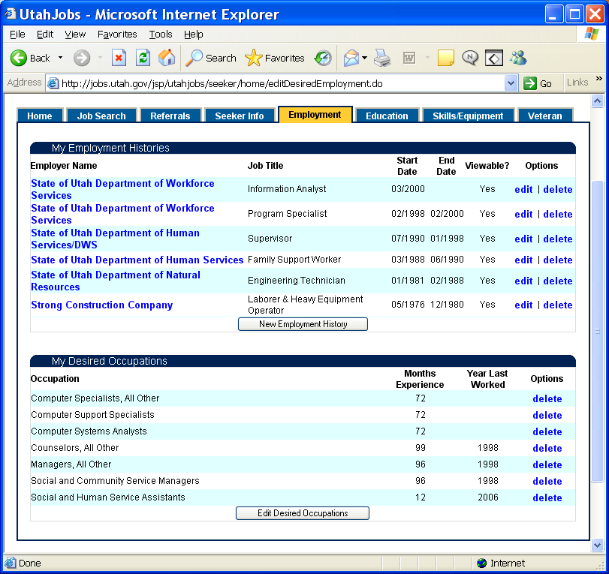
Employment Page:

The Employment tab shows the seeker employment history and the desired occupations that were entered when the seeker registered.

Select the Edit link to change an employment record or delete to delete the record. To add new employment history, click the New Employment History button. When you click a link you will see a page that looks much like the page where Employment information was entered during the seeker registration process.

To add or change Desired Occupations click the Edit Desired Occupations button. Use the Delete link to remove the record.

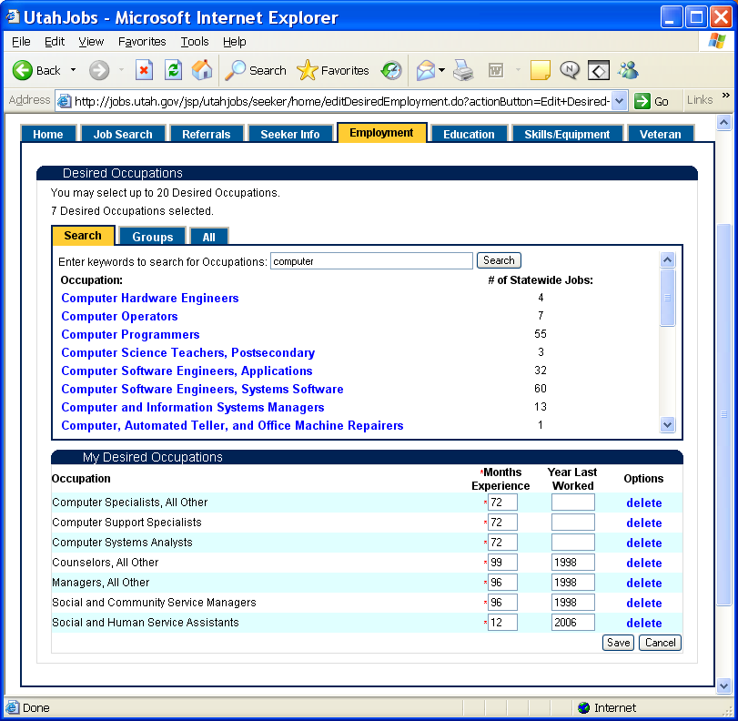
Occupations Search:

When the New Employment History button is selected on the Employment tab this page will come up. This page that looks much like the page where Desired Occupations information was entered during the seeker registration process.

The seeker can select Desired Occupations using any of the three tabs on this page.

The Search tab allows the seeker to find occupations by entering key word(s) and then selecting the Search button. The search returns all occupations that found the key word(s) in the occupations job title or description.
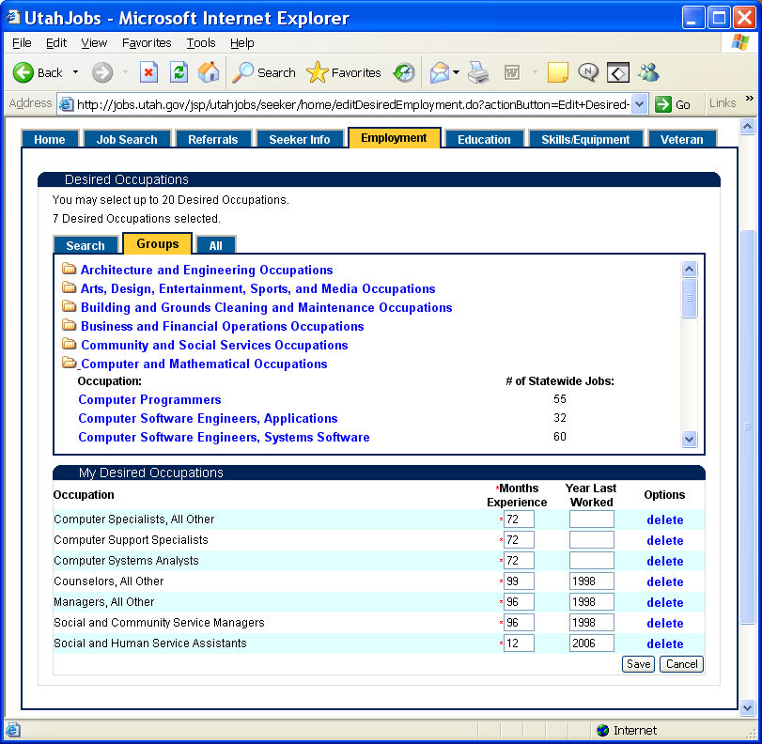
Occupations Groups:

The Groups tab allows the seeker to see occupations by clicking on folders and expanding the groups. To add an occupation to your Desired list click an occupation title from the list. The number to the right of the occupation shows the number of Job open statewide for that occupation title.

When an occupation has been added it will show under the Occupation column in My Desired Occupations section of the page. If the seeker has work experience for that occupation they should enter the Months Experience and the Year Last Worked. Months Experience is required.

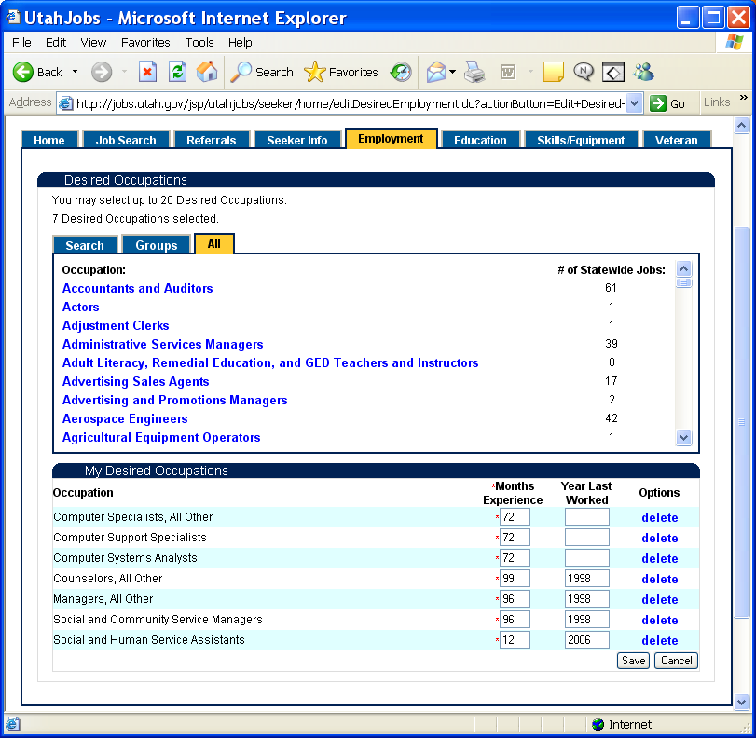
Occupations All:

The All tab allows the seeker to see all occupational titles in the entire list. To add an occupation to your Desired list click an occupation title from the list.

Enter the Months Experience and the Year Last Worked and click on the Save button.

Use the Delete link to remove an Occupational title from your list.
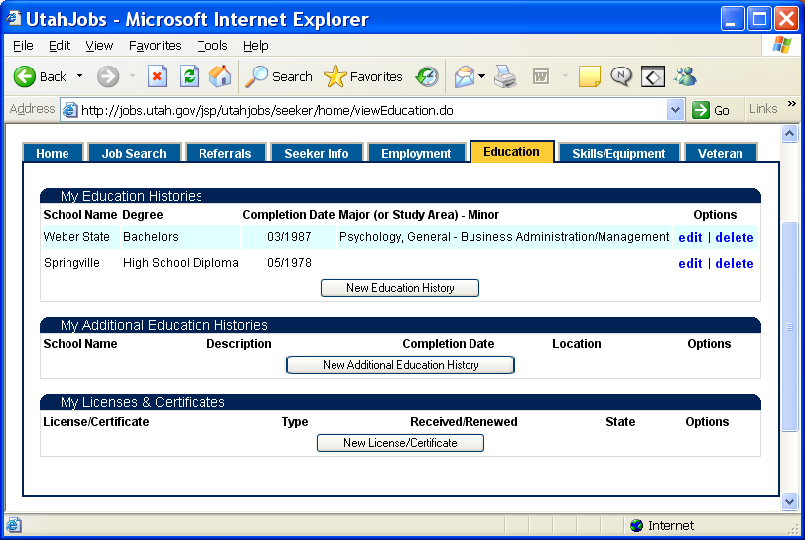
Education Page:

The Education tab shows the seeker education history, Additional Education History and Licenses/Certificates that were entered when the seeker registered.

Select the Edit or delete link to edit or delete a record. To add new education history, click the New Education History button. When you click a link you will see a page that looks much like the page where Education information was entered during the seeker registration process.

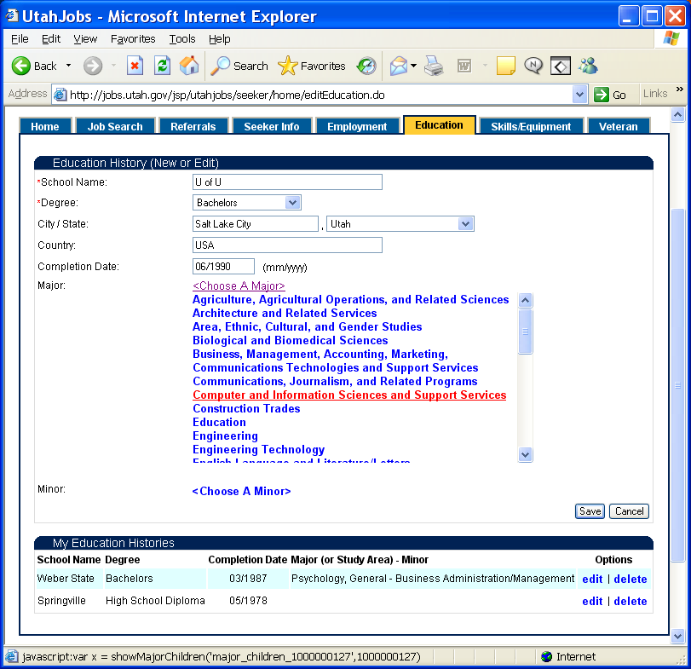
New Education:

If a Degree type is selected that has a Major or Minor the seeker should select from the list by clicking the <Choose A Major> or <Choose A Minor> link. This will bring up a list of the Majors or Minors and the seeker can find theirs and click it to select it.

Select the Save button and the Education record will be add to the list at the bottom of the page under My Education Histories.
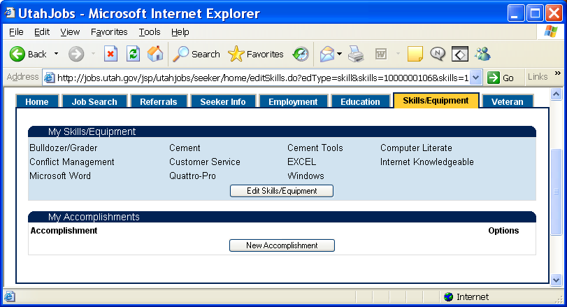
Skills/Equipment:

The Skills/Equipment tab shows the seeker the Skills/Equipment and Accomplishments that were entered when the seeker registered.

To add Skills/Equipment or Accomplishments, click the Edit Skills/Equipment or New Accomplishment button. When you click a link you will see a page that looks much like the page where this information was entered during the seeker registration process

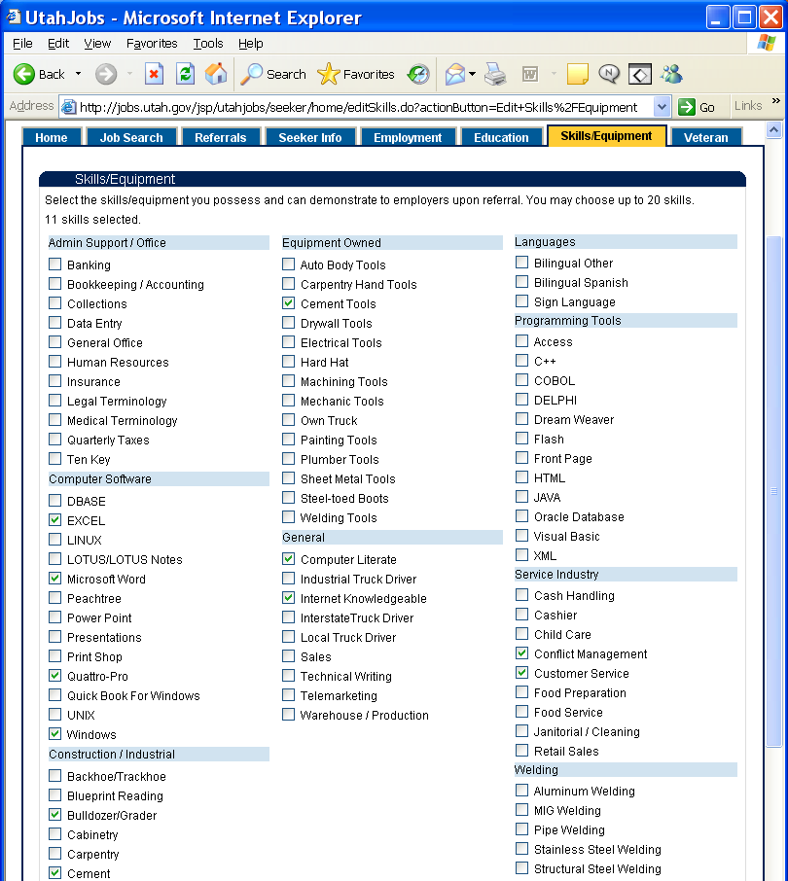
Add or Delete Skills/Equipment:

When the Edit Skills/Equipment button is selected on the Skills/Equipment tab this page will come up. This page that looks much like the page where Skills/Equipment information was entered during the seeker registration process.

Up to 20 Skills can be selected. The counter at the top of the page will show how many skills have been selected.
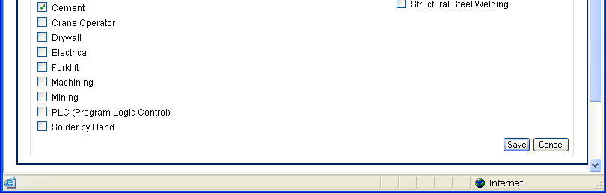
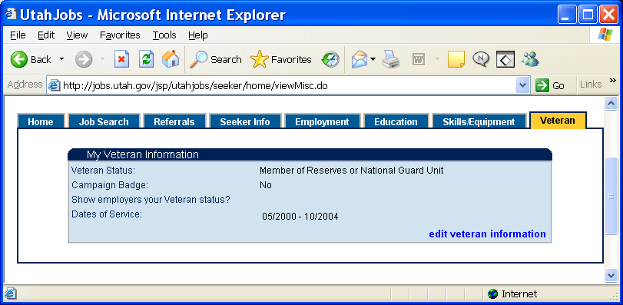
Veteran Page:

The Veteran tab shows the seeker the veteran status that was entered when the seeker registered.

If the veteran status has changed click the Edit Veteran Information link at the bottom of the page.

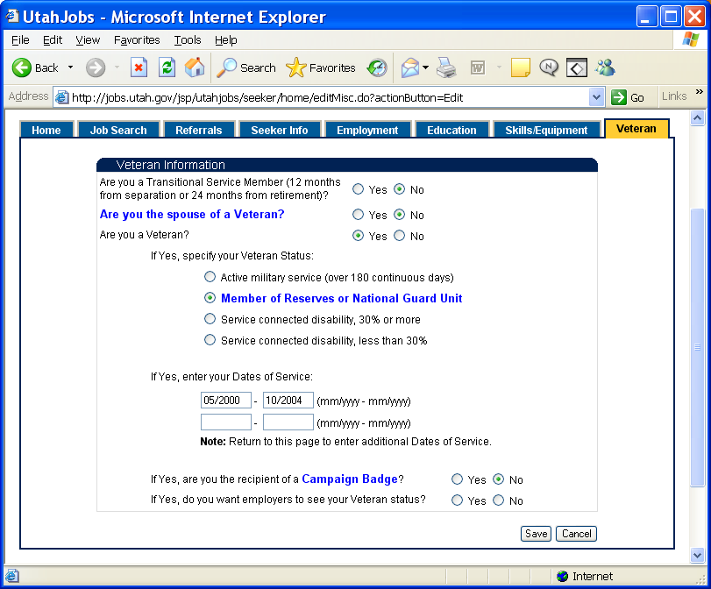
Veteran Information:

When the Edit Veteran Information link is selected on the Veteran tab this page will come up.

The blue links on this page will popup pages that will give more detail information about the questions.

When the Veteran information is entered select the Save button to save the information entered.

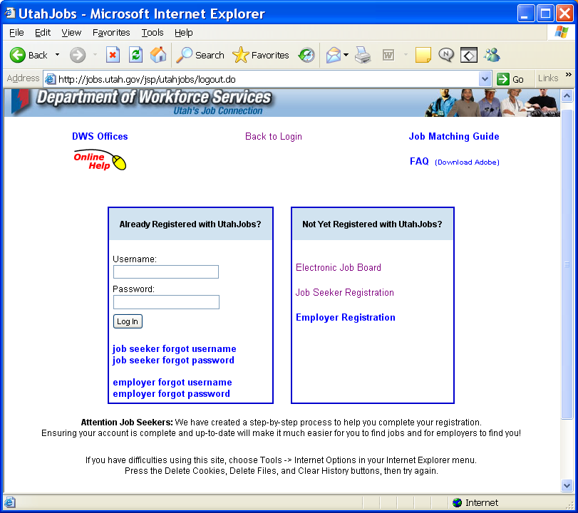
Seeker Login Page:

When you Logout or go to the “jobs.utah.gov” Job Seeker tab you can access this login page by clicking the Find a Job link. From this page you can Register, Find your Username or Reset your Password.

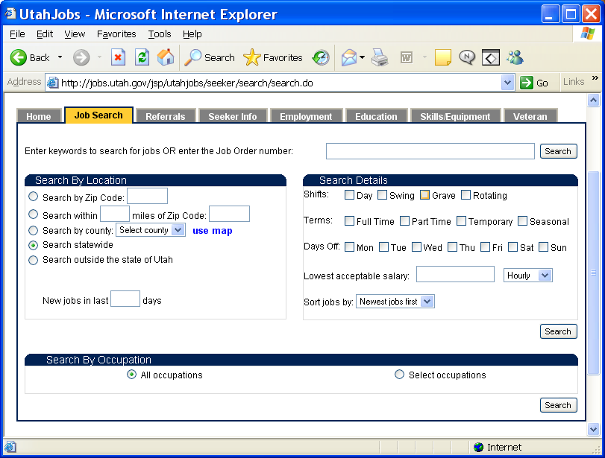
Electronic Job Board:

If a Job seeker does not want to register they can still search for jobs by clicking the “Electronic Job Board” link on the Login page. This will allow them to see job openings without registering but will not give them referral instructions. As you can see the search looks the same as when you are logged into the system but all other tabs are grayed out.

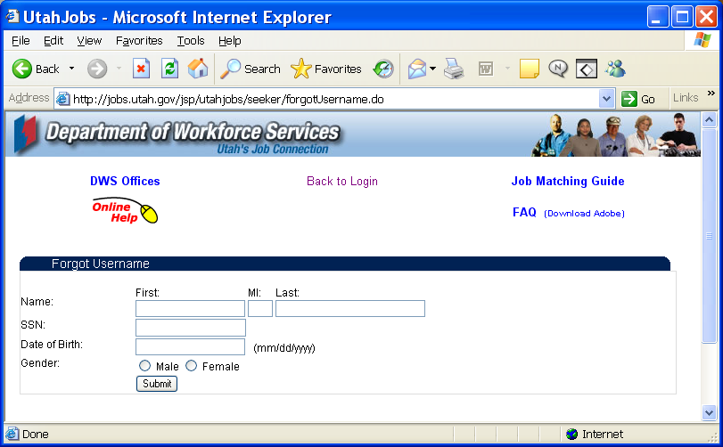
Forgot Username:

From the Login page click the Job Seeker Forgot Username link to open this page to find your Username if you have forgotten it.

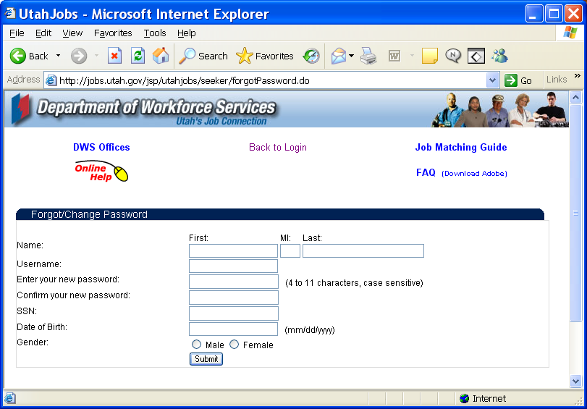
Forgot Password:

From the Login page click the Job Seeker Forgot Password link to open this page to reset your Password if you have forgotten it.

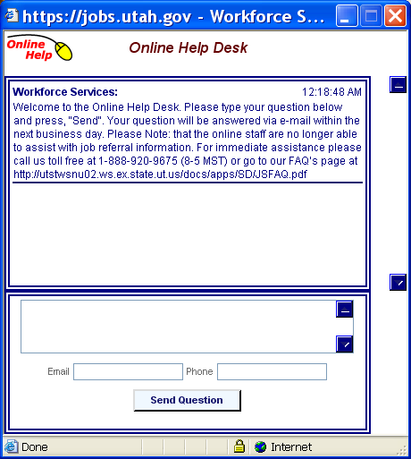
For Help click the Online Help link from the list on the left side of the Employer Home page. Type in a Message, enter your email address and phone number.

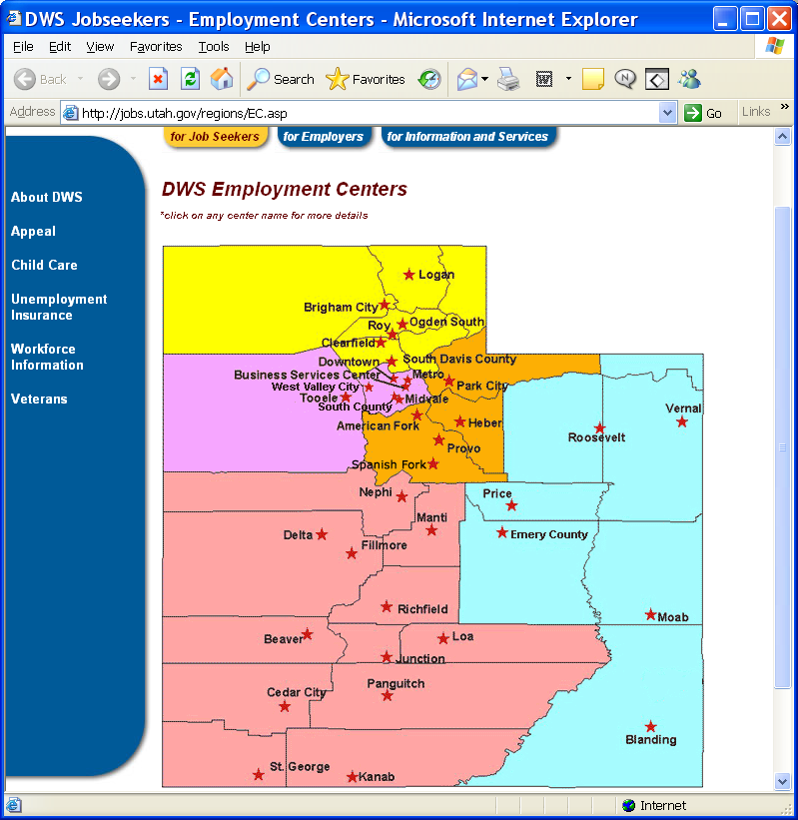
For Help click the DWS Offices link from the list on the left side of the Employer Home page. Each office on the map is a link and clicking on the link will open a page with information about the office.

